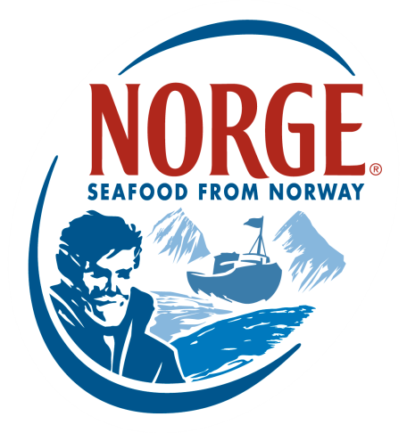
CONTACT:
Jessica Butera
The Food Group
212-329-6273
Jessica.Butera@thefoodgroup.com

FOR IMMEDIATE RELEASE

Norwegian Seafood Council Welcomes New Chefs to Culinary Board

The Norwegian Seafood Council (NSC) is excited to welcome seven new members to their Chef’s Culinary Board. Given the success of the first culinary board, which launched last year and joined award-winning chefs like Kevin Sbraga, Todd Gray and Jamie Malone, the Norwegian Seafood Council is expanding its network of chefs to help increase awareness of the pristine seafood from Norway. The Board joins renowned seafood- and sustainability-focused chefs from restaurants across the United States, unified in their efforts to support and advocate for sustainable species like Norwegian Salmon and Skrei™.

The Culinary Board brings together chefs with diverse culinary and geographic backgrounds, joined by their appreciation for high-quality seafood that is sustainably sourced with a keen respect for nature and origin. New members of the Norwegian Seafood Chef’s Culinary Board include:

- Neal Fraser – owner and chef of Redbird at Vibiana, BLD and Fritzi Dog in Los Angeles
- Tim Graham– chef of Travelle in Chicago
- Greg Hozinsky – chef of The Strand House in Los Angeles
- David Seigal – chef of Cull & Pistol in New York City
- Bart Vandaele – owner and chef of Belga Café and B Too in Washington, D.C.
- Paul Backer – chef of Tilia in Minneapolis
- Steven Brown – executive culinary director of Tilia in Minneapolis

To kick off the Chef’s Culinary Board, the Norwegian Seafood Council recently guided the chefs through Norway, where they were immersed in the country’s unique values such as seafood heritage, tradition and natural conditions. The chefs were educated in aquaculture practices, which included visits to the pristine salmon and halibut production facilities. The Culinary Board members had the opportunity to work with Norwegian chefs to learn local and traditional cooking techniques, sample authentic Nordic Cuisine and prepare an array of fresh seafood, putting their unique, modern spin on each dish. Since returning from Norway, the chefs have begun to integrate their recent learnings of the seafood, flavors and Nordic cooking philosophy into their own cooking styles.

As the Nordic movement continues to spread throughout the U.S., the Norwegian Seafood Council and Culinary Board members are looking forward to taking part in several upcoming events that will elevate awareness and interest in Nordic cuisine. First up is NORTH, a Nordic Food Festival taking place in New York City September 13–20. Scandinavian chefs from around the world will come together to host consumer-friendly events like cooking classes, kitchen collaborations, dinners and more. The NSC Culinary Board members will be hosting cooking classes at the International Culinary Center, as well as tasting menus at popular New York City restaurants. Fans of street food will welcome the Nordic Street Food Festival at the Brooklyn Brewery on September 14 and 15, where Culinary Board members showcase their favorite on-the-go seafood dishes.

Following NORTH, the Culinary Board members will return to their restaurants to develop Nordic-inspired menus, which they are excited to share, along with tales of their trip, during a special Norwegian Seafood tasting in October and November. Each chef will be featuring a unique tasting menu inspired by his or her personal experience in Norway. The limited-time menu will highlight the core values of Nordic Cuisine (purity, simplicity, freshness and ethics) and the delicious, sustainably sourced seafood such as Norwegian Salmon, Halibut, Mackerel and Cod.

“We are so happy to the see the level of engagement and passion our new Culinary Board members have exhibited so far,” says Egil Sundheim, U.S. director of the Norwegian Seafood Council. “I had the pleasure of traveling with the chefs in Norway, so I am excited to see how they translate their recent experiences into their menus.”

In the coming weeks, members of the Norwegian Seafood Council’s Chef’s Culinary Board will be busy getting ready for NORTH, as well as their own Nordic Tasting Dinners. For more information on the Chef’s Culinary Board and upcoming Nordic events, visit www.SalmonfromNorway.com and get engaged via #EatNorwegianSeafood.

***

About the Norwegian Seafood Council
Founded in 1991 by the Ministry of Fisheries, the Norwegian Seafood Council (NSC) builds awareness of and educates the public on seafood from Norway. From the headquarters in Tromsø, Norway, and a U.S. branch in Boston, Mass., the NSC carries out Norwegian Seafood promotional, media, marketing and public relations campaigns and is a resource for market information in more than 20 different markets. Its entire efforts are financed by the Norwegian seafood industry itself. As the world’s second-largest exporter of seafood, Norway provides quality, nutrient-rich seafood to over 150 different countries, and is the world's largest joint marketer of seafood. For more information on the NSC, visit www.seafoodfromnorway.com.

