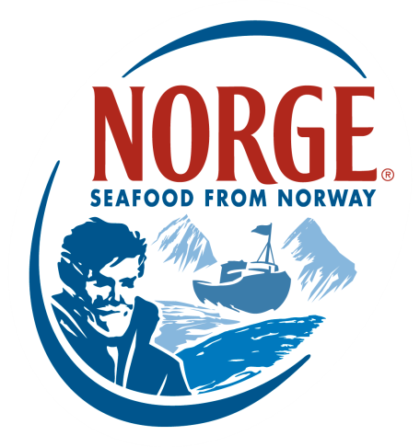
Contact:
Jessica Butera
The Food Group
212.329.6273
Jessica.Butera@thefoodgroup.com

Karin Olsen
Norwegian Seafood Council
Karin.Olsen@seafood.no

FOR IMMEDIATE RELEASE

SKREI™ - Norwegian Cod in its Prime Hits US Seafood Market

New York, NY – The Norwegian Seafood Council (NSC) is thrilled to announce the national launch of Skrei™ – Norwegian Cod in its prime. Across Europe and Scandinavia, chefs and seafood lovers eagerly await this time of the year when the Norwegian coastline comes alive with the premium, seasonal Norwegian Cod known as Skrei. The NSC introduced Skrei to a small group of New York City chefs last year and hopes to further awareness by introducing Skrei to chefs in key markets in the US.

Skrei is a unique premium seasonal Norwegian Cod that migrates along the Barents Sea to its spawning grounds off Norway’s north coast. It is only available between January and April and must meet strict criteria to be classified as Skrei. The wild fish needs to be fully-grown (about five years old) and must be in immaculate condition. Skrei must be packaged within 12 hours of being caught and stored at a temperature between 32° and 39° Fahrenheit. Whole, fresh Skrei is required to have the Skrei brand fastened to the forward dorsal fin. Sustainably managed and MSC certified, only 10% of over 400 million migrating Norwegian Cod are caught during the Skrei season and the rest return to the Barents Sea again after spawning.

Considered a culinary delicacy, Skrei is renowned for its white, lean, flaky meat and delicate flavor. Rich in protein, vitamins and minerals, as well as omega-3 fatty acids, Skrei is a healthy, sustainable seafood choice. It is not just the Skrei meat that is a delicacy; the liver, roe and tongue are also highly sought after in Europe and Scandinavia.

To commence Skrei season, Chef Ben Pollinger of Oceana, a Michelin-Starred seafood restaurant in New York City, will be traveling to Norway to experience the rich history of this seasonal cod. The wild Skrei are caught on small day boats along Norway’s north coast. As his first trip to Norway, Chef Pollinger could not be more excited to be there for Skrei season. “I was lucky enough to work with Skrei last year, so it’s a rare and inspiring opportunity to be able to travel to the source and see how this delicate fish is caught and traditionally prepared.”

In the coming weeks, the NSC will be hosting immersion events in various cities to teach local chefs about the unique qualities of Skrei. Chefs in cities across the country including New York, Chicago, San Francisco, Minneapolis, Philadelphia and Washington, DC. will have the opportunity to learn first-hand about the origins of Skrei, as well as popular ways to prepare the lean, flaky fish. As distribution for Skrei increases across the US, more and more people will have the opportunity to experience Norwegian Cod at select restaurants. In New York City you will find Skrei on a retail level at the well-known seafood market, The Lobster Place, for instance. Interested customers outside of NYC can order from The Lobster Place by calling 212.255.5672 or emailing inquiries to info@lobsterplace.com or ask your local seafood supplier.

With more chefs looking for sustainable seafood options, Skrei offers a delicious, healthy alternative to many seafood species. Whether served traditionally or with a modern spin, both chefs and consumers alike will appreciate the lean, flaky flesh and delicate flavor of Skrei.

For more information on Skrei and where to find it, visit www.SkreifromNorway.com.
Request Skrei from your local seafood supplier.

About the Norwegian Seafood Council
Founded in 1991 by the Ministry of Fisheries, the Norwegian Seafood Council (NSC) builds awareness of and educates the public on seafood from Norway. From the headquarters in Tromso, Norway and a U.S. branch in Boston, Mass., the NSC carries out Norwegian seafood promotional, media, marketing and public relations campaigns and is a resource for market information in more than 20 different markets. Its entire efforts are financed by the Norwegian seafood industry itself. As the world’s second largest exporter of seafood, Norway provides quality, nutrient rich seafood to over 150 different countries, and is the world's largest joint marketer of seafood. For more information on the NSC visit www.seafoodfromnorway.com.

