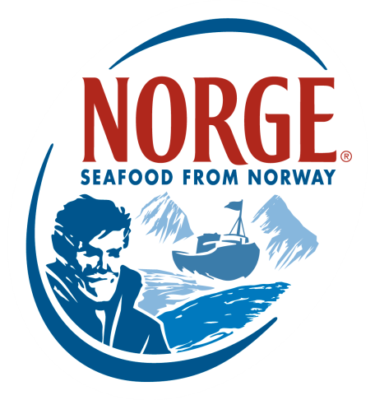
CONTACT:
Jessica Butera
The Food Group
212-329-6273
Jessica.Butera@thefoodgroup.com

Norwegian Seafood Council Chef’s Culinary Board

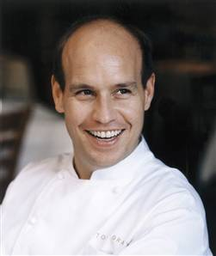
Equinox Washington, DC - EquinoxRestaurant.com
Todd Gray - Owner/Chef

At the forefront of the sustainable and seasonal food movement, Equinox offers sophisticated, pure American cuisine well established in European technique. Chef Gray stays true to his mission of using community-sourced, organic ingredients grown within 100 miles of the restaurant, whenever possible.

Todd Grey has been recognized with numerous industry accolades over the years, including the Restaurant Association Metropolitan Washington’s RAMMY Award for Best Fine Dining Restaurant, for Equinox in 2008, and Foodservice Leaders of the Year by Food Service Monthly in 2011. He has also garnered applause from The Wall Street Journal, The New York Times, CNN, Southern Living, The Washington Post, Town & Country, Gourmet Magazine, Newsweek, Time, and Travel & Leisure.

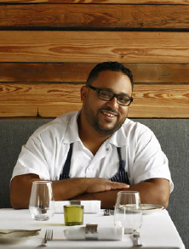
Sbraga Philadelphia, PA - Sbraga.com
Kevin Sbraga - Owner/Chef

Sbraga is a modern American restaurant located on Philadelphia’s lively Avenue of the Arts. Focused on redefining American cuisine in a simple, yet unfamiliar way, Sbraga offers inventive, seasonal fare with a focus on local and sustainable ingredients.

Kevin Sbraga was the winner of Top Chef Season 7 and has been recognized as Esquire Magazine’s “Best New Restaurant’s” 2012, Bon Appetit Magazine’s “Philadelphia’s New Originals, Lightweight Knowckout” 2012, Rising Stars “Community Chef” 2013 and Zagat Restaurant Guide’s “#1 Restaurant on Avenue of the Arts & Best Newcomer” 2013.

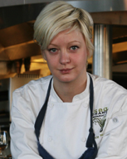
Sea Change Minneapolis, MN - SeaChangeMPLS.com
Jamie Malone - Chef

Sea Change focuses on sustainable seafood, highlighting fisheries that use environmentally responsible methods of gathering and farming seafood.

Before receiving her culinary degree from Le Cordon Bleu, Chef Malone traveled extensively in Hong Kong, Vietnam and Europe, studying food and immersing herself in the nuances of each region's cuisine. She developed her passion for cooking in high school as an avid listener of NPR's The Splendid Table, which continues to inspire her to this day. She also admires and aspires to emulate renowned Chef Thomas Keller for his organization and commitment to the craft of cooking. Jamie Malone was a 2013 semi-finalist for the James Beard Foundation Awards, “Rising Star Award.” She was also named a Food & Wine “Best New Chef for 2013.”

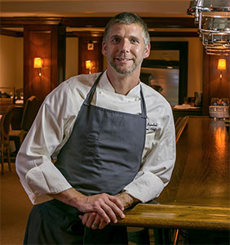
Pläj San Francisco, CA - PlajRestaurant.com
Roberth Sundell - Owner/ Executive Chef

PLÄJ is a new innovative concept where California fare and Scandinavian flavors become one. PLÄJ is a celebration of local and seasonal ingredients inspired by the rustic flavors and simple elegance of Scandinavian cuisine and embodies the soul of Scandinavia, the place to share the experience of new flavors, great wine, Scandinavian beer and cocktails.

Roberth began cooking professionally at the National Museum of Stockholm and enjoyed unique opportunities to cook for the Swedish royal family and for a Nobel Peace Prize dinner. He later moved to Britain and worked as Chef de Partie at Bailey's, one of London's oldest hotels. Upon arriving in the U.S., Roberth worked as an Executive Chef for Noble House and later moved to Los Angeles where he worked for two years as Chef de Cuisine at Café Pierre in Manhattan Beach. In 2012, Roberth introduced PLÄJ to San Francisco and was honored with the Scandinavian Pathfinder Award acknowledging his efforts in bringing Scandinavian culture to the United States through the art of food. The San Francisco Chronicle named PLÄJ one of the “Top 100 Bay Area Restaurants in 2013.”

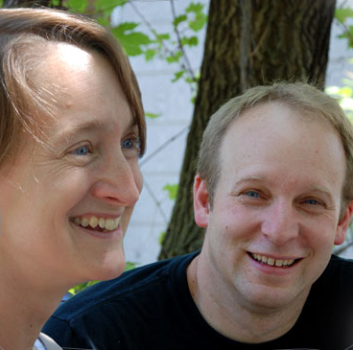
Tre Kronor Chicago, IL - TreKronorRestaurant.com
Patty Rasmussen & Larry Anderson - Owners/Chefs

The blend of Scandinavian heritage and a love of French bistros has been the long time recipe at Tre Kronor. Whether at breakfast, lunch, or dinner, there is the unmistakable aroma of entrees inspired by past generations, the simple elegance of eateries discovered on travels abroad, and the comforting hum of enthusiastic patrons.

Hungry for an adventure after college, Patty headed to Europe where she gained an appreciation of local seasonal food. She returned to Chicago to perfect her own repertoire and worked for Jovan Trboyevich at Les Nomades; there she saw firsthand the attention to detail and perfect execution of classic and comforting bistro food.

Larry started his restaurant career as a waiter while in college, exploring the many restaurants of Chicago on his nights off. Inspired by his experiences, Larry took a year off and moved to France. On returning to Chicago, Larry met Patty at a Swedish diner. They spent many enjoyable nights cooking together for family and friends. Entrepreneurial by nature, Larry convinced Patty to open a restaurant together in 1992. Transitioning from waiter to cook, Larry found his calling in front of the stove. Today, he still manages the kitchen and oversees the menu.

The couple prides themselves on fresh ingredients, cooking from scratch, and adding twists and
unique tastes to traditional recipes.

