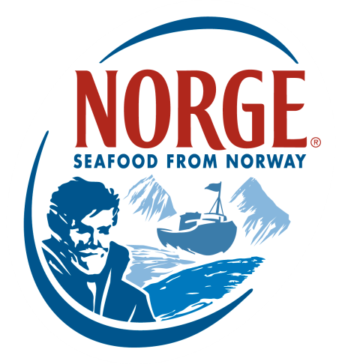
CONTACT:
Jessica Butera
The Food Group
212-329-6273
Jessica.butera@thefoodgroup.com

NEW NORDIC CUISINE
A Responsible Lifestyle Linking Origin and Heritage
Surrounded by crystal clear fjords, icy mountains and endless sky, Norway is unquestionably a jewel of the rugged Scandinavian coastline. And it is not just the landscape that is so alive. Norwegians are healthy, active and have an abiding respect for nature that is largely due to their generations-old seafaring traditions. A diet rich in seafood is a cornerstone of New Nordic Cuisine and one reason Norwegians have been practicing the cuisine’s principles for generations.
The New Nordic Cuisine, pioneered in 2004 by twelve leading Nordic chefs, including Danish entrepreneur and founder of Noma, Claus Meyer, has recently set the media abuzz with its core values of purity, simplicity, freshness and ethics. Simple preparation of fresh seafood, lean game and indigenous herbs and vegetables is key.

For Norwegians – whose eating habits have always been seafood-centric thanks to the country’s position along more than 62,700 miles of coastline (100,900 KM) – this food philosophy is nothing new; they have always eaten fresh, seasonal and readily available food.
“As Norwegians, we are proud of our oceanic traditions,” says Karin Olsen, U.S. Director of the Norwegian Seafood Council. “For us, Nordic Cuisine is more than a commitment to eating a certain way, it is about the Norwegian lifestyle and respect for our environment. Many of us are closely linked to the sea and we encourage Americans to look to Norway as a source of inspiration for health, wellness and spirit. In Norway, our children are raised on our coastal fish and we grow up with a deep appreciation for the origin of our food.”
Indeed, Norwegians believe origin is a key differentiator when it comes to their seafood. Nurtured slowly over a long period of time in icy-cold fjords, Norwegian Salmon are given the time, space and opportunity to fully mature and develop their delicate, easily distinguishable flavor. The difference is palatable and Norwegians grow up appreciating their seafood and its many nuances. It is these cultural and dietary ties to the sea, including consumption of salmon and other heart-healthy fish like Norwegian Skrei™, cod and halibut, that has helped Norway garner its reputation as supremely healthy, fit and conscientious – all qualities associated with the New Nordic Cuisine movement.
According to popular Norwegian chef, Harald Osa, the Norwegian take on Nordic Cuisine revolves around three component meals using a mix of fresh seafood with cold climate vegetables, whole grains and native berries. Cooking is based on raw materials prepared when the food is in season to maximize flavor. Osa says, “Recipes should always be simple and spare, focusing on the fresh taste of the ingredients and not over complicating them with heavy seasoning.

The recent rise in popularity of New Nordic Cuisine is testimony to how linking origin and heritage to a healthy lifestyle is an interesting, motivating way for consumers to raise the bar when it comes to their own health. The delicious flavor and heart healthy benefits of Norwegian seafood like Skrei™, salmon, cod and halibut make it simple to follow the New Nordic Cuisine. They are easy to prepare and a practical way to incorporate fish into the American diet as recently advised by the USDA.

About the Norwegian Seafood Council
Founded in 1991 by the Ministry of Fisheries, the Norwegian Seafood Council (NSC) builds awareness of and educates the public on seafood from Norway. From the headquarters in Tromso, Norway and a U.S. branch in Boston, Mass., the NSC carries out Norwegian seafood promotional, media, marketing and public relations campaigns and is a resource for market information in more than 20 different markets. Its entire efforts are financed by the Norwegian seafood industry itself. As the world’s second largest exporter of seafood, Norway provides quality, nutrient rich seafood to over 150 different countries, and is the world's largest joint marketer of seafood. For more information on the NSC visit www.seafoodfromnorway.com.

