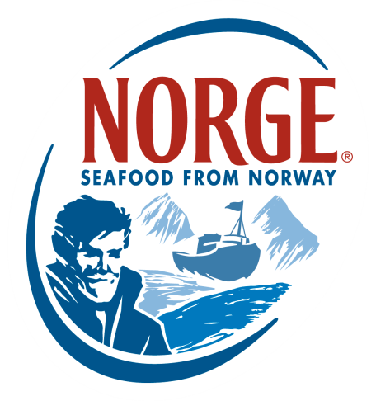
CONTACT:
Jessica Butera
The Food Group
212-329-6273
Jessica.butera@thefoodgroup.com

NORWEGIAN SALMON
The Pioneer in Aquaculture

Norwegians have an abiding respect for nature that is largely due to their generations-old seafaring traditions. This deep respect for the sea earned Norway an international reputation for purveying the finest, freshest seafood. In fact, Norway’s seafood industry pioneered the development of responsible ocean salmon farming in the early 1970’s. From these deeply ingrained traditions, their celebrated aquaculture industry – world-renowned for ocean-farmed salmon – was born.

Norwegians believe origin is a key differentiator when it comes to their seafood. Nurtured slowly over a long period of time in icy-cold fjords, the salmon are given the time, space and opportunity to fully mature and develop their delicate, easily distinguishable flavor. A deep respect for nature and cultural pride in being the best is what fuels the Norwegian seafood industries’ continued efforts to improve its already strict standards of excellence and safety applied to raising ocean-farmed salmon. This guarantees consumers enjoy fresh, delicately flavored salmon from Norway year-round.

NORWEGIAN SALMON KEY INFORMATION
- Norwegian salmon spend approximately the first year of their life in the safety of a hatchery tank on land until they are large and strong enough for life at sea.
- The salmon are then carefully transferred to spacious, protected ocean pens that allow maximum freedom to grow. To prevent overcrowding, Norwegian law requires that salmon make up less than 2.5 percent of an aquaculture facility’s volume. That means each spacious facility is made up of 97.5 percent water to allow for maximum comfort and a healthy growth cycle.
- Every aspect of the salmon’s development is closely monitored by technologically advanced systems that feed information to the farmers and their veterinarians, including when the salmon are full so the feeding device can be shut down. And, when it comes to feeding, Norway’s industry experts know exactly what salmon need to grow strong and healthy.
- Norwegian salmon are fed an all-­‐natural diet comprised of both vegetable raw and marine raw material like fish oil and fish meal from wild fish, plus vitamins, minerals and antioxidants, guaranteeing an even better tasting fish harvested with sustainability and health in mind.
INTERESTING FACTS
- Norway was one of the first countries to introduce a traceability system that tracks details about the health and harvesting of salmon and other fish to ensure reliable food safety tracking.
- Salmon aquaculture is among the most resource-efficient methods of food production, as salmon are more than twice as efficient as pork and chicken at converting feed to energy, and ultimately meat for human consumption.
- Everyday, more than 12 million seafood meals originating from Norwegian aquaculture are served internationally.
- Today, Norway’s aquaculture industry ranks among the world’s leading programs.

About the Norwegian Seafood Council
Founded in 1991 by the Ministry of Fisheries, the Norwegian Seafood Council (NSC) builds awareness of and educates the public on seafood from Norway. From the headquarters in Tromso, Norway and a U.S. branch in Boston, Mass., the NSC carries out Norwegian seafood promotional, media, marketing and public relations campaigns and is a resource for market information in more than 20 different markets. Its entire efforts are financed by the Norwegian seafood industry itself. As the world’s second largest exporter of seafood, Norway provides quality, nutrient rich seafood to over 150 different countries, and is the world's largest joint marketer of seafood. For more information on the NSC visit www.seafoodfromnorway.com.

