EMBARGO: NOT FOR PUBLICATION UNTIL 09:00 CEST, 9 SEPTEMBER 2015
PRESS RELEASE
Cocoa flavanols lower blood pressure and increase blood vessel function in healthy people
New studies by the EU-funded FLAVIOLA research consortium show that cocoa flavanols could help maintain cardiovascular health as we age
9th September 2015: Two recently published studies in the journals Age and the British Journal of Nutrition (BJN) demonstrate that consuming cocoa flavanols improves cardiovascular function and lessens the burden on the heart that comes with the ageing and stiffening of arteries. The studies also provide novel data to indicate that intake of cocoa flavanols reduces the risk of developing cardiovascular disease (CVD).
As we age, our blood vessels become less flexible and less able to expand to let blood flow and circulate normally, and the risk of hypertension also increases. Arterial stiffness and blood vessel dysfunction are linked with cardiovascular disease — the number one cause of deaths worldwide. “With the world population getting older, the incidence of cardiovascular disease, heart attacks and stroke will only increase,” says Professor Malte Kelm, Professor of Cardiology, Pulmonary Diseases and Vascular Medicine at University Hospital Düsseldorf and Scientific Director of FLAVIOLA. “It is therefore pivotal that we understand the positive impact diet can have on cardiovascular disease risk. As part of this, we want to know what role flavanol-containing foods could play in maintaining the health of the heart and blood vessels.”
Cocoa flavanols are plant-derived bioactives from the cacao bean. Dietary intake of flavanols has been shown to have a beneficial effect on cardiovascular health but the compounds are often destroyed during normal food processing. Earlier studies have demonstrated that cocoa flavanol intake improves the elasticity of blood vessels and lowers blood pressure — but, for the most part, these investigations have focused on high-risk individuals like smokers and people that have already been diagnosed with conditions like hypertension and coronary heart disease. These two studies in Age and BJN are the first to look at the different effects dietary cocoa flavanols can have on the blood vessels of healthy, low-risk individuals with no signs or symptoms of cardiovascular disease.

Cocoa flavanols increase blood vessel flexibility and lower blood pressure
In the study published in Age, two groups of 22 young (<35 years of age) and 20 older (50-80 years of age) healthy men consumed either a flavanol-containing drink, or a flavanol-free control drink, twice a day for two weeks. The researchers then measured the effect of flavanols on hallmarks of cardiovascular aging, such as arterial stiffness (as measured by pulse wave velocity), blood pressure and flow-mediated vasodilation (the extent to which blood vessels dilate in response to nitric oxide).
They found that vasodilation was significantly improved in both age groups that consumed flavanols over the course of the study (by 33% in the younger age group and 32% in the older age group over the control intervention). In the older age group, a statistically and clinically significant decrease in systolic blood pressure of 4 mmHg over control was also seen.
Improving cardiovascular health and lowering the risk of CVD
In the second study, published in BJN, the researchers extended their investigations to a larger group (100) of healthy middle-aged men and women (35-60 years) with low risk of CVD. The participants were randomly and blindly assigned into groups that consumed either a flavanol-containing drink or a flavanol-free control drink, twice a day for four weeks. The researchers also measured cholesterol levels in the study groups, in addition to vasodilation, arterial stiffness and blood pressure.
“We found that intake of flavanols significantly improves several of the hallmarks of cardiovascular health,” says Professor Kelm. In particular, the researchers found that consuming flavanols for four weeks significantly increased flow-mediated vasodilation by 21%. Increased flow-mediated vasodilation is a sign of improved endothelial function and has been shown by some studies to be associated with decreased risk of developing CVD. In addition, taking flavanols decreased blood pressure (systolic by 4.4 mmHg, diastolic by 3.9 mmHg), and improved the blood cholesterol profile by decreasing total cholesterol (by 0.2 mmol/L), decreasing LDL cholesterol (by 0.17 mmol/L), and increasing HDL cholesterol (by 0.1 mmol/L).
The researchers also calculated the Framingham Risk Score – a widely used model to estimate the 10-year cardiovascular risk of an individual – and found that flavanol intake reduced the risk of CVD. “Our results indicate that dietary flavanol intake reduces the 10-year risk of being diagnosed with CVD by 22% and the 10-year risk of dying from coronary heart disease or CVD by 37%,” says Professor Kelm.
The combined results of these studies demonstrate that flavanols are effective at mitigating age-related changes in blood vessels, and could thereby reduce the risk of CVD in healthy individuals. The application of 10-year Framingham Risk Scores should be interpreted with caution as the duration of the BJN study was weeks not years and the number of participants was around 100, not reaching the scale of the Framingham studies. That being said, Professor Kelm comments that “the reduction seen in risk scores suggests that flavanols may have primary preventive potential for CVD.” Other longer-term studies, such as the 5-year COcoa Supplement and Multivitamin Outcomes Study (COSMOS) of 18,000 men and women, are now underway to investigate the health potential of flavanols on a much larger scale.
Figures & images:
Fig. 1: After one month consuming cocoa flavanols every day, the group in the BJN study showed lower systolic blood pressure and lower cholesterol. Using the Framingham Risk Score, these results showed that cocoa flavanols reduced the subjects’ risk of developing cardiovascular disease, coronary heart disease and having a heart attack (MI, myocardial infarction).
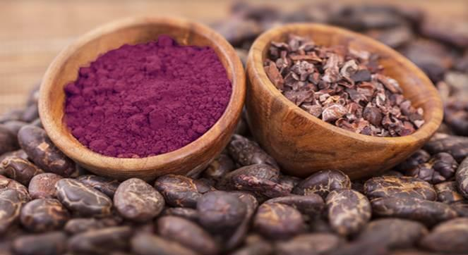
Image 1: Naturally occurring cocoa flavanols are largely destroyed by most cocoa processing methods. The cocoa flavanol drink test materials used in these studies supplied by Mars, Incorporated were extracted using a patented process from fresh cocoa beans.
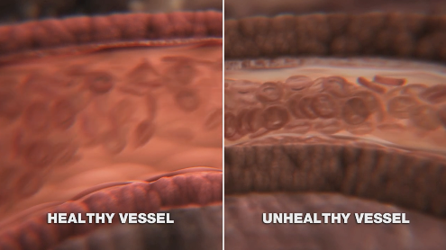
Image 2: Healthy blood vessels are elastic and can dilate in response to increased blood pressure
Contact:
Susanne Dopheide
University Hospital Düsseldorf
Tel.: +49 (0)211 81-04173
E-mail: Susanne.Dopheide@med.uni-duesseldorf.de
Julian Hill
CNC
Tel.: + 44 (0)203 817 9926
E-mail: Julian.Hill@cnc-communications.com
References:
Heiss C, Sansone R, Karimi H, et al. Impact of cocoa flavanol intake on age-dependent vascular stiffness in healthy men: a randomized, controlled, double-masked study. Age (Dordr) 2015: 37; 9794-9806. URL: http://link.springer.com/article/10.1007%2Fs11357-015-9794-9.
Sansone R, Rodriquez-Mateos A, Heuel, J, et al. Cocoa flavanol intake improves endothelial function and Framingham risk score in healthy men and women: a randomized controlled double-masked trial – The FLAVIOLA HEALTH Study. Br J Nutr 2015. Advance online publication. URL: http://journals.cambridge.org/bjn/flavanols.
Acknowledgments:
These studies were a collaborative effort between the University of Düsseldorf, the University of Reading and Mars, Incorporated (all members of the FLAVIOLA research consortium).
About FLAVIOLA
FLAVIOLA is a pan-European research project, funded under the Seventh Framework Programme (FP7) of the European Commission. The project aims to provide crucial insights into the nutritional and biomedical properties of flavanols ranging from the cellular level to their impact on the population at large. FLAVIOLA’s vision is that through collaborative and cutting-edge research, it will lay the foundation for the development of evidence-based dietary recommendations and innovative food products that harness the benefits of flavanols for cardiovascular health. FLAVIOLA members include Heinrich-Heine University (Germany), University of Reading (UK), Maastricht University (Netherlands), INRA French National Institute for Agricultural Research (France), Karolinska Institutet (Sweden), Ghent University (Belgium), SciProm (Switzerland) and Mars, Incorporated.
About cocoa flavanols
Flavanols are a distinct group of naturally occurring compounds that can be found in a variety of foods such as tea, red wine, blueberries and raw cocoa. Cocoa flavanols refers to the group of bioactives found naturally in fresh cocoa beans. Cocoa is an especially rich source of flavanols and the type and mixture of flavanols and procyanidins found in cocoa is unique. Many studies show cocoa flavanols have a range of proven health benefits, including improved circulation and cardiovascular health. For more information, visit Mars Center for Cocoa Health Science at www.marscocoascience.com.

