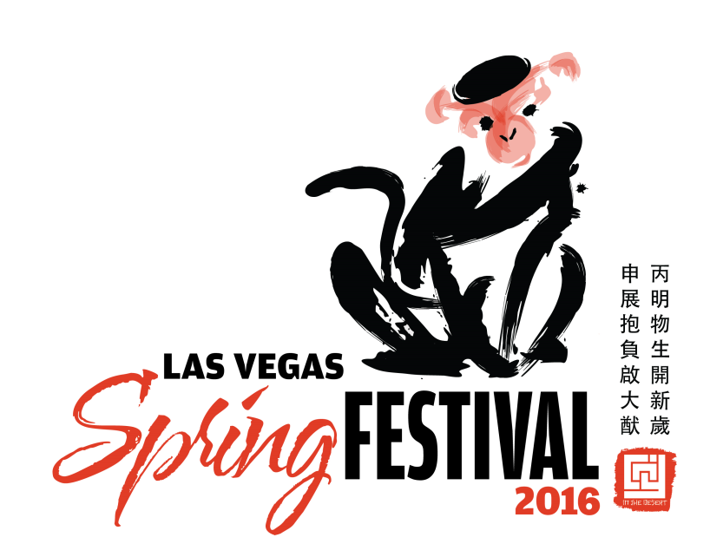

FOR IMMEDIATE RELEASE
February 1, 2016

MEDIA CONTACT:
Jan-Ie Low, Golden Catalyst, LLC.
(702) 327-2628; Janie@goldencatalyst.com

Celebrate the Year of the Monkey in Las Vegas Feb. 8 -14, 2016
Fifth Annual Chinese New Year in the Desert™/Las Vegas Spring Festival
Hosts Holiday Activities with Week-Long Celebration
**All entertainment is FREE and open to the public unless otherwise noted**
WHAT:
Chinese New Year is recognized as the most important Chinese holiday and is known as "Spring Festival" in China, “Tet New Year” in Vietnam and “Seol-lal” in Korea. For the first time, Chinese New Year in the Desert™ will be held in multiple locations over a one-week period. Participating venues include: The LINQ Promenade, The Boulevard Mall, Downtown Container Park, Fashion Show Las Vegas, Las Vegas Natural History Museum and The Forum Shops at Caesars.

The fifth annual Chinese New Year in the Desert™ will celebrate the Year of the Monkey. Forbes Magazine named Las Vegas as one of the “8 Great Places to Celebrate Chinese New Year” in the United States and Canada. Major sponsors for the 2016 celebration include: Caesars Entertainment, Las Vegas Convention and Visitors Authority and Golden Catalyst, LLC.
WHEN: Monday, Feb. 8 – Sunday, Feb. 14, 2016
WHERE:
The LINQ Promenade
Dragon Dance and Cultural Performances
Monday, Feb. 8 – Friday, Feb. 12, 7-9 p.m.
Saturday, Feb. 13 and Sunday, Feb. 14, 1 p.m. – 9 p.m.
Throughout the one-week festival, guests will be taken on a journey around the world as they experience folklore, acrobatic and traditional instrumental performances from Hunan Province and various Asian countries on The LINQ Promenade Stage. Dragon dance performances by Lohan School of Shaolin will be held nightly at 7 p.m. and 2:30pm on Sunday.

Marquee Events at The LINQ Promenade will include the following:
Las Vegas Cultural Performances
Monday, Feb. 8, 7:20pm
The LiLin Hong Ensemble and the Nevada Arts Academy with special guest, Susan Wong, help us ring in the Year of the Monkey.

CNY in the Desert™ Opening Ceremonies
Tuesday, Feb. 9, 7pm
Usher in the New Year by participating in the Opening Ceremonies and ribbon cutting. The New Year will be greeted with a live authentic dragon dance, an eye painting ceremony and performers dressed in elaborate costumes.

Ice Shaving & Fruit Carvings
Wednesday, Feb. 10, 7:20pm
Experience live ice shaving with a chain saw and fruit carvings by chef Chanh Boupha from Le Cordon Bleu College of Culinary Arts Las Vegas.

Opportunity Village’s Performers & “Baijiu” Mixology Demonstrations
Thursday, Feb. 11, 7:20pm
Opportunity Village dance and musical performers will take the stage to help Las Vegas celebrate the Chinese New Year, followed by Baijiu mixology demonstrations from Southern Wine & Spirits.

International Culinary Demonstrations
Friday, Feb. 12, 7:20pm
Enjoy live noodle pulling and pig carving by Caesars Culinary chefs.

Dance-4-a-Cause
Saturday, Feb. 13, 7:20pm
In collaboration with FightingUnited, the third annual Dance-4-a-Cause will gather thousands of Zumba®, Hot Hula Fitness, U-Jam Fitness®, and MixxedFit® participants from all over the valley. Live DJ and special guest Lady Gaga from Legends in concert will perform. Participants are asked to bring chapter books (K-12th grade) to benefit Somerset Academy and Spread the Word Nevada.

Wedding Ceremony
Sunday, Feb. 14, 3pm
Las Vegas closes out the Lunar New Year celebration with a wedding ceremony on Valentine’s Day, officiated by Elvis. the public is invited to participate. For more information, email info@fightingunited.com.

The Boulevard Mall
Community Celebration
Wednesday, Feb. 10, 5pm-7pm
If you don’t feel like going to the Strip, then come join us at the Boulevard Mall. The Celebration will include lion dances, martial arts demonstrations, a cultural fashion show, acrobats, traditional Chinese music performances and folk dances. Children can make lanterns in the craft area.

Fashion Show Las Vegas
Live Runway Shows and Lions Blessing
Friday, Feb. 12, 1:30pm – 4:30pm
Indulge in brands you love and experience lions dance, live runway fashion of traditional and modern Chinese attire, and cultural performances featuring talented singers, musicians and acrobats from the Hunan Provincial Song and Dance Theatre Company.

The Forum Shops at Caesars
Shopping Experience and Cultural Performances
Friday, Feb. 12, 3:30pm – 5:30pm
A collection of special offerings will be provided by a variety of shops and restaurants in honor of Chinese New Year. Stop by the Forum Shops to catch a variety show filled with cultural history.

Downtown Fremont Street (11th Street to 7th Street)
Westernunion.com presents the Fourth Annual Las Vegas Spring Festival Parade
Saturday, Feb. 13, 11 a.m.
The theme this year is “Celebration of the Year of the Monkey.” Local businesses, organizations, bands, drill teams, and dance groups will come together to celebrate the Chinese Lunar New Year by showcasing their talent and creativity with the most extravagant floats in vibrant colors to commemorate the rich history of the most important holiday of the Asian community.

Container Park (707 Fremont St.)
Parade- After -Party and Lunar Lantern Festival
Noon - 6p.m.
Immediately following the Parade will be an After Party at Downtown Container Park, an open-air shopping center filled with boutique retail shops, unique restaurants, live entertainment, an interactive playground featuring The Treehouse and various other free activities brought to you by CNY in the Desert™ sponsors.

Also, to commemorate the Lunar Lantern Festival, which officially ends the Chinese New Year celebrations, students of Clark County School District will be constructing paper lanterns marked with their “wish” for 2016. Guests and passersby are invited to stop in at a couple of booths to build their own complimentary lantern. The Lunar Lantern Festival is sponsored by Palm Eastern.

Las Vegas Natural History Museum
The Traditional Chinese Realistic Painting Exhibition & Live Cultural Fashion Show
Saturday, Feb. 13, 2:30pm – 3:30pm
**Museum Admission: $10 Adults; $8 Seniors/Military/Students/ $5 Children
The Fashion Ambassadors of CNY in the Desert™ will put on a cultural fashion show featuring traditional and modern styles. Starting Feb. 2 to Feb. 19, guests can also see the traditional Chinese realistic painting exhibition – the first ever in the Western U.S.

A full schedule of events can be found: http://www.CNYintheDesert.com.

About CNY in the Desert™:
Our mission is to educate the community about the Asian American & Pacific Islander culture as it relates to the annual Lunar New Year and Chinese New Year celebration, including history, tradition, customs, arts, dance, & music. Our goal is to bring the largest Lunar New Year celebration in the US to the great city of Las Vegas; thus, promoting tourism and attracting the ever-increasing numbers of leisure visitors and giving our locals a taste of what the holiday is all about.
www.CNYintheDesert.com.

