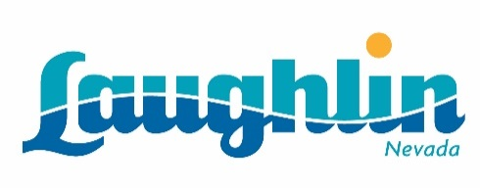

For Immediate Release:
June 25, 2015

Laughlin Launches Updated, Responsive Design Website
New and Improved Website: www.visitlaughlin.com

LAUGHLIN, Nev. — Laughlin has unveiled a new and improved website, making a more user-friendly experience for visitors traveling to the destination. The upgraded site focuses on the use of imagery in a clean, updated look that allows Laughlin to showcase the extensive offerings of the destination in one comprehensive location.

The completely redesigned site uses images to highlight the extensive entertainment, culinary, golf and outdoor activities offered in Laughlin. In addition, details on all of the resorts’ meeting and convention areas are housed on the site. Each listing has a dedicated, broken-out page, to highlight and provide even more detailed information.

Planning a Laughlin vacation is now a seamless experience with everything necessary for a grand Southern Nevada getaway in one convenient location, including room rates and availability as well as entertainment and special events.

Laughlin’s new website is a responsive design providing easy access while traveling, as well as in the destination.

Laughlin is located south of Las Vegas along the beautiful Colorado River. The destination is a local favorite and popular tourist stop for the many outdoor activities along the River. Laughlin is also known for top performers, including Carrie Underwood, Rascal Flatts, Pat Benatar and more.

For more information on Laughlin and to view the website, please visit www.visitlaughlin.com.

###

About Laughlin
Located 90 miles south of Las Vegas, Laughlin is a unique resort destination with a relaxed and friendly atmosphere that welcomes nearly 2 million visitors annually. This oasis along the Colorado River has grown to include nine resorts with affordable first-class accommodations, live entertainment, fine dining, spa experiences, golf courses, the recreational paradise known as North Reach Trail and a multitude of water activities. Laughlin has also become a leading special-event destination in the Southwest, offering everything from an eight-mile inner tube float on the Colorado River to the largest motorcycle rally in the West. For more information: www.visitlaughlin.com.

