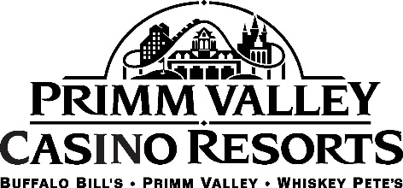

DINING

Primm is located 30 minutes south of the Strip on the California-Nevada border. This oasis features many culinary delights where guests can feast like a king and indulge on meals at unique restaurants.

Upscale dining is taken to a new level at GP’s Steakhouse, a favorite among guests. The restaurant serves filet mignon, prime rib, lobster and other indulgent menu items with equally as delicious sides to complement the main course. The intimate and cozy setting of GP’s is in Primm Valley.

Traditional Mexican dishes and south of the border favorites are served at Guillermo’s Cocina & Cantina in Buffalo Bill’s. The recently renamed and redesigned restaurant serves authentic cuisine with live music from mariachi bands and other Latin-inspired acts.

After a day on the course or if you’re just looking for a laid-back evening, The Back Nine is the perfect spot. This bar and lounge features all the classics in a casual setting overlooking the casino floor. The Back Nine features live music on the weekends at Primm Valley.

The Original Pancake House, Denny’s and IHOP dish up a hearty breakfast for guests. These established restaurants and many options offer their twists on breakfast, lunch and dinner.

The resorts also offer two buffets, Country Club Buffet located in Primm Valley and Miss Ashley’s Buffet in Buffalo Bill’s. Both buffets offer various tastes and offerings for all types of food-lovers.

Other onsite restaurants include La Salsa, The Dog House, Coffee Corner, McDonald’s, Pizza, Panda Express, The Ice Cream Shop and more.

A truck stop and gas station located near Whiskey Pete’s with Qdoba, Dairy Queen, Starbucks and Subway allow for quick bites on the go.

Other fast dining establishments include Carl’s Jr., Taco Bell, KFC, Mad Greek Café.

