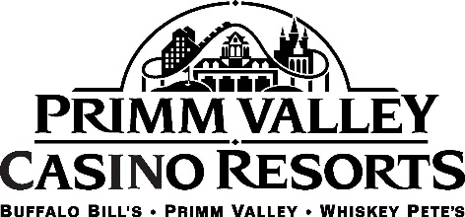

ACCOMMODATIONS
Half an hour from the Strip, Primm Valley sits on the California-Nevada border and offers travelers a mini oasis. Three properties make up Primm Valley Casino Resorts, including Primm Valley, Buffalo Bill’s and Whiskey Pete’s. Each of the properties are connected by a short tram ride.
Primm Valley is the most luxurious of the properties with an in-house spa, resort-style pool and other upgrades and features. With recent renovations, including a new check-in area, new dining options and room amenities, Primm Valley is home away from home. More than 600 rooms and suites have the luxurious feel of world-class resorts.
Located across the I-15 from Whiskey Pete’s is Buffalo Bill’s. The Star of the Desert Arena and Desperado roller coaster call Buffalo Bill’s home. The resort has undergone room renovations and has a sophisticated and elegant feel with accents of purple. More than 1,240 rooms and suites in the casual resort give visitors a fun western-themed getaway.
Whiskey Pete’s is a budget-friendly option that makes everyone feel right at home. Leave the tux and dresses behind in this casual hotel with more than 770 rooms and suites. The historic Whiskey Pete’s is named after the original founder, Pete MacIntyre, who set up a gas station on the site until he resorted to bootlegging to make ends meet. After his death in 1933, legend has it that MacIntyre requested he be buried standing up with a bottle in his hand to look over the area. Whiskey Pete’s now holds his name.

