Press Contact: For Immediate Release
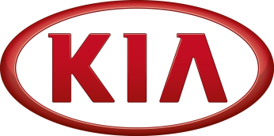
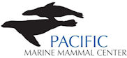
Melissa Sciacca
Pacific Marine Mammal Center
949.494.3050
msciacca@pacificmmc.org

PACIFIC MARINE MAMMAL CENTER AND KIA MOTORS KICK OFF NEW PHILANTHROPIC PARTNERSHIP WITH
DONATED KIA SOUL FOR PMMC’S COMMUNITY OUTREACH IN 2014

Donated Kia Soul outreach vehicle to support the mission of Pacific Marine Mammal Center

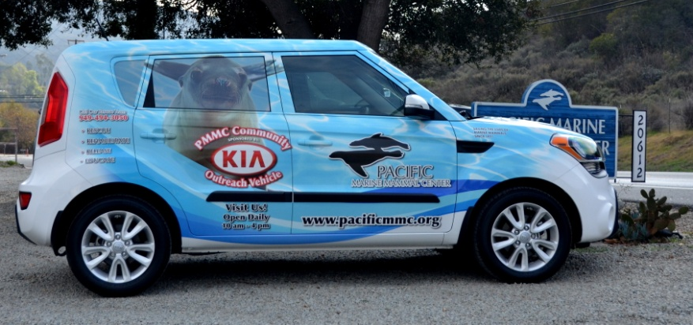

Laguna Beach, Calif. – Pacific Marine Mammal Center today announced Kia Motors America (KMA) as a new partner of the non-profit organization, dedicated to animal welfare and ocean education. KMA pledged to support the center’s efforts and environmental messaging in a multitude of ways, including the donation of a community outreach vehicle, participating in staff beach clean-ups, sponsoring recovering sea lion patients at the hospital, and more. The Kia Soul will be used to support the organization’s mission of marine mammal rehabilitation and education.
“We are pleased that Kia has taken an interest in our cause, and sets a great example to other corporations about community philanthropy,” said Keith Matassa, executive director, PMMC. “We look forward to working together to bring awareness to the public about environmental conservation and consideration to benefit our planet.”

In 2013, PMMC was hit with the biggest crisis in sea lion pup strandings in the history of its organization. More than 375 marine mammals came ashore in need of medical attention in Orange County, causing a resource shortage for the rescue group. Reasons behind the mass stranding event point to a fish stock shortage-primarily sardines, that significantly influenced the influx of patients received by PMMC.

“Kia understands that a conscious dedication to environmental education and sustainability is crucial to the communities we call home and the world at large,” said Michael Sprague, executive vice president, marketing & communications, KMA. “Since its founding, The Pacific Marine Mammal Center has grown to be a widely recognized leader in marine mammal rehabilitation science and as the Center continues to expand its reach, it is the perfect partner with which Kia can pursue its vision for a greener future.”

About Pacific Marine Mammal Center:
Established in 1971, Pacific Marine Mammal Center is among the forerunners in marine mammal rehabilitation science. The only organization of its kind in Orange County, PMMC responds to approximately 300 marine mammal rescue calls each year. Pacific Marine Mammal Center is a non-profit organization with a mission to rescue, medically treat, and rehabilitate pinnipeds and cetaceans that strand along the Orange County coastline due to injury or illness; to release healthy marine mammals back to their natural habitat while preserving species diversity; and to increase public awareness of the marine environment through education and research.

About Kia Motors America
Kia Motors America (KMA) is the marketing and distribution arm of Kia Motors Corporation based in Seoul, South Korea. KMA proudly serves as the "Official Automotive Partner" of the NBA and LPGA and surpassed the 500,000 annual sales mark for the second consecutive year in 2013 following the launch of seven all-new or significantly redesigned vehicles. KMA offers a complete line of vehicles, including the flagship K900 rear-drive sedan, Cadenza premium sedan, Sorento CUV, Soul urban passenger vehicle, Sportage compact CUV, Optima midsize sedan, Optima Hybrid, the Forte compact sedan, Forte5 and Forte Koup, Rio and Rio 5-door sub-compacts and the Sedona minivan, through a network of more than 765 dealers across the United States.
Information about Kia Motors America and its full vehicle line-up is available at its website – www.kia.com. For media information, including photography, visit www.kiamedia.com. To receive custom email notifications for press releases the moment they are published, subscribe at http://www.kiamedia.com/us/en/newsalert.

Pacific Marine Mammal Center is located in the large red barn at 20612 Laguna Canyon Road. The Center and gift shop are open to the public from 10:00 a.m. to 4:00 p.m. daily. For more information about memberships, educational programs, volunteer opportunities, or to make a donation, please contact Pacific Marine Mammal Center at 949.494.3050 or visit us on the web at www.pacificmmc.org.



  

