Goodyear presents CityCube, a unique concept tire for the Toyota i-TRIL concept car
The Goodyear CityCube features sensor technology and mixed fitment for Toyota's innovative concept car

Geneva, March 8th - Goodyear presents its latest concept tire, Goodyear CityCube, designed for the Toyota i-TRIL concept car unveiled at the 2017 Geneva International Motor Show.
Thanks to advanced sensor technology and a unique tread design, the CityCube can identify a variety of road conditions and transmit this data to the vehicle to support the advanced collision prevention systems.
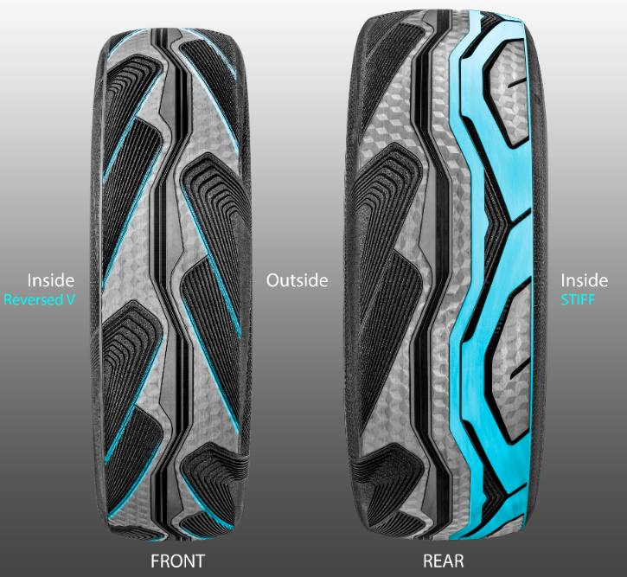
The front wheels on the Toyota i-TRIL tilt, which inspired Goodyear’s designers to think about motorcycle tire design. The result is a unique contour shape and mixed fitment, a tall and narrow tire at the front and a wider asymmetric design for the rear.
The front tilting wheels fit Tall and Narrow tires with reverse direction, inspired by the symmetric design of motorcycle tires.
This helps enhance safe driving and removes water for the larger rear tire, providing better grip.
The rear tires have an asymmetric design with a more solid inside part for more cornering stability.

Goodyear has also introduced a new Hologram Texture to the design, with state of the art gradient sidewall colours which offer a unique, premium and appealing appearance.
Tailored to meet Toyota’s exacting requirements, CityCube is designed to be lightweight with low rolling resistance, which is an important feature for future electric vehicle tires. The CityCube also has a reduced groove volume, providing higher mileage and reduces noise levels which can add to a better city life.
David Anckaert, General Director OE Product Development EMEA at Goodyear, commented: “We are delighted to present this innovative concept tire for the Toyota i-TRIL concept car. Once again, Goodyear confirms its expertise in the development of tailor-made solutions for car manufacturers. We are committed to designing solutions to enable new mobility trends, such as autonomous vehicles and smart cities.”
###

Note to editor: Follow us on Twitter @GoodyearPress and join our ThinkGoodMobility group on LinkedIn. All press materials are available for download at news.goodyear.eu

About Goodyear
Goodyear is one of the world’s largest tire companies. It employs about 66,000 people and manufactures its products in 48 facilities in 21 countries around the world. Its two Innovation Centers in Akron, Ohio and Colmar-Berg, Luxembourg strive to develop state-of-the-art products and services that set the technology and performance standard for the industry. For more information about Goodyear and its products, go to www.goodyear.com/corporate.

