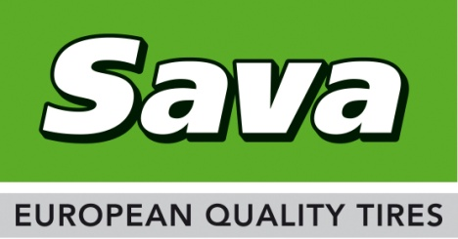
Contact:
Mirko Kraus
Communications Manager EMEA
+49 (0) 6181 68 1521
mirko.kraus@goodyear-dunlop.com

PRESS RELEASE

New Trailer Truck Tire Size from Sava

Mega trailer tire introduced to meet market needs
Brussels, August 1st, 2016 – Sava Tires, southeast Europe’s leading tire brand, is introducing a new size to its Cargo 4 trailer tire line-up for the increasingly popular mega trailer market. The low trailer height achieved by the 435/50R19.5 size, enabling fleets operating trailers with 100m³ volume capacity.
The new 435/50R19.5 Sava Cargo 4 is a cost competitive European quality trailer tire. Featuring high levels of versatility and wet grip along with good durability and a high level of retreadability, the new tire complements the recently introduced Avant 4Plus steer tire and Orjak 4Plus drive tire ranges.
“Sava truck tires meet the needs of cost-conscious commercial vehicle operators and the new trailer tire further widens that choice,” said Benjamin Willot, Director Marketing Commercial Tires Goodyear Europe, Middle East and Africa. “Mega trailers with their 100m³ capacity play an increasingly significant role in European transport and require specialist truck tires. We are very pleased to be able to offer such a tire that not only offers European quality and helps keep down operating costs but also which is at an affordable price.”
The addition of the 435/50R19.5 low profile trailer tire to the already comprehensive Sava on road truck tire range, gives vehicle operators, who seek affordable quality, an even wider choice. The new Cargo 4 435/50R19.5 with EU tire label gradings of B for Rolling Resistance, C in Wet Grip and 70 dbA and one wave for External Noise is available now, and regroovable and retreadable.
Sava Truck Tire Range
The Sava on road truck tire range offers cost-conscious commercial vehicle operators a wide choice of popular sizes. The current range comprises the Avant 4Plus steer tire, Orjak 4Plus drive tire and Cargo 4 trailer tire, and covers increasingly popular low aspect ratio sizes as evidenced by the new size. For mixed service vehicles operating on and off road, Sava offers the MS range and for municipal vehicles the City U4 all position tire is a popular choice. All Sava truck tires are regroovable and retreadable.

About Sava

Sava is a leading brand in Goodyear's product portfolio and is one of the best known tire brands in Central and South-East Europe. The brand name originates from Slovenia, where Goodyear has a large manufacturing facility, and offers a wide range of commercial vehicle and passenger car tires. Sava tires are sold throughout Europe and exported to other parts of the world. When buying Sava branded tires, customers acquire European quality products driven by Goodyear technology.

For more information on Sava Tires, visit www.sava-tires.com.

