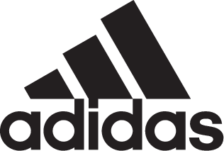

Straight from the stadium to the street – adidas Soccer and Manchester United light up Hollywood
- Alongside the full United squad, guests in attendance included Jamie Foxx and Emily Ratajkowski -
- Held at The Highlight Room in West Hollywood, the event featured a live performance from hip hop artist YG -
- United players were seen wearing the adidas NEMEZIZ Tango 17.1 triple black street shoe, the latest drop from adidas Soccer -
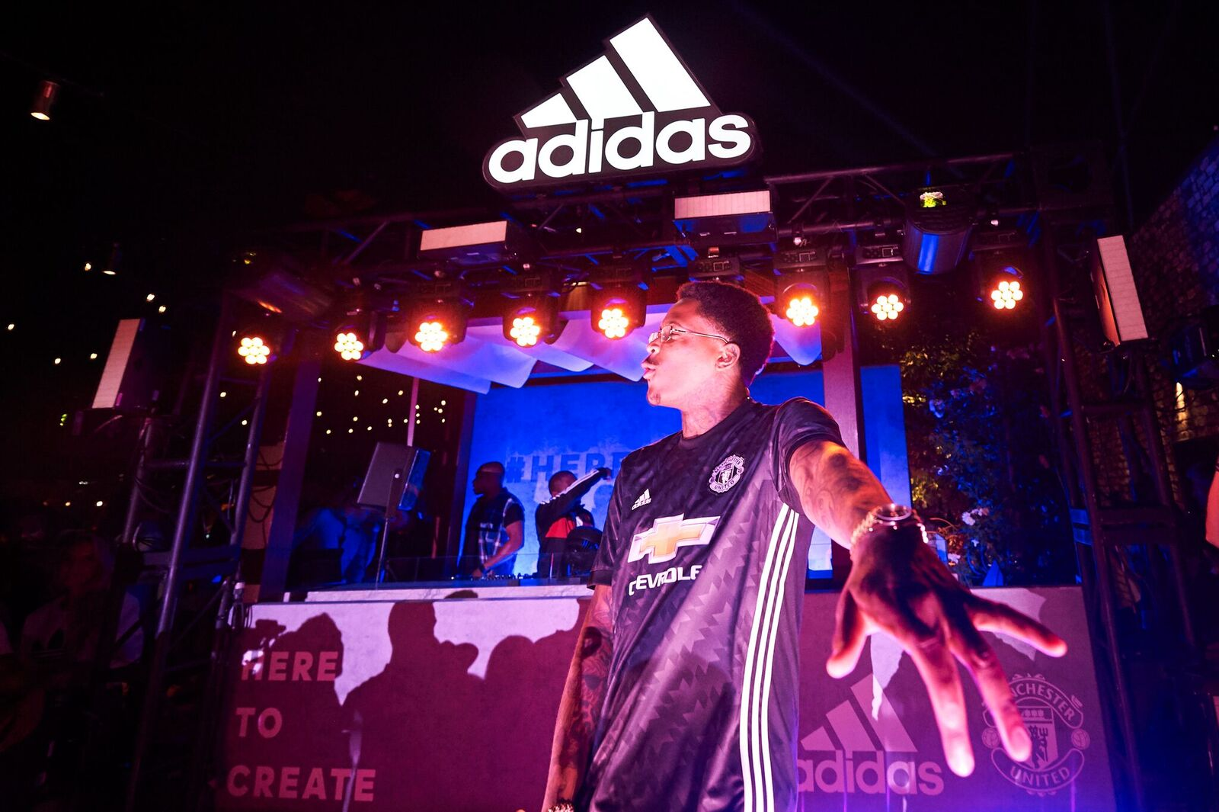

LOS ANGELES, July 16th, 2017 – On the back of the 5-2 victory versus LA Galaxy in the first game of Manchester United’s pre-season tour, adidas Soccer and Manchester United brought together entertainment stars from movies, music and American sports in an exclusive event at The Highlight Room - Hollywood’s newest rooftop party venue.

The event was attended by the United squad, adidas Soccer’s Tango Squad and a host of U.S. athletes and influencers, including Jamie Foxx, Emily Ratajkowski and music artist Desiigner.
In a true showing of adidas Soccer’s latest mantra – from stadium to street - guests were treated to a live performance from LA-based hip hop artist YG and DJ sets by ESTA and A$AP Lou.

Manchester United’s midfielder, Jesse Lingard, commented: “Only adidas can bring together such a star studded event. Clearly the focus for us is on football [soccer] with a busy schedule of games coming up but the event has given us a great opportunity to soak up being in LA and meet so many famous faces.”
United will continue their pre-season tour on July 20th when they face Major League Soccer club Real Salt Lake, before taking on Manchester City, Real Madrid and Barcelona.

For more information visit http://www.adidas.com/us/soccer and join the conversation on Twitter​ and Instagram​ with #HereToCreate.

- END -

For further media information please visit http://news.adidas.com/US/home/SOCCER or contact:

Cristina Maillo Belda
PR Manager, adidas Soccer
Email: Cristina.maillobelda@external.adidas.com
Tel: 503.915.9129

About adidas Soccer
adidas is the global leader in soccer. It is the official sponsor / official supplier partner of the most important soccer tournaments in the world, such as the FIFA World Cup™, the FIFA Confederations Cup, the UEFA Champions League, the UEFA Europa League and the UEFA European Championships and Major League Soccer. adidas also sponsors some of the world’s top clubs including Manchester United, Real Madrid, FC Bayern Munich, Juventus and AC Milan. Some of the world’s best players also on the adidas roster are Leo Messi, Paul Pogba, Gareth Bale, Karim Benzema, Roberto Firmino, Thomas Müller, Luis Suárez, James Rodríguez, Diego Costa, Mesut Özil, Renato Sanches and Julian Draxler.

