EMBARGOED UNTIL 18 MAY, 8:30AM CET
Please download high res images here and design video here.

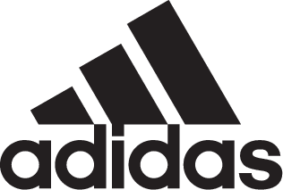

adidas Soccer Reveals FC Bayern Munich Home Kit for the 2017/18 Season

- Jersey pays homage to the notorious kit played in the 70’s -
- adidas Soccer reveals design film to celebrate kit launch -
- Predominantly red kit features thin, vertical white stripes and a crew neck collar -

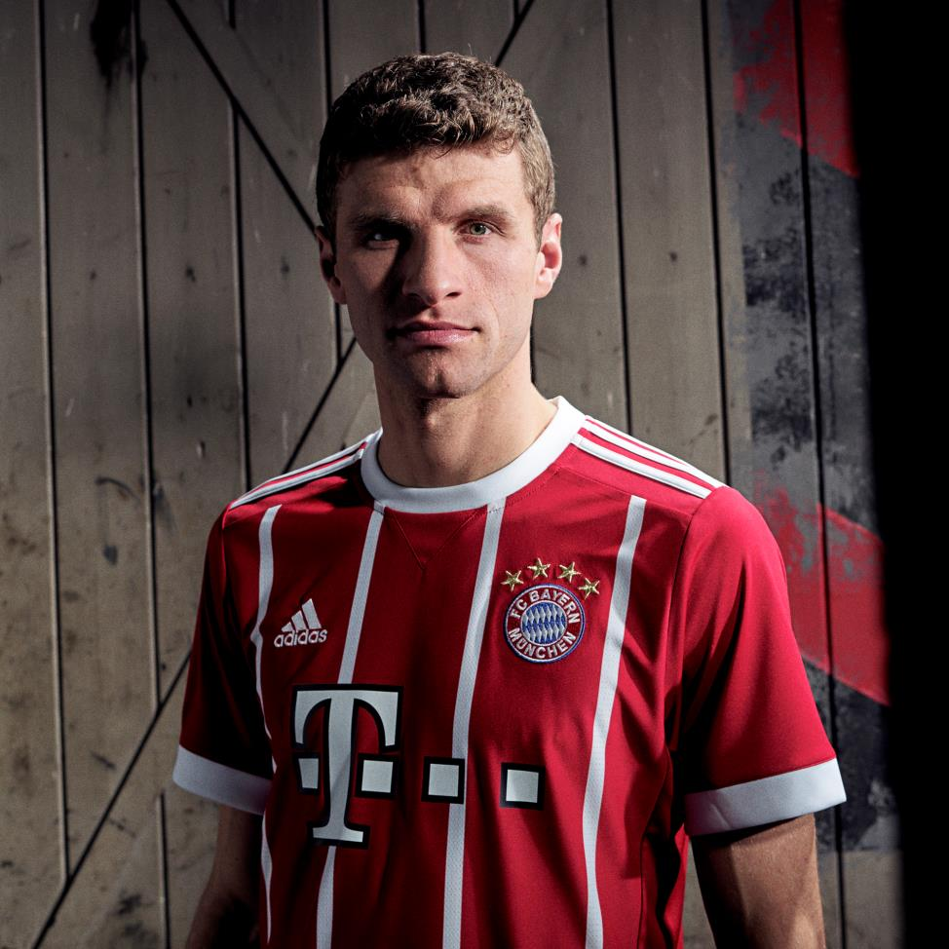

Portland, Ore., May 18th, 2017 – adidas Soccer revealed today the FC Bayern home jersey for the 2017/18 season which draws inspiration from one of the most iconic shirts in the club’s history, a jersey worn by the likes of Franz Beckenbauer, Uli Hoeness and Gerd Müller in the successful period of the 70’s.

The new kit pays homage to the past while being brought into the future thanks to technical, breathable fabrics and mesh engineering. The predominantly red jersey features thin, vertical white stripes alongside the classic adidas three stripes on the shoulder. FC Bayern’s motto “Mia San Mia” – roughly translating to “We know where we come from, who we are and what we aim for” – features on the reverse of the kit.

To mark the launch, adidas has revealed a design film featuring Jürgen Rank, Senior Design Director, discussing the inspiration behind the design. It details the innovative materials used, the journey from ideation to creation and concludes by explaining how the latest kit is created to inspire a new wave of players and fans, both on-field and on the streets.

The kit will be seen on the field for the first time when FC Bayern Munich face FC Freiburg on May 20th. It is now available for purchase in the U.S. on adidas.com.

For more information visit http://www.adidas.com/us/soccer and join the conversation on Twitter​ and Instagram​ with #HereToCreate.

- END -

For further media information please visit http://news.adidas.com/US/home/SOCCER or contact:

Cristina Maillo Belda
PR Manager, adidas Soccer
Email: Cristina.maillobelda@external.adidas.com
Tel: 503.915.9129

About adidas Soccer
adidas is the global leader in soccer. It is the official sponsor / official supplier partner of the most important soccer tournaments in the world, such as the FIFA World Cup™, the FIFA Confederations Cup, the UEFA Champions League, the UEFA Europa League, the UEFA European Championships and Major League Soccer. adidas also sponsors some of the world’s top clubs including Manchester United, Real Madrid, FC Bayern Munich, Juventus, Chelsea and AC Milan. Some of the world’s best players also on the adidas roster are Leo Messi, Paul Pogba, Gareth Bale, Thomas Müller, Luis Suárez, James Rodríguez, Diego Costa and Mesut Özil.

