Performance with purpose; adidas introduces Parley editions of game-changing running footwear

- New Parley editions of UltraBOOST, UltraBOOST X, and UltraBOOST Uncaged announced
- Made with Parley Ocean Plastic™, the latest designs in blue colourway inspired by the shades of the oceans will be available from May 10th
- adidas to celebrate World Oceans Week with a digital run, calling runners world-over to join. Registration opens today, adidas.com/runfortheoceans

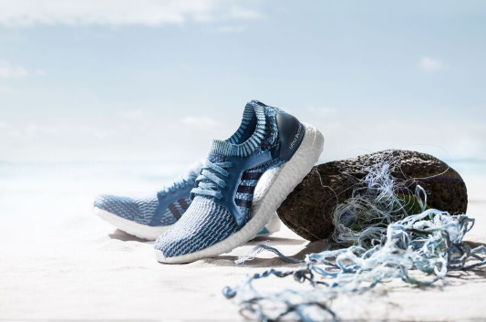

Herzogenaurach, April 21st, 2017 – adidas today revealed Parley editions of UltraBOOST, UltraBOOST X and UltraBOOST Uncaged, all in a fresh blue colourway inspired by the shades of the oceans. Using marine plastic debris, adidas is turning a threat into a thread to form signature elements of its iconic performance-led designs. This latest milestone in the partnership reflects both parties’ commitment to the oceans through a mutual focus on the implementation of the Parley A.I.R Strategy - avoiding virgin plastic, intercept plastic waste, and redesigning new alternatives; challenging the status quo together, one step at a time.

Reusing an average of 11 plastic bottles per pair, UltraBOOST Parley, Parley UltraBOOST X and UltraBOOST Uncaged Parley feature laces, heel webbing, heel lining, and sock liner covers made from recycled PET material. Not only do the latest additions to the adidas Parley collection have a purpose, they also deliver the same elite performance with every stride.

Key benefits include:
- Primeknit – wraps the foot to supply lightweight comfort and fit; made from up to 95% Parley Ocean Plastic™
- Heel fit counter system – supportive heel construction, designed to enable free motion of the Achilles
- Torsion system – made from a renewable source, the system supports the foot’s natural flex from heel to toe
- Rubber outsole – with superior grip that adapts to every runner’s foot strike by moving in harmony with boost to provide a smoother and more flexible ride
- BOOST – industry-leading, ultra-responsive comfort and cushioning that stores and returns energy every time the foot hits the ground

UltraBOOST X Parley also features the distinctive Adaptive Arch, ensuring freedom of movement during a run, for increased comfort and support.

Mathias Amm, Product Category Director, adidas Running, said: “The new additions to the adidas x Parley collection are another step in our journey to creating one million pairs of UltraBOOST from up-cycled marine plastic. As a global brand we have a responsibility to help change the world for the better. These designs reflect our support for a great cause, while delivering the exceptional performance we are renowned for - a powerful combination, which we hope will excite and inspire our global community as much as it does us.”

Additionally, as part of its commitment to create a global movement, adidas calls on its global community to join the adidas x Parley Run for the Oceans digital event – hosted by Runtastic, and taking place around World Oceans Day 2017 (June 5-11). Runners are invited to show their commitment to the cause by joining the run - from the city streets, the beach, or wherever they happen to be during that week.
To find out more, get involved and sign up, please visit adidas.com/runfortheoceans.
UltraBOOST Parley, UltraBOOST X Parley and UltraBOOST Uncaged Parley will be available from May 10th in-store and online at adidas.com/Parley. Follow the conversation at @adidasrunning on Instagram, Twitter and Facebook using #UltraBOOST #adidasParley.

ENDS

For questions or more information please contact:
Delia López
adidas España s.a.
Public Relations Manager. Marketing
e-mail: delia.lopez@adidas.com

