adidas and Major League Soccer Join forces with Parley for the Oceans, Introducing the First MLS Club Jerseys Made from Parley Ocean Plastic™

- Both leaders in sport unite to address marine plastic pollution –
- Unique kits to be worn during play for New York City FC vs. Orlando City SC on FS1 and LA Galaxy vs. Seattle Sounders FC on ESPN on Sunday, April 23rd -

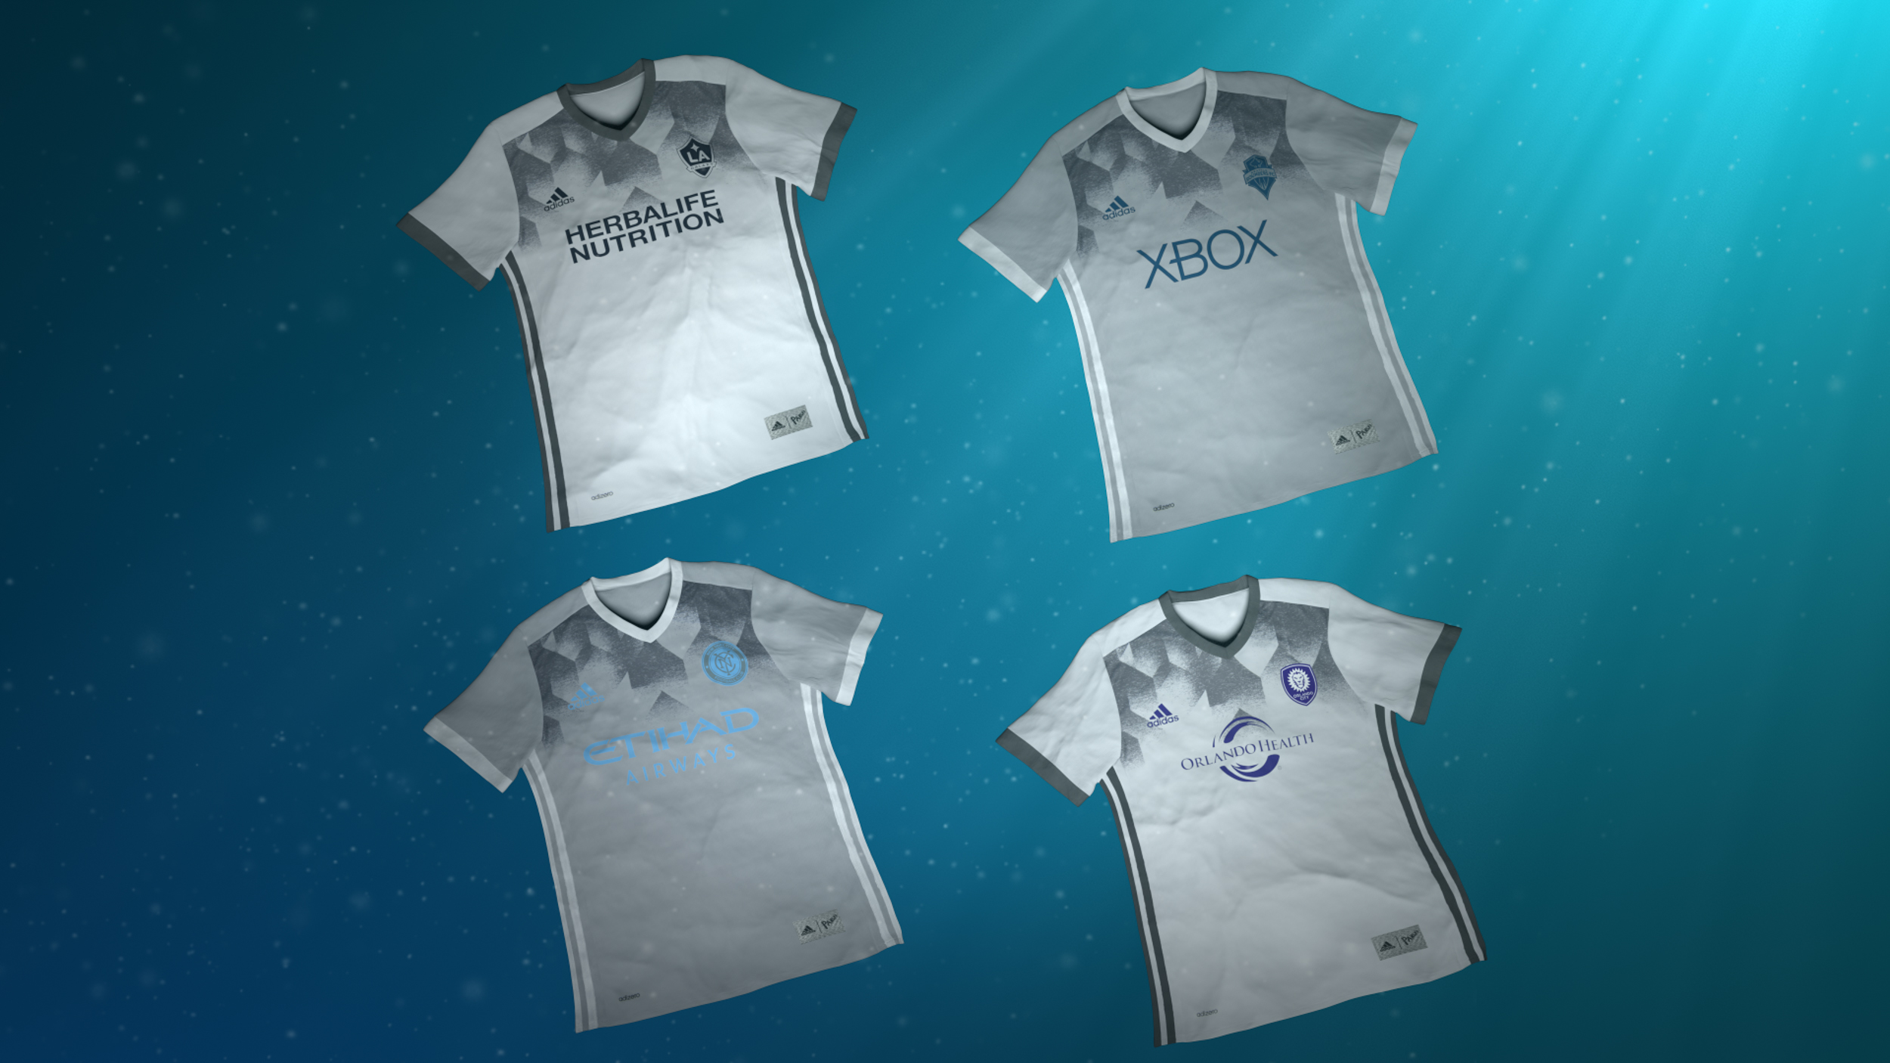

Portland, Ore. April 19th, 2017 – Today, adidas, Major League Soccer and Parley For The Oceans unite to raise awareness around the harmful impact of marine plastic pollution with the unveiling of four adidas MLS Parley club jerseys. The kits—each made from technical yarns containing Parley Ocean Plastic™—will be seen on-pitch on Sunday, April 23rd when New York City FC host Orlando City SC at Yankee Stadium, and when LA Galaxy welcome reigning MLS Cup champions Seattle Sounders FC at StubHub Center.

“We are very proud to be working with a new partner in MLS and its participating teams to enforce the usage, messaging and awareness around the beauty and fragility of the Oceans,” said Michael Batz, adidas Vice President of Product, Global Brands, Soccer. “Our core brand belief is that through sport, we have the power to change lives and feel that MLS is an ideal partner to transport and establish this belief in soccer – connecting a global sport with meaningful desire to preserve the environment. It will be the first step to explore and expand future opportunities.”

Following the inception of the adidas FC Bayern Munich and Real Madrid C.F. Parley Jerseys in November 2016, the new MLS jerseys expand on this initial collaboration, bringing the initiative to North America for the first time. The new MLS white and grey jerseys feature alternative colorway details and are crafted from Parley Ocean Plastic™ upcycled from marine plastic intercepted by Parley clean-up operations in coastal areas of the Maldives. Once collected, the original plastic source is reworked into technical fibers that can then be repurposed for use in either apparel or footwear – and in this instance, the jerseys worn by MLS clubs. To commemorate this unique process of repurposing marine plastic debris, the message “For the Oceans” is featured on the back-neck tape detailing, found inside each jersey.

"Every second breath we take is generated by the oceans. And still, we are at war with the sea,” said Cyrill Gutsch, Founder of Parley for the Oceans. “We are killing it off in rapid speed. Now is the time to negotiate peace with our life support and to invent our way out of this mess. Soccer can lead the way. It shows what we can achieve with the right balance of creativity, collaboration and technology. Let's accept the oceans defense as our biggest challenge and protect the air we need."

Since the announcement of the adidas and Parley partnership in April 2015, the focus of the collaboration is the brand’s commitment to implement the Parley A.I.R. strategy (Avoid, Intercept, Redesign). As a part of “Redesign”, adidas is committed to increasing the use of eco-innovative materials such as Parley Ocean Plastic™ in its products as a replacement for virgin plastic, as well as setting new industry standards with a focus on creativity and collaboration.

“Major League Soccer and our clubs are committed to raising awareness about environmental issues through the League’s Greener Goals platform,” said JoAnn Neale, Chief Administrative & Social Responsibility Officer, Major League Soccer. “Off the pitch, we’ll service our local communities as part of MLS WORKS Week of Service leading up to Earth Day, and we’re thrilled to support efforts on the field with adidas and Parley For the Oceans to help create a cleaner, healthier environment.”

As part of MLS’ Soccer Sunday action, the New York City FC vs. Orlando City SC match will be broadcast live on FS1 and FOX Deportes at 10:30 a.m. PT, while ESPN and ESPN Deportes will follow up the programming with the LA Galaxy vs. Seattle Sounders FC game at 1 p.m. PT.

For more information visit http://www.adidas.com/us/soccer and join the conversation on Twitter​ and Instagram​ with #adidasParley and #NeverFollow​.

- END -

For further media information please visit http://news.adidas.com/US/home/SOCCER and www.adidas.com/parley or contact:

Cristina Maillo Belda
PR Manager, adidas Soccer
Email: Cristina.maillobelda@external.adidas.com
Tel: 503.915.9129

About adidas Soccer
adidas is the global leader in soccer. It is the official sponsor / official supplier partner of the most important soccer tournaments in the world, such as the FIFA World Cup™, the FIFA Confederations Cup, the UEFA Champions League, the UEFA Europa League, the UEFA European Championships and Major League Soccer. adidas also sponsors some of the world’s top clubs including Manchester United, Real Madrid, FC Bayern Munich, Juventus, Chelsea and AC Milan. Some of the world’s best players also on the adidas roster are Leo Messi, Paul Pogba, Gareth Bale, Thomas Müller, Luis Suárez, James Rodríguez, Diego Costa and Mesut Özil.

About Major League Soccer
Headquartered in New York City, Major League Soccer features 22 clubs throughout the United States and Canada. For more information about MLS, visit www.MLSsoccer.com.

Learn more about Parley
Parley for the Oceans is a collaboration network and organization that raises awareness for the beauty and fragility of the oceans and unites the creative industries in projects that can end their destruction. Led by the Parley AIR Strategy (Avoid, Intercept, and Redesign), the Parley Ocean Plastic Program drives locally tailored, global initiatives with a focus on communication and education, research and development, direct action, and eco innovation to end the cycle of pollution long-term.
www.parley.tv
www.oceanplastic.com

