Please see high res images here.

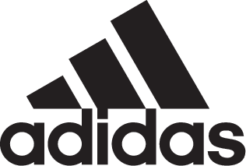

Adidas Soccer Meets Adidas Originals with the EQT Green Pack

– Iconic adidas Originals EQT range integrated into soccer product for the first time –
– Continues adidas strategy of merging lifestyle and performance –
– Green and black colorway available in cage and street silos –

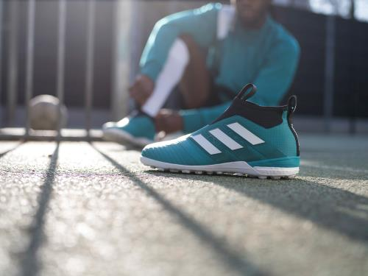

Portland, Ore. April 16th, 2017 – adidas Soccer revealed today its latest limited collection, the EQT Green Pack, bringing the popular adidas Originals EQT range into soccer for the first time, as the brand continues its aim to bring style from the stadium to the street.

The EQT Green ACE cage shoe features the iconic green and black colorway and includes a PRIMEKNIT upper with a layer of NSG film to provide ultimate control. A stretchable layer of TECHFIT material optimizes comfort and a green EVA strip above the heel’s BOOST offers stability.

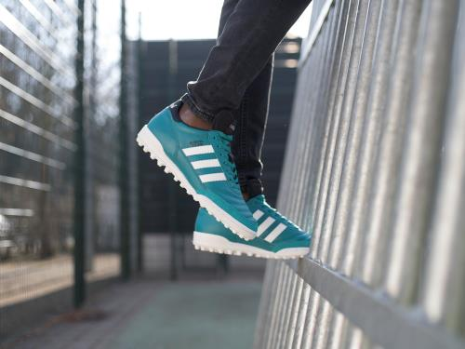

The Mundial Team EQT Green offers a sleek, premium design engineered for an urban environment. Made with a K-Leather upper, it features a black tongue, white midsole and green suede toe cap. The words “Mundial Team” in gold sit above the classic three stripes.

The EQT Green Pack will be available in the U.S. tomorrow on adidas.com and at select retailers nationwide.

For more information visit http://www.adidas.com/us/soccer and join the conversation on Twitter​ and Instagram​ with #NeverFollow​.

- END -

For further media information please visit http://news.adidas.com/US/home/SOCCER or contact:

Cristina Maillo Belda
PR Manager, adidas Soccer
Email: Cristina.maillobelda@external.adidas.com
Tel: 503.915.9129

About adidas Soccer
adidas is the global leader in soccer. It is the official sponsor / official supplier partner of the most important soccer tournaments in the world, such as the FIFA World Cup™, the FIFA Confederations Cup, the UEFA Champions League, the UEFA Europa League and the UEFA European Championships. adidas also sponsors some of the world’s top clubs including Manchester United, Real Madrid, FC Bayern Munich, Juventus, Chelsea and AC Milan. Some of the world’s best players also on the adidas roster are Leo Messi, Paul Pogba, Gareth Bale, Thomas Müller, Luis Suárez, James Rodríguez, Diego Costa and Mesut Özil.

