adidas Football Launches ACE 17 Turbocharge football boots

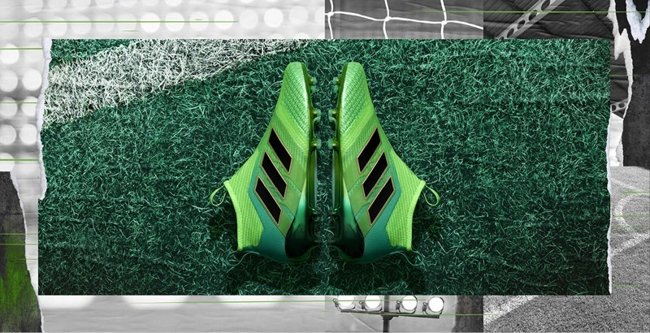

Cape Town, 24 March 2017 – adidas Football has today unveiled its Turbocharge collection featuring on pitch ACE 17+ PURECONTROL; the continuation of a journey which started with the Red Limit campaign under the ‘Stadium to Street” umbrella in November 2016.

The Turbocharge ACE 17+ PURECONTROL features a PURECUT Sock System - designed to lock the foot in place while adjusting to complex movements - and a 360 degree fully PRIMEKNIT upper to ensure zero wear-in time. The boot also features the iconic adidas BOOST sole to deliver unrivalled energy return with every step.

The Turbocharge will be worn on-pitch from 31st March by adidas global athletes and 1st April in South Africa. Players donning the ACE17+ PURECONTROL in South Africa will be Thulani Hlatshwayo, Travis Graham and Tebogo Mokoena amongst others.

The boots will be available on the 31 March 2017 on adidas’ ecommerce platform (www.adidas.co.za/football), adidas Own retail stores, and at selected football specialists across the country, at a retail price of P0 R3999 and P1 - R2999.

For further information please visit adidas.com/football or go to facebook.com/adidasfootball or follow @adidasZA on twitter and Instagram to join the conversation.

- ENDS -
For further media information please visit
http://newsZA.adidas.com/ or contact:

Tebogo Kgosi  Senior Manager Newsroom and PR  Email: tebogo.kgosi@adidas.com  Tel: +27 11 798 6906 | Amava Kamana  PR Account Executive – Magna Carta  Email: amava.kamana@magna-carta.co.za  Tel: +27 21 87 997 0111
Notes to editors:
About adidas Football
adidas is the global leader in football. It is the official sponsor / official supplier partner of the most important football tournaments in the world, such as the FIFA World Cup™, the FIFA Confederations Cup, the UEFA Champions League, the UEFA Europa League and the UEFA European Championships. adidas also sponsors some of the world’s top clubs including Manchester United, Real Madrid, FC Bayern Munich, Juventus, Chelsea and AC Milan. Some of the world’s best players also on the adidas roster are Leo Messi, Paul Pogba, Gareth Bale, Thomas Müller, Luis Suárez, James Rodríguez, Diego Costa and Mesut Özil.

