Turbocharge Collection: The Latest Cleat Drop from Adidas Soccer

- Stadium, Cage and Street versions available from 24th March -
- Paul Pogba and Mesut Ozil will take to the pitch in the latest ACE 17+ PURECONTROL colorway -

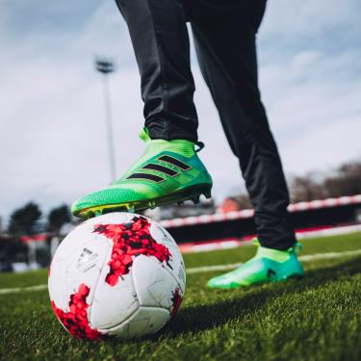

Portland, Ore., March 24th 2017 – adidas Soccer launched today the Turbocharge collection, featuring on-pitch, cage and street versions of the ACE 17+ PURECONTROL.

The Turbocharge ACE 17+ PURECONTROL features a PURECUT Sock System - designed to lock the foot in place while adjusting to complex movements - and a 360 degree fully PRIMEKNIT upper to ensure zero wear-in time. The boot also features the iconic adidas BOOST sole to deliver unrivalled energy return with every step.

The Turbocharge ACE 17+ PURECONTROL Cage version features the same two-tone green colorway as the on-pitch silo. It includes a PRIMEKNIT upper with a layer of NSG film to provide close ball control and a stretchable layer of TECHFIT material to optimize comfort. The shoe features a green EVA strip above the heel’s BOOST and three stripes in chrome with gold accents.

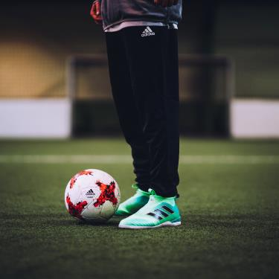

The ACE 17+ Street shoe completes the Turbocharge collection. Inspired by the street, the predominantly grey colorway is constructed with a three-piece PRIMEMESH material for a lifestyle-focused look. A TECHFIT color coating covers the three stripes while a full-length BOOST midsole enhances the lifestyle look.

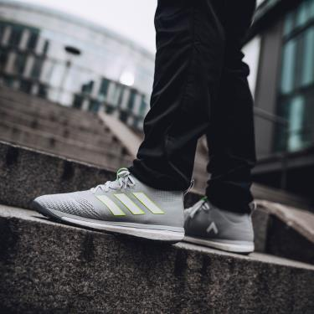

For further information please visit adidas.com/us/soccer or go to facebook.com/adidassoccer or follow @adidassoccer on twitter to join the conversation.

- END -

For further media information please visit http://news.adidas.com/US/home/SOCCER or contact:

Cristina Maillo Belda
PR Manager, adidas Soccer
Email: Cristina.maillobelda@external.adidas.com
Tel: 503.915.9129

About adidas Soccer
adidas is the global leader in soccer. It is the official sponsor / official supplier partner of the most important soccer tournaments in the world, such as the FIFA World Cup™, the FIFA Confederations Cup, the UEFA Champions League, the UEFA Europa League and the UEFA European Championships. adidas also sponsors some of the world’s top clubs including Manchester United, Real Madrid, FC Bayern Munich, Juventus, Chelsea and AC Milan. Some of the world’s best players also on the adidas roster are Leo Messi, Paul Pogba, Gareth Bale, Thomas Müller, Luis Suárez, James Rodríguez, Diego Costa and Mesut Özil.

