The court is your canvas – adidas Tennis introduces the Art Pack footwear collection

- adidas introduces footwear collection that celebrates the players who express themselves on the court -
- Re-imagined with looks inspired by famous movements in art -

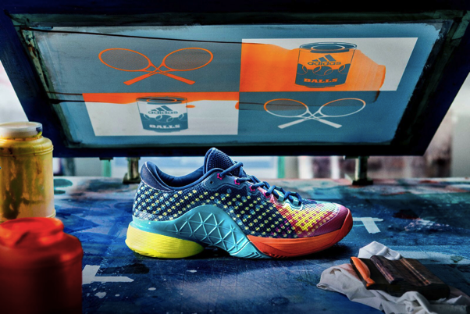

Herzogenaurach, Germany 13th February 2017: adidas Tennis has today unveiled the Art Pack footwear collection, inspired by the world of art and in a tribute to the creators who express themselves on to the court. The collection is made up of the Barricade 2017 POP ART, Ubersonic 2 Art Nouveau and the adizero Ubersonic 2 Street Art.

The Barricade 2017 POP ART is inspired by the artists of the Pop Art movement that re-defined how art interacts with popular culture. Featuring a repeating tennis ball print and vibrant graphics, the Barricade shoe is for every tennis player looking for their moment to shine. The Barricade 2017 POP ART is globally available on the 15 February 2017.

The Ubersonic 2 Art Nouveau is made for those who play with elegance and fluency. Every stylish detail of this women’s limited edition shoe is homage to Art Nouveau, including the graphic text of the product’s name written on the tongue. The Ubersonic 2 Art Nouveau is globally available on the 15 February 2017.

The adizero Ubersonic 2 Street Art is inspired by bold colours and graphics, making it the choice for players looking to stand out on the court. Delivering the advantage of speed and with street art one of the fastest art forms to create, the technical performance benefits of the shoe align with the overall design. A yellow balloon graphic creates a pop of colour, while the inclusion of a menacing Lion street art graphic is a statement of confidence for players. The Ubersonic 2 Street Art is globally available on the 1 May 2017.

Alex Chan, Director at adidas Tennis said: “When the best tennis players take to the court, they bring with them their own style, similar to artists. With the Art Pack we wanted to pay homage to these great creators of the court with a product that matches their own style.”

All footwear in the Art Pack comes with a matching graphic tee in a climalite fabric, which prevents sweat and heat build-up and adidas’ suite of performance features.

The new Art Pack is globally available from adidas.com/tennis and tennis retailers. Follow the conversation at @adidastennis on Twitter and Instagram.

ENDS

For further media information please contact:
Lindsey Rossell
lindsey.rossell@hkstrategies.com
+44 (0) 207 413 3163

Notes to editors:

About adidas Tennis
adidas Tennis is represented by top players such as Simona Halep, Angelique Kerber, Garbiñe Muguruza, Caroline Wozniacki, Tomas Berdych, Lucas Pouille, Dominic Thiem, Jo-Wilfried Tsonga, Sascha Zverev and Novak Djokovic (Footwear Only). For more information on adidas Tennis, please visit www.adidas.com/tennis. For additional images please visit our media news room on news.adidas.com and follow us on Twitter or on Instagram under @adidasTennis.

About adidas
The adidas Group is a global leader in the sporting goods industry, offering a broad portfolio of footwear, apparel and hardware for sport and lifestyle around the core brands adidas, Reebok, TaylorMade and CCM Hockey. Headquartered in Herzogenaurach, Germany, the Group employs more than 55,000 people across the globe and generated sales of around € 17 billion in 2015.

