ADIDAS REDEFINES PINNACLE PERFORMANCE SHOE FOR WOMEN – INTRODUCING ULTRABOOST X
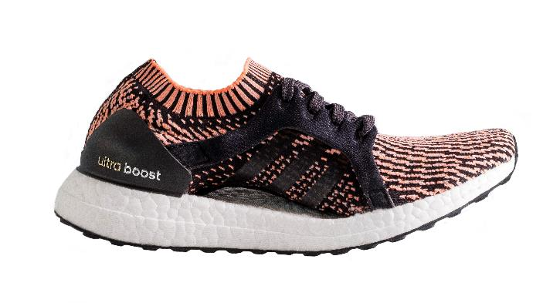
Cape Town, 6 February: adidas Running today revealed the latest version of its iconic UltraBOOST shoe, designed to give female runners their greatest running experience.

Tailored to the unique shape of the female foot, UltraBOOST X is designed to reflect the foot’s natural running silhouette for an enhanced performance for the female runner.

The ARAMIS system, a motion tracking technology that enables a detailed analysis into the movement of the body, was used to allow adidas innovation teams to see exact points where female runners need the most support and where their foot needs room for natural expansion. This process led to the unique design of the UltraBOOST X shoe.

The full length midsole is 100% BOOST, proven to provide the best energy return in the industry. It is also durable in all temperatures. The Continental Rubber 4-way stretch web outsole was designed for a female gait and provides good traction for urban running, in any condition. The iconic shape of UltraBOOST gives her the confidence that she can break her personal barriers, and her own goals.

Pieter Warnich, Snr Manager BU Running & Outdoor adidas SA said: “The ARAMIS insights allow us to uniquely tailor the leading performance technology of Ultraboost to women specifically. We’re encouraging female runners around the globe to uplift their running experience with UltraBOOST X.”

The UltraBOOST X shoe launches alongside a range of running apparel, including a Primeknit Tee and double layer shorts. The collection is designed to coordinate with the unique shoe design, whilst working in harmony with the body and running environment.

The adidas UltraBOOST X has an RSP of R 2799 and the UltraBOOST X apparel starts from R899. Both are available on adidas ecomm, Own Retail, Total Sports and participating stores.

For further information please follow @adidasZA on twitter and Instagram to join the conversation.

- ENDS -
For questions or more information please contact:
http://newsZA.adidas.com/ or contact:
Tebogo Kgosi  Manager Newsroom and PR  Email: tebogo.kgosi@adidas.com  Tel: +27 11 798 6906 | Star Mkhize  PR Senior Account Manager – Magna Carta  Email: Star@magna-carta.co.za  Tel: +27 87 997 0111

