EMBARGOED UNTIL 20th JANUARY- 10am CET
Please see high res images here.

adidas Soccer Introduces Blue Blast Collection

- Brand new Purecut Sock System features alongside BOOST technology in the ACE 17+ PURECONTROL -
- Stadium, Cage and Street versions available from 26 January -
- The ACE 17+ PURECONTROL will be worn by the likes of Paul Pogba and Mesut Ozil -
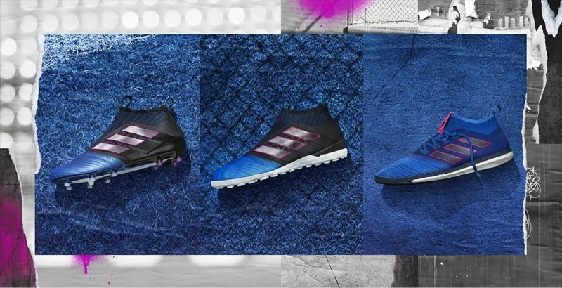

Portland, Ore., January 20, 2017 – adidas Soccer launches today the new ACE 17+ PURECONTROL as part of the Blue Blast collection, including on-pitch, cage and street versions.

The Blue Blast ACE 17+ PURECONTROL’s latest feature is an all-new Purecut Sock System. Designed to provide an optimal fit, the highly stretchable material helps lock the foot in place while adjusting to even the most complex movements. It features a 360 degree fully PRIMEKNIT upper to ensure zero wear-in time is required and is protected by an ultra-thin Non Stop Grip (NSG) film to provide increased levels of grip.

Another innovative design feature is the inclusion of adidas’ industry-defining BOOST technology. The BOOST sole is made up of thermoplastic polyurethane (TPU), which delivers an unrivalled energy return with every step. The boot also features a SPRINTFRAME sock liner, with the end result being more energy than conventional midsoles and unrivalled levels of comfort.
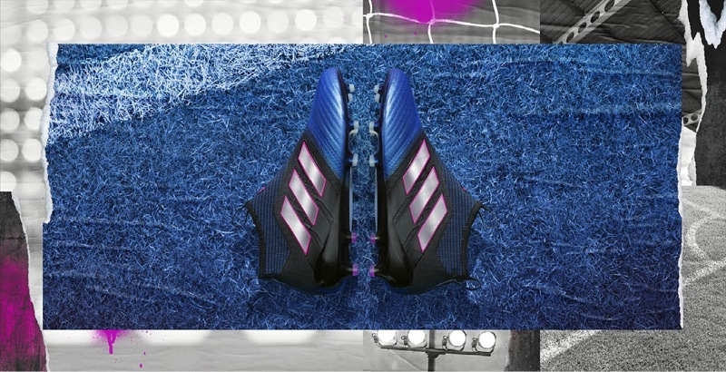

The collection also includes the Blue Blast ACE 17+ PURECONTROL Cage version. Featuring the same blue and black colorway as the on-pitch silo, the cage version includes a PRIMEKNIT upper with a layer of NSG film to provide close ball control. A stretchable layer of TECHFIT material between the blue and black color blocks optimizes comfort, while a black EVA strip features above the heel’s BOOST to offer stability. The three stripes in chrome also feature pink accents for a more lifestyle look. Comfort, stability and energy return are offered through the BOOST material on the heel counter.
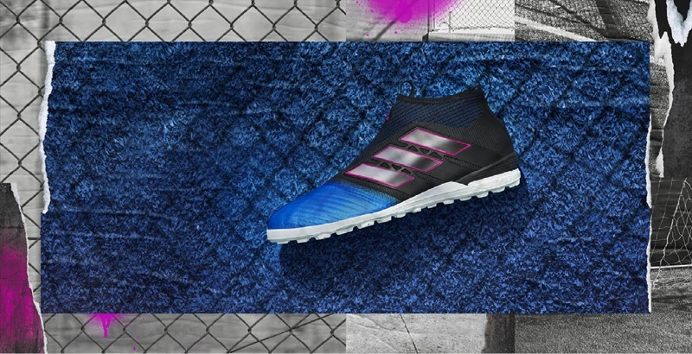

Inspired by the street, the ACE 17+ Street shoe completes the Blue Blast collection. The predominantly blue colorway features pink details and is constructed with a three-piece PRIMEMESH material for a lifestyle-focused look. A TECHFIT color coating covers the three stripes while a full-length BOOST midsole enhances the lifestyle look and offers energy return.

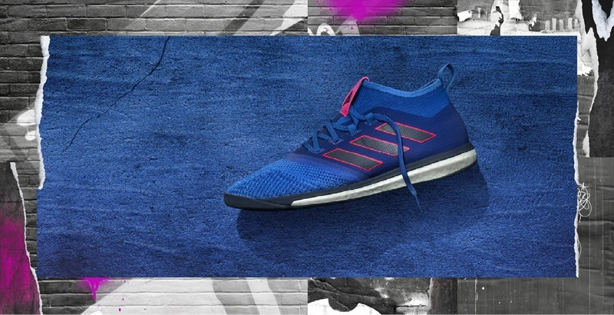

For further information please visit adidas.com/us/soccer or go to facebook.com/adidassoccer or follow @adidassoccer on twitter to join the conversation.

- END -

For further media information please visit http://news.adidas.com/US/home/SOCCER or contact:

Cristina Maillo Belda
PR Manager, adidas Soccer
Email: Cristina.maillobelda@external.adidas.com
Tel: 503. 915.9129

About adidas Soccer
adidas is the global leader in soccer. It is the official sponsor / official supplier partner of the most important soccer tournaments in the world, such as the FIFA World Cup™, the FIFA Confederations Cup, the UEFA Champions League, the UEFA Europa League, the UEFA European Championships and Major League Soccer. adidas also sponsors some of the world’s top clubs including Manchester United, Real Madrid, FC Bayern Munich, Juventus, Chelsea and AC Milan. Some of the world’s best players also on the adidas roster are Leo Messi, Paul Pogba, Gareth Bale, Thomas Müller, Luis Suárez, James Rodríguez, Diego Costa and Mesut Özil.

