adidas evolves Barricade footwear franchise for 2017 tennis season

- Continued innovation and craftsmanship ensures Barricade still owns the court –
- Barricade 2017 BOOST will be worn by Jo Wilfred Tsonga–
- Barricade 2017 will be worn by players including Tomas Berdych and Dominic Thiem -
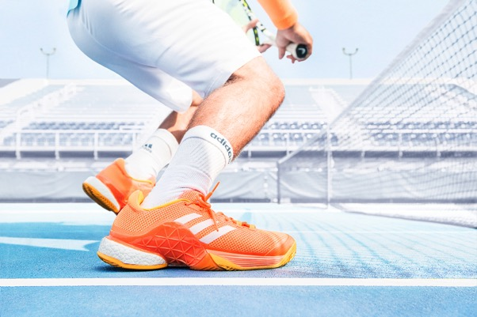
Herzogenaurach, Germany, 1 January 2017: adidas has updated its market leading Barricade tennis performance franchise, integrating the latest innovations to deliver confident performance at any level and on any surface. With state-of-the-art design and craftsmanship the Barricade 2017 continue to be the most stable and durable shoe on court.

Designed with smart materials incorporated into the toe and outsole areas, the Barricade is built to provide power and stability on the court. A knitted upper and seamless construction gives an anatomical fit providing comfort and manoeuvrability. Worn by Jo Wilfred Tsonga, the Barricade 2017 BOOST flagship model features the integration of BOOST technology for the ultimate energy return, allowing you to unleash energy more efficiently in every stride, resulting in ultimate responsiveness alongside the stability of Barricade. The Barricade 2017 BOOST continues to provide maximum mid-sole support and fit with its new GEOFIT construction and dynamic chassis.

The new Barricade 2017 is built for the power player and will be worn by top men’s players including Tomas Berdych and Dominic Thiem. With the strength of a full-length ADIPRENE+ sole, the Barricade 2017 continues to optimise cushioning and rebound through the foot whilst playing. Hitting the court in 8 new colourways the Barricade 2017 continues to be adidas’ ultimate technical performance footwear.

Thomas Weege, Head of adidas Tennis design, comments “From the very first line in the late nineties until today, I had to improve the design process over and over and over again. The game got so much faster - 20 years ago it was a different sport. Today it is so much more dynamic, aggressive and powerful. Taking a look at the Barricade today, we’re looking at the ultimate performance piece for tennis players. All our learnings, all our knowledge and experience went into the design process of the new Barricade 2017.”

The new 2017 adidas Barricade is available online now at http://www.adidas.co.uk/tennis. Follow the conversation at @adidastennis on twitter.

ENDS

For further media information please contact:
Lindsey Rossell
lindsey.rossell@hkstrategies.com
+44 (0) 207 413 3163

About adidas Tennis
adidas Tennis is represented by top players such as Simona Halep, Angelique Kerber, Garbiñe Muguruza, Caroline Wozniacki, Tomas Berdych, Lucas Pouille, Dominic Thiem, Jo-Wilfried Tsonga, Sascha Zverev and Novak Djokovic (Footwear Only). For more information on adidas Tennis, please visit www.adidas.com/tennis. For additional images please visit our media news room on news.adidas.com and follow us on Twitter or on Instagram under @adidasTennis.

About adidas
The adidas Group is a global leader in the sporting goods industry, offering a broad portfolio of footwear, apparel and hardware for sport and lifestyle around the core brands adidas, Reebok, TaylorMade and CCM Hockey. Headquartered in Herzogenaurach, Germany, the Group employs more than 55,000 people across the globe and generated sales of around € 17 billion in 2015.

