World’s Greatest Player to Play in the New Red Limit MESSI 16

- Red Limit MESSI 16 launched as part of the Red Limit Collection -
- Leo Messi to wear Red Limit MESSI 16 on-pitch from 26th November -
- AGILITYKNIT, PUREAGILITY HEEL LINING and SPRINTFRAME outsole all feature -

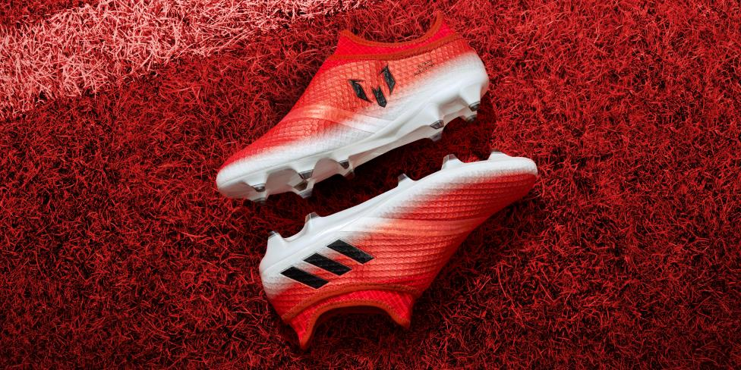

Herzogenaurach, 24th November – From this weekend, the world’s greatest player Leo Messi will wear the Red Limit MESSI 16, launched by adidas Football as part of the Red Limit Collection.

The Red Limit MESSI 16 is designed with agility in mind, to suit the playing style of the five time Ballon d’Or winner. The boot features AGILITYKNIT to ensure zero wear-in time, while a PURECUT SOCK SYSTEM and PUREAGILITY HEEL LINING combine to deliver an uncompromising fit. A SPRINTFRAME outsole creates balance and stability at high-speed changes of direction.

For further information please visit adidas.com/football or go to facebook.com/adidasfootball or follow @adidasfootball on twitter to join the conversation.

- END -

For further media information please visit http://news.adidas.com/GLOBAL/PERFORMANCE/FOOTBALL or contact:

Simon Bristow  PR Director – Herzo Newsroom  Email: simon.bristow@adidas.com  Tel: +49/9132/84-73 703 | Julien Lanfrey  Global PR Manger, adidas Football  Email: julien.lanfrey@adidas.com  Tel: +49/1609/77-16 429
Notes to editors:
About adidas Football
adidas is the global leader in football. It is the official sponsor / official supplier partner of the most important football tournaments in the world, such as the FIFA World Cup™, the FIFA Confederations Cup, the UEFA Champions League, the UEFA Europa League and the UEFA European Championships. adidas also sponsors some of the world’s top clubs including Manchester United, Real Madrid, FC Bayern Munich, Juventus, Chelsea and AC Milan. Some of the world’s best players also on the adidas roster are Leo Messi, Paul Pogba, Gareth Bale, Thomas Müller, Luis Suárez, James Rodríguez, Diego Costa and Mesut Özil.

