DFB reveal new kit as FIFA World Cup winners continue on road to Russia 2018

- Kit is inspired by the away shirt of the World Cup winning DFB team in 1990 -
- Iconic design was unveiled in “Urban Football Gallery” in Düsseldorf -
- The “Mannschaft” will wear the new kit on their way to defend the World Cup in Russia -
- Kit will also feature during the FIFA Confederations Cup (17 June to 2 July 2017) -
- Kit will debut on Friday, 11 November at the World Cup qualifying match in San Marino -

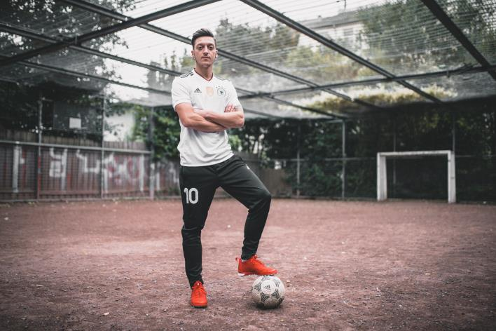

Herzogenaurach/Düsseldorf, Sunday 6 November 2016 – adidas has reinvented one of the most legendary designs in German football history to bring it back to the stadium and to the street. The German team’s new kit draws upon the design of the away kit worn by the world champions in 1990. The most striking feature is the graphic on the chest that reminds football fans of earlier triumphs and has since become iconic in street and skateboarding culture.

The home shirt, which the “Mannschaft” will now be wearing on their way to defend the World Cup in Russia and during the FIFA Confederations Cup (17 June to 2 July 2017), is also adorned by a black, red and gold collar and the reigning world champions’ emblem. adidas’ signature 3-Stripes have once again been applied to the sleeves. Black shorts and white socks complete the outfit. The shirt also comes in a women’s cut. World champion Mats Hummels says: “I am a fan of our more traditional kits, but the new variant is even cooler and more dynamic and I really like it.”

Today, adidas and the DFB have teamed up with midfielder Ilkay Gündogan to present the kit in Düsseldorf as part of an Urban Football Gallery. The exhibition showcases portrait photographs of national players Mesut Özil, Mats Hummels and Gündogan as well as young players, all away from the stadium: celebrating the German tradition of playing football on the streets, on makeshift pitches and in the backyards of the cities.

From Monday, 7 November, the kit will be available from the DFB online shop (www.dfb-fanshop.de), adidas stores, the adidas online shop (www.adidas.com/football) and specialist stores. The new kit will see action on Friday, 11 November at the World Cup qualifying match in San Marino.

For further information please visit adidas.com/football or go to facebook.com/adidasfootball or follow @adidasfootball on twitter to join the conversation.

- END -

For further media information please visit http://news.adidas.com/GLOBAL/PERFORMANCE/FOOTBALL or contact:

Simon Bristow  PR Director – Herzo Newsroom  Email: simon.bristow@adidas.com  Tel: +49/9132/84-73 703 | Julien Lanfrey  Global PR Manager, adidas Football  Email: julien.lanfrey@adidas.com  Tel: +49/160/977 16429
Notes to editors:
About adidas Football
adidas is the global leader in football. It is the official sponsor / official supplier partner of the most important football tournaments in the world, such as the FIFA World Cup™, the FIFA Confederations Cup, the UEFA Champions League, the UEFA Europa League and the UEFA European Championships. adidas also sponsors some of the world’s top clubs including Manchester United, Real Madrid, FC Bayern Munich, Juventus, Chelsea and AC Milan. Some of the world’s best players also on the adidas roster are Leo Messi, Paul Pogba, Gareth Bale, Thomas Müller, Luis Suárez, James Rodríguez, Diego Costa and Mesut Özil.

