adidas unveils UltraBOOST Uncaged Parley, the first mass-produced running shoe made from Parley Ocean Plastic
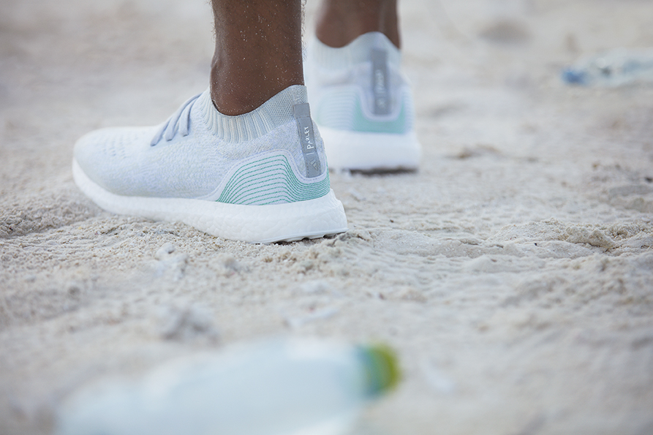
- UltraBOOST Uncaged Parley is the first step in the company’s commitment to creating one million pairs of shoes made with Parley Ocean Plastic by end of 2017
- The adidas and Parley partnership launched in April 2015 as an example of adidas’ collaborative approach to innovation

Cape Town, 4 November 2016 – In a game-changing move for a more eco-innovative future, adidas today unveiled the UltraBOOST Uncaged Parley running shoe; the first mass-produced footwear created using Parley Ocean Plastic. The revolutionary footwear will launch mid-November, with 7,000 pairs available globally.

UltraBOOST Uncaged Parley features a Primeknit upper made from a mix of Ocean PlasticTM, created from plastic waste retrieved by Parley coastal interception and clean-up operations in the Maldives (95%), and recycled polyester (5%); with each pair reusing eleven plastic bottles. The shoe laces, heel cap base material, heel webbing, heel lining and the sock-liner cover are also made with recycled materials. Its design is inspired by ocean waves, to reflect the shoe’s unique story and adidas and Parley’s commitment to end the cycle of pollution in the oceans.

UltraBOOST Uncaged Parley is created using new technologies specifically engineered to up-cycle marine plastic debris into technical yarn fibres. The specially-developed Primeknit upper is combined with UltraBOOST’s signature elements to deliver an innovative running shoe that requires no compromise on performance.

A Continental™ natural rubber Stretchweb outsole for all-weather traction works with the innovative full-length BOOST™ midsole for unrivalled energy return. The Torsion® system bar, also from a renewable source, supports the foot’s natural flex with every step.

Eric Liedtke, adidas Group Executive Board member responsible for Global Brands, said:
“This represents another step on the journey of adidas and Parley for the Oceans. But we won’t stop there. We’re now committed to scaling those initiatives. We will make one million pairs of shoes using Parley Ocean Plastic in 2017 – and our ultimate ambition is to eliminate virgin plastic from our supply chain.”
adidas’ 2017 target will mean that at least eleven million bottles retrieved from coastal areas by the Parley Global Clean-up Network and Remote Island Interception operations will be recycled and repurposed into elite performance sportswear. This plan forms part of a larger commitment by the brand to increase the use of more sustainable materials in its products and to make eco-innovation the new industry standard through implementation of the Parley A.I.R. Strategy (avoid, intercept, redesign), which aims to end the cycle of marine plastic pollution long-term.

“Nobody can save the oceans alone. Each of us can play a role in the solution. It’s in the hands of the creative industries to reinvent faulty materials, products, and business models. The consumer can boost the demand for change. But it’s up to eco innovation leaders, like adidas, to make change a reality. With this shoe we demonstrate what’s possible. It’s even more than a shoe. It’s a flag, an invitation to join our movement. ” Cyrill Gutsch, Founder, Parley for the Oceans.

Earlier in the year, adidas celebrated World Oceans Day by releasing the first-ever edition running shoe in partnership with Parley for the Oceans. With a limited run of only 50 pairs available worldwide, Instagram users were given the chance to win a piece of sportswear history by raising awareness of the cause and uploading a video to show how they implement Parley A.I.R. and pledge to avoid single-use plastic.

UltraBOOST Uncaged Parley will be available in limited quantities at adidas ecomm launching at 10am on 15th November for R2799. For more information on drop dates sign-up at adidas.com/parley.
- END –
Notes to Editors:
In April 2015, adidas announced a partnership with Parley for the Oceans, an environmental organization and collaboration network that raises awareness for the beauty and fragility of the oceans and implements comprehensive strategies to end their destruction.

As founding member, adidas supports Parley for the Oceans in its efforts in communication and education, research and development, direct action and eco innovation. The mutual focus is on Parley's comprehensive Ocean Plastic Program, which is led by the Parley A.I.R. Strategy (Avoid, Intercept, and Redesign) to end marine plastic pollution.

Learn more about Parley:
www.parley.tv
www.oceanplastic.com
For further information contact:
Saadiyah Hendricks
Magna Carta Reputation Management Consultants
Account Director
Email: saadiyah@magna-carta.co.za
Tel: +27 (87) 997 0111
Portia Gxasheka
adidas SA
PR Specialist
Email: portia.gxasheka@externals.adidas.com
Tel: +27 21 442 6200

