adidas and Parley for the Oceans release Real Madrid and Bayern Munich Jerseys Made From Parley Ocean Plastic

- Groundbreaking partnership creates first football jerseys made from Parley Ocean Plastic-
- Unique jerseys to be worn on-pitch on Saturday 5 and Saturday 26 November –
- Kits feature club and sponsor logos in club colour to reflect the jersey’s unique story -

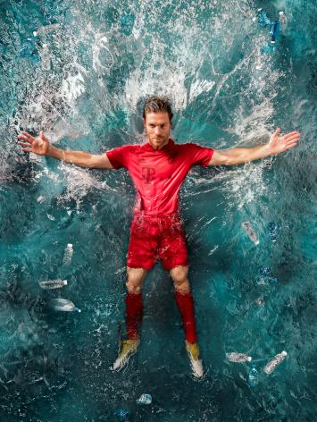

Herzogenaurach, Friday 4 November 2016 – Today adidas and Parley for the Oceans have unveiled the first performance football products with the launch of the adidas x Parley Real Madrid and Bayern Munich home jerseys. The jerseys will be seen on-pitch for the first and only time when Bayern take on TSG 1899 Hoffenheim on Saturday 5 November and Real Madrid face Real Sporting de Gijón on Saturday 26 November.

Made from Parley Ocean Plastic and water-based environmentally friendly prints, the all-white Real Madrid and all-red Bayern Munich kits feature the club logo, three stripes and sponsors’ logos in the same colour as the kit for a unique look. The Ocean PlasticTM used in the jerseys is created from up-cycled marine plastic pollution intercepted by Parley clean-up operations in coastal areas of the Maldives. To reflect the jersey’s unique story and Parley’s commitment to the oceans, both club and sponsors agreed not to have the logo visible in order to make the shirt as sustainable as possible.

The one-off kit design also features mesh inserts on the inside of sleeves for improved ventilation, a back-neck tape with the message “For the oceans” and an adidas x Parley loop label with an integrated NFC chip to offer fans further information on the partnership.

“It’s an honour to go on this journey with adidas and to have the opportunity to wear the adidas x Parley kit on-pitch for the first time. With every second breath we take coming from our oceans, it’s really important that we do what we can do safeguard them. Wearing a kit that is made from recyclable ocean waste is something I’m very happy about as it’s a fantastic opportunity to raise awareness about the need to protect and preserve our oceans. I know this is the start of something very special,” said Bayern Munich midfielder, Xabi Alonso.

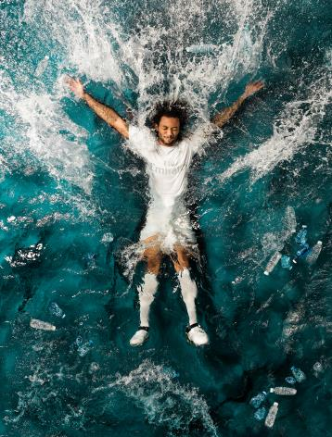

Real Madrid defender, Marcelo, said: “The Ocean is a place I hold close to my heart after growing up in Rio de Janeiro and I have fond memories of playing on the beach when I was a kid. It’s amazing to be part of this project and to know that the club I love is making a difference in helping to keep the oceans clean.”

As a founding member, adidas supports Parley for the Oceans in its education and communication programmes, as well as its comprehensive Ocean Plastic Program that intends to end plastic pollution of the oceans though the three pillars of the Parley A.I.R. Strategy: Avoid, Intercept and Redesign. Additionally, adidas and Parley collaborate to turn ocean waste into high-performance apparel by converting up-cycled marine plastic debris into technical yarn fibres.

The adidas x Parley Bayern Munich jersey is available on adidas.com/parley and in selected stores from Friday 4 November. The adidas x Parley Real Madrid jersey is available on adidas.com/parley and in selected stores from Thursday 24 November.

For more information about the partnership and products, sign-up on www.adidas.com/parley .

- END -

Notes to Editors:
In April 2015, adidas announced a partnership with Parley for the Oceans, an environmental organization and collaboration network that raises awareness for the beauty and fragility of the oceans and implements comprehensive strategies to end their destruction.

As founding member, adidas supports Parley for the Oceans in its efforts in communication and education, research and development, direct action and eco innovation. The mutual focus is on Parley's comprehensive Ocean Plastic Program, which is led by the Parley A.I.R. Strategy (Avoid, Intercept, and Redesign) to end marine plastic pollution.

Learn more about Parley: www.parley.com / www.oceanplastic.com
For further information contact:
Simon Bristow Julien Lanfrey
adidas Global PR Director Global Public Relations Manager, Football
E: simon.bristow@adidas.com E: Julien.lanfrey@adidas.com
T: +49 160 485 1388 T: +49 160 977 16429

