Virtual Meets Real World as adidas Turns Gaming Skills into a Professional Contract Experience

- Football-mad teenagers worldwide offered the chance to emulate the career of Alex Hunter, hero of FIFA17 ‘The Journey’, and win contract experience with adidas through dark social -
- First winners of FIFA17 competition per market follow in the footsteps of players like Paul Pogba and Luis Suàrez by flying to adidas Headquarters -
- adidas the first brand to use dark social to build football communities around the globe –

adidas Football’s Vice President of Sports Marketing welcomes the first e-gamer to the adidas family

Herzogenaurach, 20th October 2016 – adidas today brought the worlds of on-pitch football and on-screen football gaming closer than ever before, by offering a real contract experience to football-mad teenagers in London, Paris, Berlin, Madrid, Vienna and Prague who have reached a certain level in ‘The Journey’, the new story mode feature of FIFA17.

As part of adidas’ partnership with EA Sports, virtual amateur player Alex Hunter is offered an adidas boot deal when he reaches a certain level within ‘The Journey’ on FIFA17 – after roughly 10 hours of gameplay, depending on the standard. To celebrate Hunter joining the virtual adidas family, a call-to-action went out to teenagers around the globe earlier this month inviting them to send a selfie of themselves and their screen the moment when Hunter receives his adidas boots. Just as Alex Hunter receives a sponsorship deal in the game, the first players to send their selfie within each city have been offered a real adidas contract experience and welcomed to the brand.

Florian Alt, Senior Director Brand Communications at adidas said: “We want to be the world’s most personal brand, building and rewarding hyper-local communities in cities around the world and use these groups to live the adidas speed philosophy. This coveted opportunity for football-mad gamers perfectly unites that speed philosophy and personal approach – offering them the exceptional chance to experience first-hand what it’s like to be part of the adidas family.”

Having been flown to Germany yesterday, the winners were treated to a unique adidas experience, training with the FC Bayern Munich Academy and a chance to be scouted by one of Europe’s biggest clubs. Yesterday evening, they were VIP guests at the Allianz Arena for the UEFA Champions League tie between FC Bayern Munich and PSV Eindhoven.

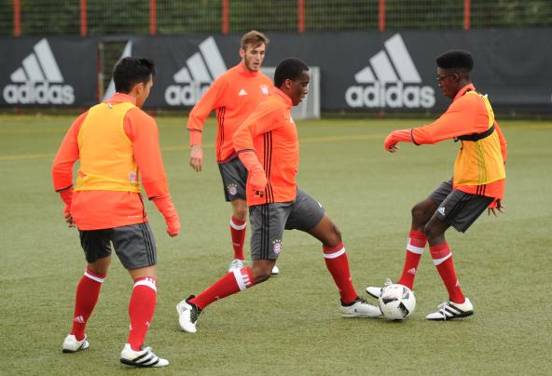

Today, they were invited to the World of Sports, adidas Group’s global headquarters in Germany, where they were treated to a brand induction.

They were then given a guided tour of the entire 346 acre adidas campus, home to playing fields, Adi Dassler stadium, the adidas Brand Centre, an award-winning cafeteria “Stripes” facing an on-campus lake and an entirely new state-of-the art “Laces” building, before taking part in a professional photo-shoot of their own. In addition, they were gifted a personalised pair of either X or ACE Stellar Pack boots, representative of the choice they made in-game when Hunter receives his boot deal in FIFA17.

To round the day off in style and officially mark their partnership with adidas, they were met by Claus-Peter Mayer, Vice President of Sports Marketing for Football at adidas to welcome them to the brand.
Mayer said: “adidas has signed some of the greatest players to play the game and today marks something totally new for the brand. Football gaming is a hugely interesting development area and it’s a great pleasure to welcome these young footballers to the adidas community.”

For further information please visit adidas.com/football or go to facebook.com/adidasfootball or follow @adidasfootball on twitter to join the conversation.

- END -

For further media information please visit http://news.adidas.com/GLOBAL/PERFORMANCE/FOOTBALL or contact:

Simon Bristow  PR Director – Herzo Newsroom  Email: simon.bristow@adidas.com  Tel: +49/9132/84-73 703 | Julien Lanfrey  Global Public Relations Manager I Football Email: Julien.lanfrey@adidas.com  Tel: +49/1609/77-16 429
Notes to editors:
About adidas Football
adidas is the global leader in football. It is the official sponsor / official supplier partner of the most important football tournaments in the world, such as the FIFA World Cup™, the FIFA Confederations Cup, the UEFA Champions League, the UEFA Europa League and the UEFA European Championships. adidas also sponsors some of the world’s top clubs including Manchester United, Real Madrid, FC Bayern Munich, Juventus, Chelsea and AC Milan. Some of the world’s best players also on the adidas roster are Leo Messi, Paul Pogba, Gareth Bale, Thomas Müller, Luis Suárez, James Rodríguez, Diego Costa and Mesut Özil.

