Embargoed until 10am.
adidas Run Your Crew Registrations are Now Open
RYC is Run Your Crew
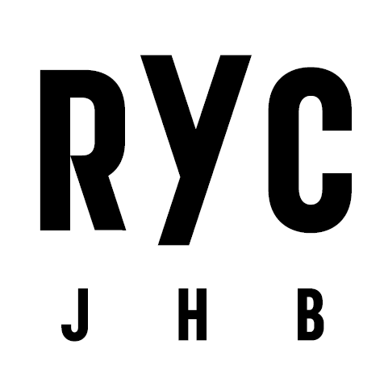
South Africa, Tuesday Oct. 18, 2016 –
adidas announces the opening of registration for Run Your Crew today, a new inner-city crew night run taking place in Johannesburg, on 03 December 2016, at 7pm.
Runners must now register to secure one of the limited spaces available by signing up their six crew members at runyourcrew.com. Entries cost R1200 per crew (R200 per person). All registered crews will receive an entry to the race, an adidas race pack and access to the block party. The race pack contains six adidas RYC race tees, phone pouches, R75 Uber vouchers, timing chips and RYC stickers. After finishing the race together each crew member will also receive their access band to the block party.
Join the adidas Runners community at Runbase, Braamfontein, during the month of November for weekly night runs followed by social crew evenings on the Runbase deck. Follow the schedule on Facebook.
To register visit runyourcrew.com, or follow @adidasZA on Twitter / Instagram and use the hashtag #WHYIRUNJOBURG to join the conversation.

- END -

For further media information please visit:

Saadiyah Hendricks
Magna Carta Reputation Management Consultants
Account Director
Email: saadiyah@magna-carta.co.za
Tel: +27 (87) 997 0111

Portia Gxasheka
adidas South Africa
PR Specialist
Email: Portia.Gxasheka@externals.adidas.com
Tel: +27 (21) 442 6200

Notes to editors:
About Run Your Crew
A highly anticipated running event offering a unique format: runners must enter a six-person crew to compete, with all crews able to choose the route or distance they’d like to run on the night of the race. The only rule is that all members of a crew must stay within 50m of each other for the entire run.
The run starts for all crews at the Sci Bono Centre in Newtown. Each crew has the option to run 4, 8 or 12 km, with the routes diverging at multiple points along the course. All routes converge again for the last kilometre, having all crews finish together at a multi-stage block party hosted directly at the finish line.

