adidas Football Announces Latest Boot Drop With Stellar Pack

- X16+ PURECHAOS and ACE 16+ PURECONTROL feature in adidas Football’s latest release –
- Pack features white and gold colourway to represent the light side of the moon –
- Boots to be worn on pitch from 27th September by the likes of Paul Pogba and Gareth Bale –
- In a first for football adidas launches boots with in-store Virtual Reality experience -
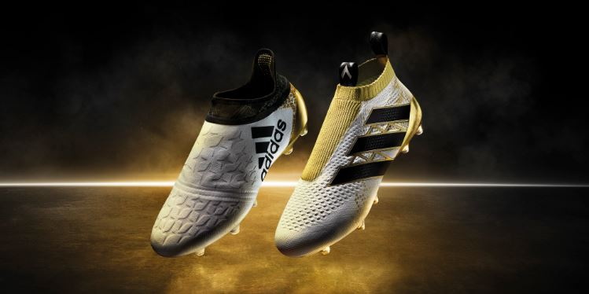

Herzogenaurach, 23rd September 2016 – adidas Football has today unveiled its Stellar pack boots and the continuation of a journey which started with the release of Mercury Pack, followed by the Speed of Light Pack. Inspired by the light side of the moon, the boots are available in a white and gold colourway and come in adidas’ X16+ PURECHAOS and Ace 16+ PURECONTROL silos.

The world’s first high-performance laceless boot and one of the most innovative boots in the industry – The ACE 16+ PURECONTROL - features a white Primeknit upper with NON STOP GRIP (NSG) technology to deliver an unrivalled surface for close ball control, whilst a PURECUT system, in gold, creates an uninterrupted striking surface. The ACE 16+ PURECONTROL will be worn by the likes of Paul Pogba and Mesut Ozil.

The X16+ PURECHAOS – designed for the game’s fastest players and those who like to cause chaos – features a state-of-the-art PURECUT SOCK SYSTEM, which covers the boot laces to give players the ultimate fit. The white NON STOP GRIP (NSG) finish features an updated star design whilst a gold SPRINTFRAME outsole offers stability during high-speed movements. The X16+ PURECHAOS will be worn by the likes of Gareth Bale and Luis Suarez.

Customers at adidas' flagship stores across Europe have already been the first to see the new Stellar pack through a ground-breaking in store Virtual Reality experience on PlayStation®VR. Visitors were not only the first to see the new boots, but were given an exclusive experience on the new PlayStation®VR headset before its release. The in store experience went live on September 21st and is the first time a football boot has been launched through a VR experience before its official release. The experience will continue until October 9th in flagship stores all over Europe including London, Barcelona, Madrid, Berlin, Paris and Milan. PlayStation®VR is the forthcoming Virtual Reality headset for PlayStation®4, launching globally on October 13th 2016.

Stellar Pack will be worn on-pitch from September 27th by some of football’s biggest names - including Paul Pogba, Gareth Bale, Luis Suarez and Mesut Ozil – and will be available to purchase from selected retailers and adidas.com from September 30th.

For further information please visit adidas.com/football or go to facebook.com/adidasfootball or follow @adidasfootball on twitter to join the conversation.

- ENDS -
For further media information please visit http://news.adidas.com/GLOBAL/PERFORMANCE/FOOTBALL or contact:

Simon Bristow  PR Director – Herzo Newsroom  Email: simon.bristow@adidas.com  Tel: +49/9132/84-73 703 | Julien Lanfrey  Global Public Relations Manager I Football Email: julien.lanfrey@adidas.com  Tel: +49/1609/ 77-16 429
Notes to editors:
About adidas Football
adidas is the global leader in football. It is the official sponsor / official supplier partner of the most important football tournaments in the world, such as the FIFA World Cup™, the FIFA Confederations Cup, the UEFA Champions League, the UEFA Europa League and the UEFA European Championships. adidas also sponsors some of the world’s top clubs including Manchester United, Real Madrid, FC Bayern Munich, Juventus, Chelsea and AC Milan. Some of the world’s best players also on the adidas roster are Leo Messi, Paul Pogba, Gareth Bale, Thomas Müller, Luis Suárez, James Rodríguez, Diego Costa and Mesut Özil.

