Angelique Kerber tops off sensational season with US Open victory and World No.1 WTA ranking
adidas celebrates newly crowned champion in New York
Kerber reached her 4th final of the year including the Australian Grand Slam title win
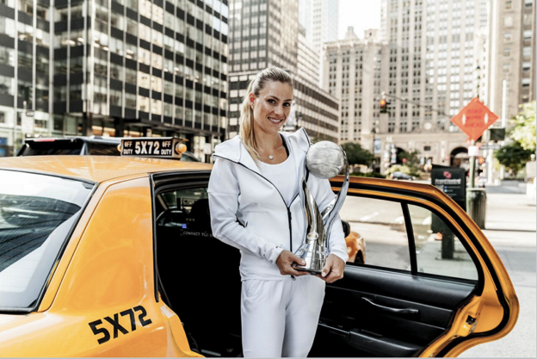
New York, USA (September 13th, 2016) – adidas celebrates newly crowned World Number 1 Angelique Kerber’s US Open victory in New York. Kerber won her second ever Grand Slam title in the city on Saturday in three nail-biting sets. The victory came fresh after being crowned World No.1 after the tournament semi-finals and made official by the WTA on Monday.
Angelique Kerber’s winning season started with her first ever Grand Slam title victory at the Australian Open, doubling with this weekend’s title win in addition to making the finals at Wimbledon and in Rio this summer.
Speaking of her win during a celebratory photoshoot in New York with adidas, Angelique Kerber said: "To be number 1 and have that title is everything I’ve ever worked for. Every early morning session, every late night, every work out in the gym, has gone into this moment and topping it off with my second Grand Slam win has been incredible. After all of the hard work getting to spend time enjoying my victory with adidas has inspired me to push even harder next season. So watch this space.
I would like to thank the tennis fans and of course the New York fans in particular who have supported me throughout the past two weeks and made this event even more special."
Kerber is the first German to hold the World Number 1 ranking since Steffi Graf in 1987, who commented "Really happy for all of Angie's achievements this year. Especially getting to world number 1 which takes talent, commitment and a great deal of hard work. With her determination and work ethic she can only continue to improve. It's been a pleasure getting to know her on and off the court and she can count on me rooting her on!"

Throughout the tournament, Angelique Kerber wore the adizero collection, refreshed for the US open with an eye-catching, multifaceted print inspired by the architecture and landscape of New York.
The 2016 adidas U.S. Open adizero collection is available online at http://www.adidas.co.uk/tennis

- END -
For further media information please contact
Lindsey Rossell
lindsey.rossell@hkstrategies.com
+44 (0) 207 413 3163

Notes to editors:
About adidas Tennis
adidas Tennis is represented by top players such as Simona Halep, Ana Ivanovic, Angelique Kerber, Garbiñe Muguruza, Caroline Wozniacki, Tomas Berdych, Lucas Pouille, Dominic Thiem, Jo-Wilfried Tsonga, Sascha Zverev and Novak Djokovic (Footwear Only). For more information on adidas Tennis, please visit www.adidas.com/tennis. For additional images please visit our media news room on news.adidas.com and follow us on Twitter or on Instagram under @adidasTennis.

About adidas
The adidas Group is a global leader in the sporting goods industry, offering a broad portfolio of footwear, apparel and hardware for sport and lifestyle around the core brands adidas, Reebok, TaylorMade and CCM Hockey. Headquartered in Herzogenaurach, Germany, the Group employs more than 55,000 people across the globe and generated sales of around € 17 billion in 2015.

www.adidas.com/tennis
https://twitter.com/adidastennis
https://www.instagram.com/adidastennis/

