Paul Pogba’s World Record Transfer to Manchester United Celebrated by adidas

- adidas releases a music video to celebrate Pogba joining the club -
- Film shows Pogba dancing to a track by UK Grime artist, Stormzy –
- Video shuts down speculation of the most talked about transfer of the summer –
- Stormzy features in the new Manchester United away kit with Pogba’s name –
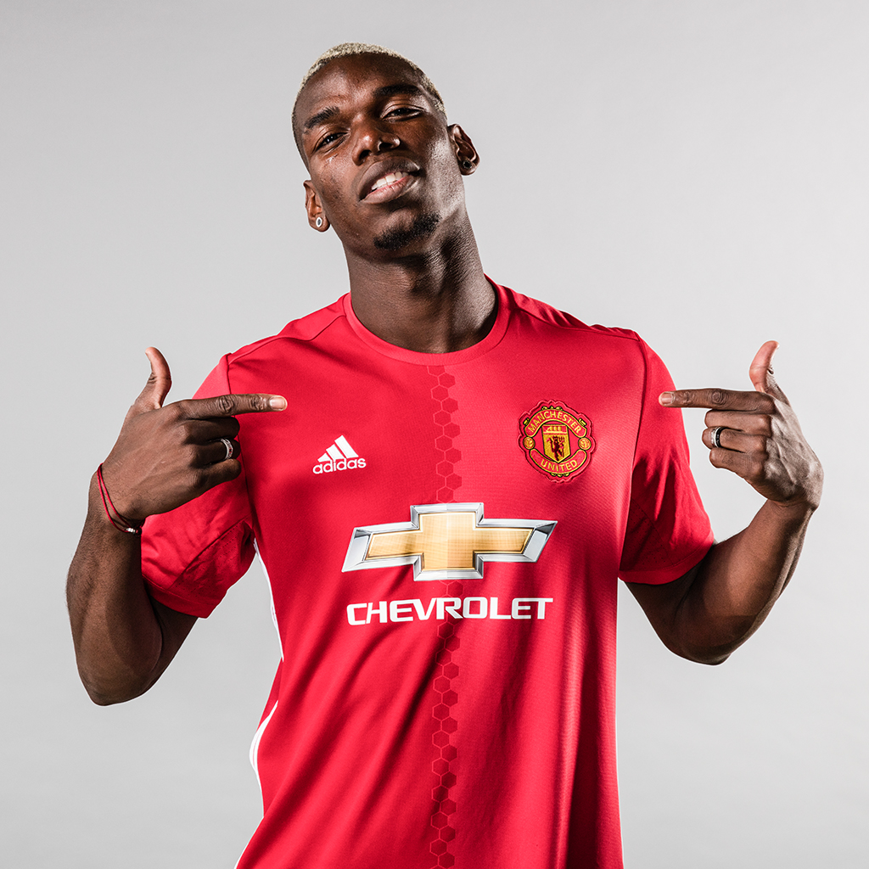
Herzogenaurach, 09 August 2016 – To celebrate Paul Pogba - one of the world’s most exciting footballers - completing his world record transfer to Manchester United, adidas has released a music video of the player showcasing his famous swagger as he dances to a track by UK Grime artist, Stormzy.

In the video fans can see Pogba dancing to the artist’s track ‘Nigo Duppy’. The film pays tribute to the player’s unique style by showcasing his fresh haircuts and trending goal celebrations, paying homage to his on-pitch and off-pitch flair. Lifelong Manchester United supporter Stormzy also features in the track, as he replicates some of Pogba’s most celebrated dance moves.

The video continues the First Never Follows film series, which in pre-season has shown adidas clubs and players responding to the criticism and hype (the “blah blah blah”) of the transfer window, something which has pursued Pogba throughout the summer as speculation increased. The music video shuts down the rumours and celebrates the player’s move to Manchester United in authoritative fashion.

The film concludes with the rapper turning his back to camera, revealing Pogba’s name on the back of the new Manchester United away kit to celebrate the French star’s move to the club. The pair have previously met at adidas’ global HQ in March, where Stormzy dubbed them “a couple of young kings” on Instagram, a line he repeats in the opening of the dance clip. Stormzy was also involved at the launch of the new Manchester United away kit alongside David Beckham, to celebrate the re-opening of the adidas flagship store in London in May.

Pogba joined the adidas family in March, where the brand celebrated the signing by releasing an exclusive ACE 16+ PURECONTROL model in Pogba’s signature black and gold colours.

To view the film, visit: https://youtu.be/5Jfn-U6EGzU

For further information, please visit adidas.com/football or go to facebook.com/adidasfootball or follow @adidasfootball on twitter and Instagram to join the conversation.

- END –

For further media information please visit http://news.adidas.com/GLOBAL/PERFORMANCE/FOOTBALL or contact:

Simon Bristow  PR Director – Herzo Newsroom  Email: simon.bristow@adidas.com  Tel: +49/9132/84-73 703 | Julien Lanfrey  Global PR manager, adidas Football  Email: julien.lanfrey@adidas.com  Tel: +49/9132/84-73 915
Notes to editors:
About adidas Football
adidas is the global leader in football. It is the official sponsor / official supplier partner of the most important football tournaments in the world, such as the FIFA World Cup™, the FIFA Confederations Cup, the UEFA Champions League, the UEFA Europa League and the UEFA European Championships. adidas also sponsors some of the world’s top clubs including Manchester United, Real Madrid, FC Bayern Munich, Juventus, Chelsea and AC Milan. Some of the world’s best players also on the adidas roster are Leo Messi, Paul Pogba, Gareth Bale, Thomas Müller, Luis Suárez, James Rodríguez, Diego Costa and Mesut Özil.

