EMBARGOED 29TH JULY – 2PM (CET)

adidas Reveals FC Bayern Munich’s Third Kit for 2016/17 Season

- New design pays tribute to the club’s Bavarian roots–
- Players will wear kit as they aim for more Bundesliga and Champions League glory–
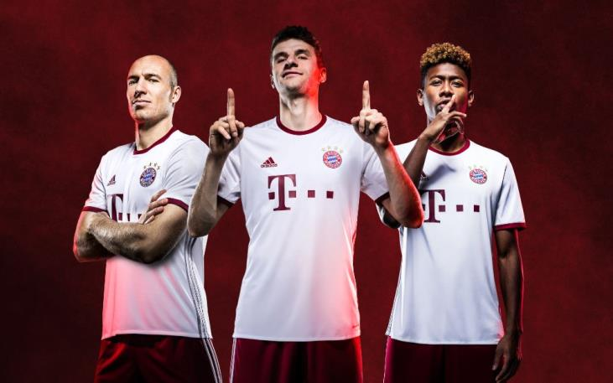

Munich, 29th July 2016– Today adidas launched the FC Bayern Munich third kit for the 2016/17 season, paying tribute to the club’s Bavarian roots as they aim for more Bundesliga and UEFA Champions League glory in the forthcoming campaign.

The new third kit is white with silver accents, in a nod to the club’s European success, and is completed with a burgundy collar. The adidas three stripes have been moved from the shoulder to the side panels and the sleeves feature a subtle diamond pattern. The diamond pattern is echoed in the centre of the club’s crest and is a replication of the same pattern which appears on the flag of Bavaria, to showcase the club’s regional heritage.

The shirt also features the Bayern Munich motto “Mia san mia,” which translates as “We are who we are,” on the inside of the shirt’s collar.

The new kit is now available in the FC Bayern Munich online store, the adidas online shop (www.adidas.com/soccer​) as well as in all FCB-Fan-Shops and in further retail.

- ENDS –

For further media information please visit: http://news.adidas.com/GLOBAL/PERFORMANCE/FOOTBALL or contact:

Simon Bristow  Global PR Director  Email: simon.bristow@adidas.com  Tel: +49/9132/84-73 703 | Wendelin Hübner  Senior Manager Public Relations Germany  Email: wendelin.huebner@adidas.com  09132 84 3131  0160-8843131

Notes to editors:
About adidas Football
adidas is the global leader in football. It is the official sponsor / official supplier partner of the most important football tournaments in the world, such as the FIFA World Cup™, the FIFA Confederations Cup, the UEFA Champions League, the UEFA Europa League and the UEFA European Championships. adidas also sponsors some of the world’s top clubs including Manchester United, Real Madrid, FC Bayern Munich, Juventus, Chelsea and AC Milan. Some of the world’s best players also on the adidas roster are Leo Messi, Paul Pogba, Gareth Bale, Thomas Müller, Luis Suárez, James Rodríguez, Diego Costa and Mesut Özil.

