adidas Launches Juventus Film as part of First Never Follows Film Series

- Film features Miralem Pjanic, Paulo Dyabala, Alex Sandro and Giorgio Chiellini -
- New adidas Speed of Light boots appear in Juventus film -
- Film also launches new Juventus third kit for 2016/17 season -

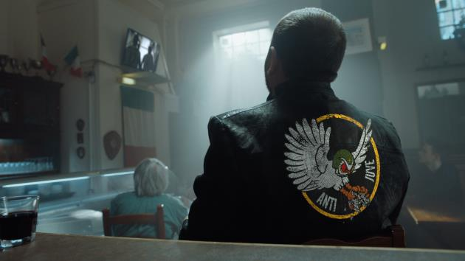

Herzogenaurach, 29th July 2016 – adidas has today launched a unique Juventus film starring Miralem Pjanic, Paulo Dybala, Alex Sandro, Giorgio Chiellinin and other members of the squad, as part of its new First Never Follows film series.

The series – featuring bespoke films of some of the biggest clubs, players and managers in the world - provides a defiant response from a series of star players to the feverous gossip, debate and hype that surrounds each club in the build-up to the start of the 2016/17 season.

The film features an opposition fan – wearing a jacket with ‘ANTI JUVE’ on the back and an owl which is considered bad luck in Italy – imploring Juventus to lose and reacting angrily when the club scores. During the film, the players use the fan’s negativity to buoy their own performances, and demonstrate the on-pitch craftsmanship that shows they’re ready to take on succeed again in the 2016/17 season.

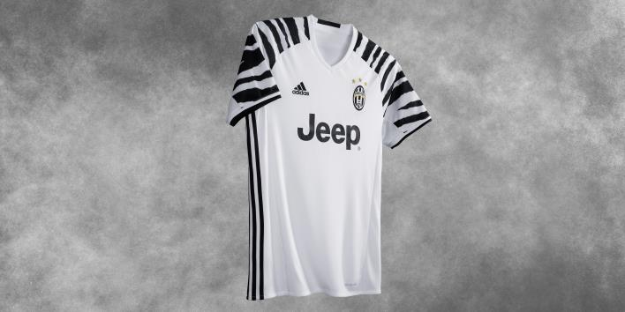

The film launches the new Juventus third kit which the team will be wearing for the coming season. The adidas three stripes have been moved from the sleeves to the side of the jersey. The sleeves feature a striking zebra pattern, paying homage to the 90’s in which, for a brief period of time, the club’s crest was replaced with a zebra. As an eye-catching contrast to the home kit for 2016/17 which is predominantly black, the third kit is primarily white.

The players in the film also debut the new Speed of Light boots – the ACE 16+ PURECONTROL in Solar Yellow and X16+ PURECHAOS in Solar Red – which will be worn on pitch for the start of the 2016/17 season.

To view the film, visit: https://youtu.be/L5UPZntW4SA

For further information please visit adidas.com/football or go to facebook.com/adidasfootball or follow @adidasfootball on twitter to join the conversation.

- END -

For further media information please visit http://news.adidas.com/GLOBAL/PERFORMANCE/FOOTBALL or contact:

Simon Bristow  Global PR Director – Herzo Newsroom  Email: simon.bristow@adidas.com  Tel: +49/9132/84-73 703 | Julien Lanfrey  Global PR Manager, adidas Football  Email: julien.lanfrey@adidas.com  Tel: +49/160/977/16429
Notes to editors:
About adidas Football
adidas is the global leader in football. It is the official sponsor / official supplier partner of the most important football tournaments in the world, such as the FIFA World Cup™, the FIFA Confederations Cup, the UEFA Champions League, the UEFA Europa League and the UEFA European Championships. adidas also sponsors some of the world’s top clubs including Manchester United, Real Madrid, FC Bayern Munich, Juventus, Chelsea and AC Milan. Some of the world’s best players also on the adidas roster are Leo Messi, Paul Pogba, Gareth Bale, Thomas Müller, Luis Suárez, James Rodríguez, Diego Costa and Mesut Özil.

