adidas RELEASE New Manchester United HOME jersey

JERSEY for 2016/17 season inspired by ICONIC 1878 NEWTON HEATH DESIGN
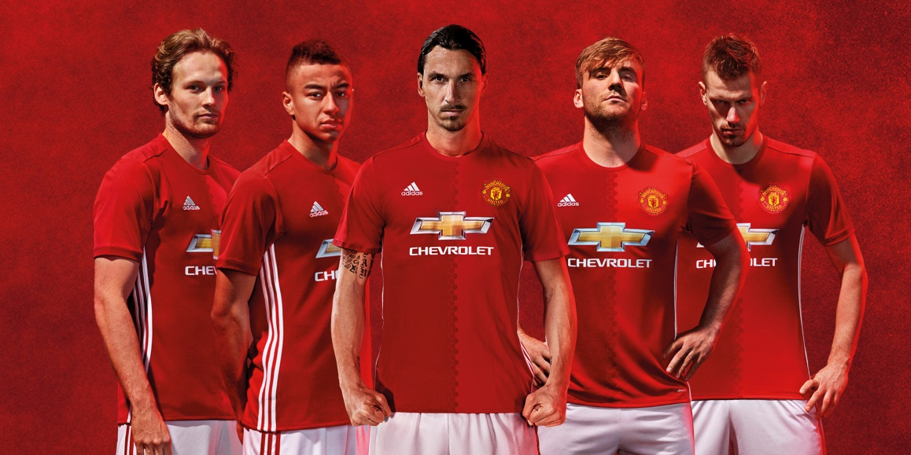
Cape town, 23 JULY 2016: adidas and Manchester United launches the club’s new home jersey for the 2016/17 season, taking inspiration from the club’s early years as Newton Heath LYR Football Club.
In the second year of the partnership with Manchester United, adidas has taken cues from the Club’s illustrious history, with a two tone red split design evoking the two-tone Newton Heath kit of 1878.

The official coat of arms for the City of Manchester was the basis behind the idea for the honeycomb graphic that knits together the two red block designs on the shirt. It was inspired by the worker bee which appears in the crest and originates from the Industrial Revolution, in which Manchester played a significant role. The strong work ethic of the city is also part of the club’s DNA, instilled in the players whenever they pull on the jersey and represent the Club.

The home jersey will be launched officially in China during Tour 2016 presented by Aon, a first for the club, and will be worn on pitch for the first time when United take on Manchester City in Beijing on 25th July.

The Man U jerseys will be available from today (23rd July) on adidas ecommerce, Own retail, Studio 88, Cross Trainer, Total Sports and football specialist stores at a retail price of R899.

Follow @adidasZA on twitter and Instagram to join the conversation.

-END-

For further media information please visit
http://newsZA.adidas.com/ or contact:

Gugu Ntuli  Manager Newsroom and PR  Email: gugu.ntuli@adidas.com  Tel: +27 21 4426238 | Siyavuya Madikane  Senior PR Account Manager – Magna Carta  Email: siyavuya.madikane@magna-carta.co.za  Tel: +27 21 87 997 0111

Notes to editors:

About adidas Football
adidas is the global leader in football. It is the official sponsor / official supplier partner of the most important football tournaments in the world, such as the FIFA World Cup™, the FIFA Confederations Cup, the UEFA Champions League, the UEFA Europa League and the UEFA European Championships. adidas also sponsors some of the world’s top clubs including Manchester United, Real Madrid, FC Bayern Munich, Juventus, Chelsea and AC Milan. Some of the world’s best players also on the adidas roster are Leo Messi, Paul Pogba, Gareth Bale, Thomas Müller, Luis Suárez, James Rodríguez, Diego Costa and Mesut Özil.

About Manchester United
Manchester United is one of the most popular and successful sports teams in the world, playing one of the most popular spectator sports on Earth. Through our 138-year heritage we have won 63 trophies, enabling us to develop the world’s leading sports brand and a global community of 659 million followers. Our large, passionate community provides Manchester United with a worldwide platform to generate significant revenue from multiple sources, including sponsorship, merchandising, product licensing, new media & mobile, broadcasting and match day.

