Mana, Strength and Heritage Inspire New Māori All Blacks jersey

- Renowned Māori artist, Dave Burke, has helped to create the latest jersey -
- Māori All Blacks’ team kaumātua, Luke Crawford, also played a crucial role in development of kit -
- Design take inspiration from powerful, free-flowing style of rugby played by Māori All Blacks -

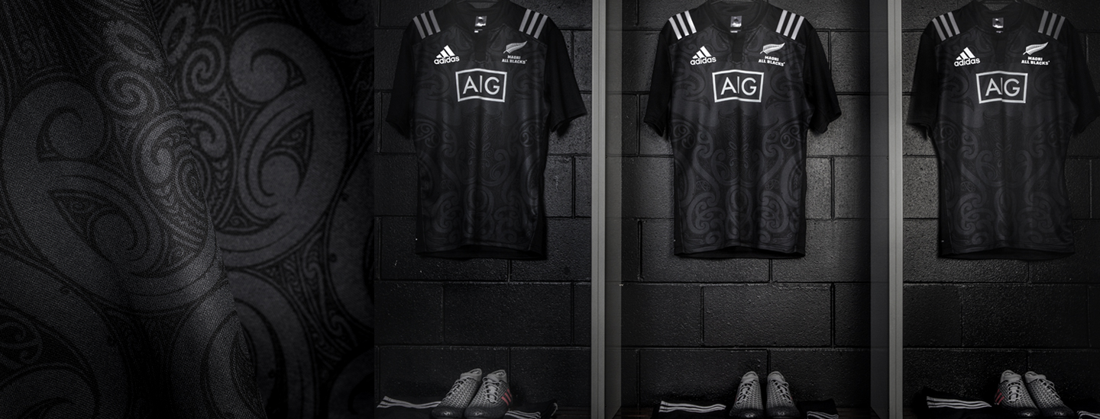

Auckland, Monday 1st August, 2016: adidas has today released the new Māori All Blacks jersey, inspired by the natural elements of Aotearoa.

Renowned Māori artist, Dave Burke, and the Māori All Blacks’ team kaumātua, Luke Crawford, worked collaboratively over 18 months to design the jersey. The complex final design embodies the powerful, free-flowing rugby for which the team is famous, and pays respect to traditional Māori culture.

New Zealand’s powerful oceans are central to the jersey design to showcase the strength and agility of the Māori All Blacks. “The kōwhaiwhai patterns surrounding Tangaroa represent tidal flow, movement, strength, determination, power and speed,” explains Burke.

Burke’s intricate design also showcases the team’s unity: “A waka paddle runs through the mānawa (heart) line and flows in through Tangaroa becoming the arero (tongue) of Tangaroa. This symbolises moving together in one direction with one heartbeat, unity, whānau and purpose.”

The team’s famed free-flowing style is also represented by the cutting edge of the waves. The carving design on the waka paddle represents koiri (to flourish),” says Burke.

The background infill of the designs represent scales, which link back to the central theme of Tangaroa, and the residents of his domain, such as Mangōpare, Mako and Mangōtipi.

Simon Cartwright, Senior Director, adidas Rugby, says: “It’s great to have Dave Burke and Luke Crawford on board again this year to create one of the most complex designs for the jersey ever. They have successfully incorporated the strength and determination of the Māori All Blacks into the Tangaroa theme.”

The themes and design components in the jersey are integrated throughout the entire Māori All Blacks retail leisure range. The replica Māori All Blacks jersey is available from August 1 for €80/$80 (RRP). The jersey is stocked at all adidas stores and major sporting goods retailers, rugby retailers throughout the world, and online at www.adidas.com.

- ENDS –

For further media information contact:

Adam Daysh
Brand Communications
Heartbeat Sports ⎜adidas AG
P: +64 27 577 3439
E: Adam.Daysh@adidas.com

Note to editors:

Designed by Luke Crawford and Dave Burke

Glossary of terms:
- Mangōpare - Hammerhead Shark

- Mangōtipi – White Pointer Shark

- Mako – Blue Pointer Shark

- Tangaroa – God of Oceans

- Arero – Tongue

