adidas changes the look of energy running as BOOST is launched in Color
- adidas introduces color to its revolutionary BOOST technology –
- Available in UltraBOOST Uncaged Triple Red and Triple Black -

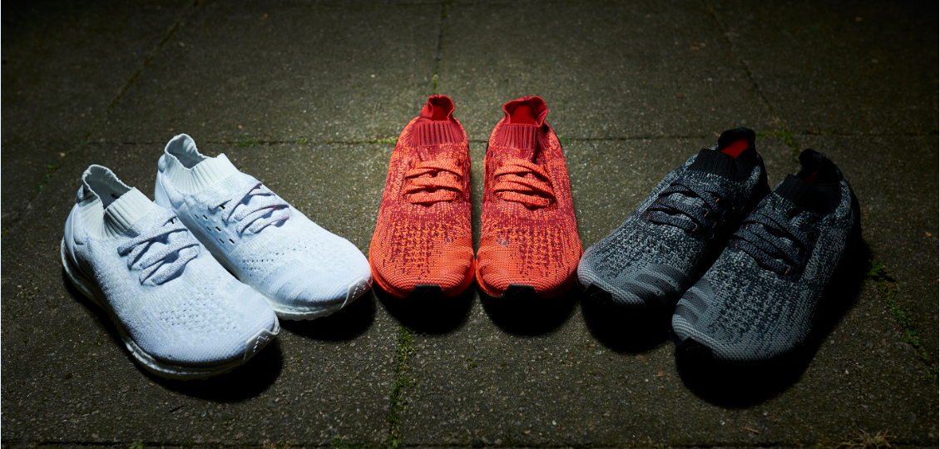

Herzogenaurach, July, 18th - Today adidas gives BOOST™ a bold new look by introducing it in color for the first time. Available in red and black, the highly anticipated color update to BOOST offers runners a completely new aesthetic. The new colorways will make their debut alongside the iconic white BOOST midsole on Triple Red, Black and White versions of the latest drop from adidas, UltraBOOST Uncaged.

This evolution of adidas’s original UltraBOOST Uncaged is focused on offering runners a completely new aesthetic, as each component of the shoe is presented in the same color as the BOOST midsole – giving runners a fresh new look on the streets.

Ben Herath, Vice President of Design for adidas Running says: “The introduction of BOOST with Color reflects our dedication to identifying and understanding exactly what our consumers want and to pushing the boundaries of aesthetic design. BOOST is an industry-leading innovation that will now be available in a style that matches the elite standard of its performance.”

UltraBOOST Uncaged with Color is available instore and at adidas.com from July16th, RRP (180€/USD). Join the adidas Energy Running movement by following @adidasrunning on Twitter and Instagram using #UltraBOOST.

- ENDS –

Si deseas obtener más información ponte en contacto con:

Delia López
adidas España s.a.
Public Relations Manager. Marketing
e-mail: delia.lopez@adidas.com
voice: + 34 976 710 199
mobile: + 34 600 915 326
fax: + 34 976 710 103
www.news.adidas.com

