EMBARGOED 15th JULY 2016

adidas Football releases new Speed of Light boots for 2016/7 season

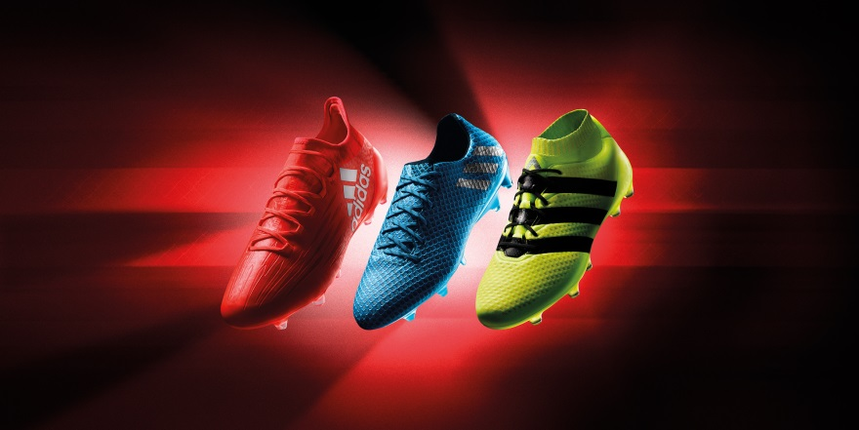

Cape Town, 15th July 2016 – Today, adidas Football unveiled its Speed of Light boots series, a cutting-edge range released ahead of the start of the 2016/17 football season.

Inspired by the colours created by the refraction of light during light speed experiments, the boots are available in Solar Red, Solar Yellow and Shock Blue colourways. They come in adidas’ X16.1, ACE 16.1 and Messi 16.1 styles.

The X16.1 designed for the fastest players in the world has been transformed into a Solar Red colour to represent the ultimate in speed. adidas’ lightest and most aerodynamic shoe features a state-of-the-art PURECUT SOCK SYSTEM and SPRINTFRAME outsole to give players the ultimate fit. X16.1 will be worn by the likes of Luis Suarez and locally, the Bafana and Orlando Pirates defender, Thabo Matlaba.
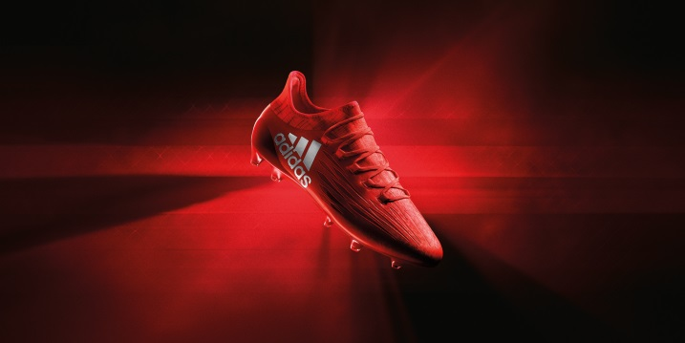

The ACE 16.1 - one of the most innovative boots in the industry has been transformed into a striking Solar Yellow colour. The Primeknit upper and NON STOP GRIP (NSG) technology delivers an unrivalled surface for close ball control in all playing conditions. The ACE 16.1 will be worn by the likes of Paul Pogba, Ivan Rakitic and local Bidvest Wits defender, Thulani Hlatshwayo.

The MESSI 16.1 has been given the Shock Blue treatment. Inspired by the world’s best player, the boot features an innovative SPRINTFRAME and agility knit material designed to provide stability and traction in the lightest possible weight.

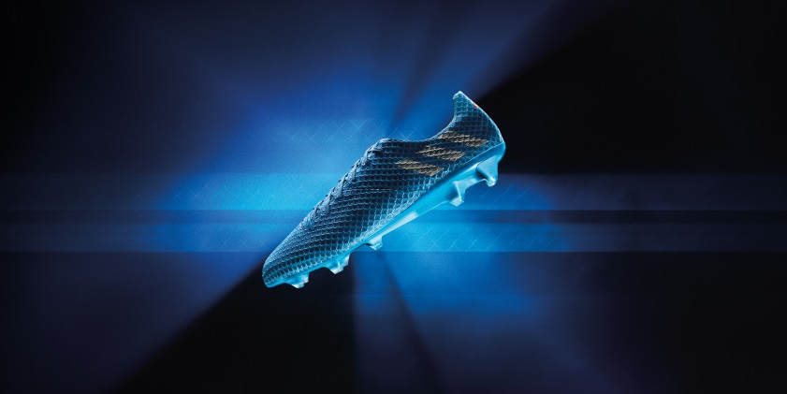

Adrian de Souza, Head of Football at adidas South Africa confirmed: “The Speed of Light Pack is the most vibrant range of boots adidas has ever launched, designed to assist players dominate on the pitch. Led by the fastest boot we’ve ever built, the most agile boot we’ve ever built, and the boot that takes ball control to another level, our new Speed of Light range will be integral to deciding some of the biggest games this season between the PSL’s best players.”

The three Speed of Light boots will be available on the today (15th July) on adidas ecom - www.adidas.co.za/football adidas Own retail stores, as well as at selected football specialists across the country, at a retail price range of R799 - R2499.

Follow @adidasZA on twitter and Instagram to join the conversation.

- ENDS -
For further media information please visit
http://newsZA.adidas.com/ or contact:

Gugu Ntuli  Manager Newsroom and PR  Email: gugu.ntuli@adidas.com  Tel: +27 21 4426238 | Siyavuya Madikane  Senior PR Account Manager – Magna Carta  Email: siyavuya.madikane@magna-carta.co.za  Tel: +27 21 87 997 0111
Notes to editors:
About adidas Football
adidas is the global leader in football. It is the official sponsor / official supplier partner of the most important football tournaments in the world, such as the FIFA World Cup™, the FIFA Confederations Cup, the UEFA Champions League, the UEFA Europa League and the UEFA European Championships. adidas also sponsors some of the world’s top clubs including Manchester United, Real Madrid, FC Bayern Munich, Juventus, Chelsea and AC Milan, as well as local giants Orlando Pirates FC and Ajax Cape Town. Some of the world’s best players also on the adidas roster are Leo Messi, Paul Pogba, Gareth Bale, Thomas Müller, Luis Suárez, James Rodríguez, Diego Costa and Mesut Özil.

