adidas Reveals Bayern Munich Away Kit for 2016/17 Season

- Club to wear kit as they aim to win a fifth consecutive league title –
- New design pays homage the streets of Germany –
- For the first time ever, the kit launched live on the club’s Facebook page -

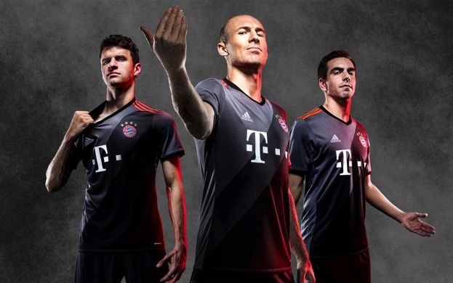

Munich, 14th July 2016– Today adidas launched the Bayern Munich away kit for the 2016/17 season, as Germany’s most decorated club aims to win a record fifth consecutive Bundesliga title.

Inspired by the City streets of Germany, where the country’s young footballers develop their skills, the kit has a two-toned grey design. The classic adidas three stripes in orange give it an injection of colour, while the four stars above the crest symbolise the club’s league success; as only teams with twenty or more league titles are allowed to feature four stars. The shirt is completed with the Bayern Munich motto “Mia san mia,” meaning “We are who we are”.

In a first for Bayern Munich, the club launched the kit live on its Facebook page, giving fans the opportunity to witness the reveal first hand.

To see the video, visit: facebook.com/fcbayern.

The new kit is now available in the FC Bayern Munich online store, the adidas online shop (www.adidas.com/soccer​) as well as in all FCB-Fan-Shops and in further retail.

- ENDS –

For further media information please visit: http://news.adidas.com/GLOBAL/PERFORMANCE/FOOTBALL or contact:

Simon Bristow  Global PR Director  Email: simon.bristow@adidas.com  Tel: +49/9132/84-73 703 | Wendelin Hübner  Senior Manager Public Relations Germany  Email: wendelin.huebner@adidas.com  09132 84 3131  0160-8843131

Notes to editors:
About adidas Football
adidas is the global leader in football. It is the official sponsor / official supplier partner of the most important football tournaments in the world, such as the FIFA World Cup™, the FIFA Confederations Cup, the UEFA Champions League, the UEFA Europa League and the UEFA European Championships. adidas also sponsors some of the world’s top clubs including Manchester United, Real Madrid, FC Bayern Munich, Juventus, Chelsea and AC Milan. Some of the world’s best players also on the adidas roster are Leo Messi, Paul Pogba, Gareth Bale, Thomas Müller, Luis Suárez, James Rodríguez, Diego Costa and Mesut Özil.

