EMBARGOED 13th JULY 2016

adidas Football Releases Brand New Ace16+ Purecontrol UltraBOOST

- New Speed of Light pack given makeover to take players from pitch to street –
- Revolutionary UltraBOOSTTM sole added to ACE16 + PURECONTROL upper –

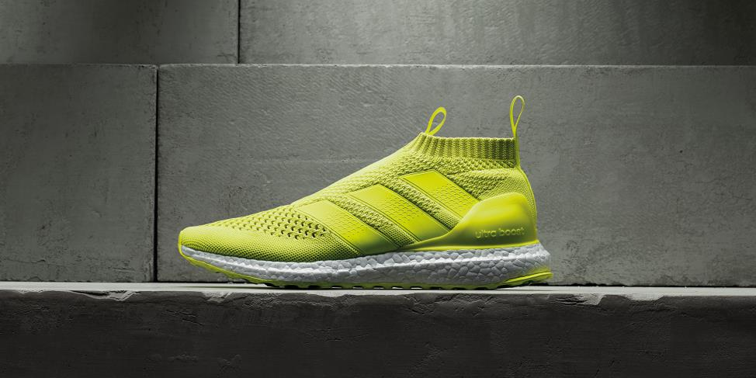

Herzogenaurach, 13th July 2016 – adidas Football has today unveiled a brand new off-pitch interpretation of the ACE16+ PURECONTROL, the ACE16+ PURECONTROL UltraBOOST. It brings together the adidas Primeknit upper from adidas Football and the industry-leading BOOSTTM technology used in adidas Running products, to meet players’ off-pitch needs.

The ACE 16+ PURECONTROL will be available in solar yellow, the on-pitch colourway from the new Speed of Light range, as well as a blackout version. The ACE 16+ PURECONTROL is the first time that football’s leading brand has taken an on-pitch shoe and reinvented it as a lifestyle shoe. It marks the beginning of a new focus which will see future new football products followed by similar off-pitch alternatives.

Sam Handy, adidas Football Vice President of Design said: “We know a footballer’s life doesn’t end when he leaves the pitch. The ACE 16+ PURECONTROL UltraBOOST takes the best upper from adidas Football, the best craftsmanship from adidas Running, and brings it together for the first time.

“We’ve created something that football players and fans want to see. We‘ve recognised that people love wearing our football boots on-pitch, and want to replicate that off-pitch. So we’re going to start following our on-pitch releases with off-pitch versions – this is the start of an exciting journey.”

For further information please visit adidas.com/football or go to facebook.com/adidasfootball or follow @adidasfootball on twitter to join the conversation.

- ENDS -
For further media information please visit http://news.adidas.com/GLOBAL/PERFORMANCE/FOOTBALL or contact:
Simon Bristow  Global PR Director  Email: simon.bristow@adidas.com  Tel: +49/9132/84-73 703 | Alan McGarrie  Global Director PR & Social Media, adidas Football  Email: alan.mcgarrie@adidas.com  Tel: +49/9132/84-4686
Notes to editors:
About adidas Football
adidas is the global leader in football. It is the official sponsor / official supplier partner of the most important football tournaments in the world, such as the FIFA World Cup™, the FIFA Confederations Cup, the UEFA Champions League, the UEFA Europa League and the UEFA European Championships. adidas also sponsors some of the world’s top clubs including Manchester United, Real Madrid, FC Bayern Munich, Juventus, Chelsea and AC Milan. Some of the world’s best players also on the adidas roster are Leo Messi, Paul Pogba, Gareth Bale, Thomas Müller, Luis Suárez, James Rodríguez, Diego Costa and Mesut Özil.

