adidas Football releases new Speed of Light boots for 2016/7 season

- X16+ PURECHAOS, ACE 16+ PURECONTROL and MESSI 16+ PUREAGILITY boots feature in Speed of Light series –
- Pack features Solar Red, Solar Yellow and Shock Blue colourways –

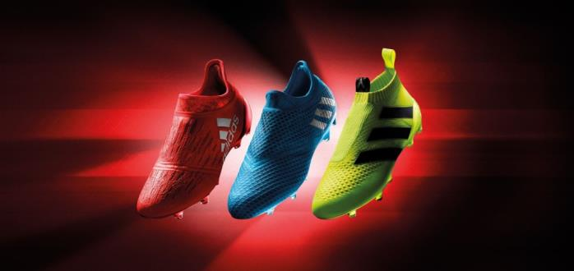

Herzogenaurach, 12th July 2016 – adidas Football has today unveiled its Speed of Light boots, a cutting-edge range released ahead of the start of the 2016/17 season.

Inspired by the colours created by the refraction of light during light speed experiments, the boots are available in Solar Red, Solar Yellow and Shock Blue colourways. They come in adidas’ X16+ PURECHAOS, Ace 16+ PURECONTROL and MESSI 16+ PUREAGILITY styles.

The X16+ PURECHAOS – which is designed for the fastest players in the world – has been transformed into a Solar Red colour to represent the ultimate in speed. adidas’ lightest and most aerodynamic shoe features a state-of-the-art PURECUT SOCK SYSTEM which covers the boot laces to give players the ultimate fit X16+ PURECHAOS will be worn by the likes of Gareth Bale and Luis Suarez.

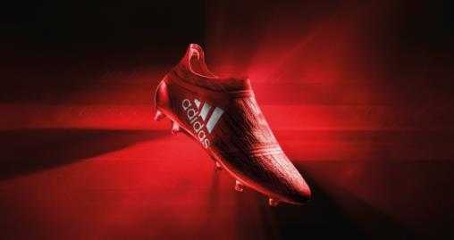

The ACE 16+ PURECONTROL - one of the most innovative boots in the industry and the world’s first high-performance laceless boot – has been transformed into a striking Solar Yellow colour. The Primeknit upper and NON STOP GRIP (NSG) technology delivers an unrivalled surface for close ball control. The ACE 16+ PURECONTROL will be worn by the likes of Paul Pogba and Ivan Rakitic.
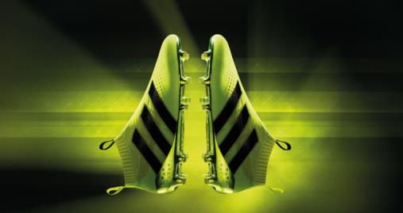

The MESSI 16+ PUREAGILITY has been given the Shock Blue treatment. Inspired by the world’s best player, the boot features a PURECUT internal lacing system and an innovative SPRINTFRAME, designed to provide stability and traction in the lightest possible weight.
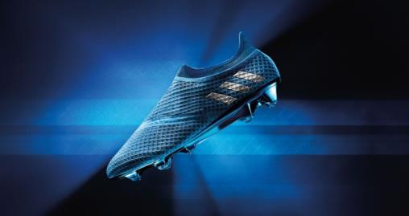

Sam Handy, Vice President of Design said: “The Speed of Light Pack is the most dynamic range of boots adidas has ever launched, designed to help players standout and lead on the pitch. Spearheaded by the fastest boot we’ve ever built, the most agile boot we’ve ever built, and the boot which takes ball control to another level, our new footwear will be integral to deciding some of the biggest games this season between the world’s best players.”

For further information please visit adidas.com/football or go to facebook.com/adidasfootball or follow @adidasfootball on twitter to join the conversation.

- ENDS -
For further media information please visit http://news.adidas.com/GLOBAL/PERFORMANCE/FOOTBALL or contact:

Simon Bristow  PR Director – Herzo Newsroom  Email: simon.bristow@adidas.com  Tel: +49/9132/84-73 703 | Alan McGarrie  Global Director PR & Social Media, adidas Football  Email: alan.mcgarrie@adidas.com  Tel: +49/9132/84-4686
Notes to editors:
About adidas Football
adidas is the global leader in football. It is the official sponsor / official supplier partner of the most important football tournaments in the world, such as the FIFA World Cup™, the FIFA Confederations Cup, the UEFA Champions League, the UEFA Europa League and the UEFA European Championships. adidas also sponsors some of the world’s top clubs including Manchester United, Real Madrid, FC Bayern Munich, Juventus, Chelsea and AC Milan. Some of the world’s best players also on the adidas roster are Leo Messi, Paul Pogba, Gareth Bale, Thomas Müller, Luis Suárez, James Rodríguez, Diego Costa and Mesut Özil.

