adidas Crowned “Most Shareable Brand” of UEFA EURO 2016

- adidas dominates brand battle for content shares around major football moments of the summer -
- #FirstNeverFollows campaign “redefines the rules of real time marketing” -
- Brand generates more than 1.6m shares across key social channels -
- Campaign hashtag used seven times more than closest competitor across Instagram and Twitter -

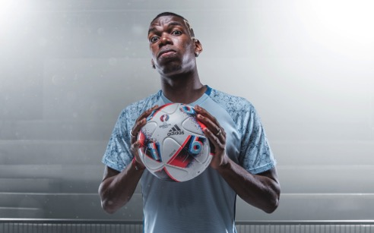

Herzogenaurach, 10th July – adidas has claimed the title of “most shareable brand” during a summer of football that has included the UEFA Champions League Final, Copa America and UEFA EURO 2016. Following on from the achievement of “most talked about brand” during the 2014 FIFA World Cup Brazil, this time around adidas has placed a strategic focus on “quality” – measuring shares as the most valuable form of consumer interaction on social media.

Focusing its content approach on key assets, federations and footwear products, adidas was the number one brand in terms of shareability. The brand accumulated 1.61m shares across Twitter (retweets), Facebook (shares), YouTube (direct shares and shares to other social platforms), Instagram (user tags) and Online Media (shares to social platforms).

During the UEFA EURO 2016 tournament in particular, adidas was able to dominate the daily share volume for 27 of 30 days from the tournaments first game on June 10 and the final on July 10. This resulted in a total of 1.17m shares, more than twice the number of the next biggest brand.

One particular highlight for adidas was that its share of voice, in terms of hashtag usage, was seven times higher than the next best brand. In total it received 685k hashtag mentions across Instagram and Twitter, meaning that as well as having the most shareable campaign content on social media, adidas was also by far the most visible brand.

adidas focussed its efforts on the strong relationships the brand has with its partners – leveraging short films, images and GIFs relating to federations like Germany, Wales, Belgium and Spain as well as key players like Paul Pogba, Mesut Özil and Gareth Bale. The brand also displayed an innovative approach to its UEFA rights with access to match footage, exclusive post-game player portraits, and in-stadia LED boards utilised as content streams throughout the tournament.

Product wise, the focus was around the Mercury Pack footwear worn by a number of the world’s biggest stars with all storytelling designed to contextualise the feeling of being first and ultimately landing the brand’s campaign message of “First Never Follows”.

Commenting on the success of the “First Never Follows” campaign, adidas Senior Director Global Brand Communications Football, Florian Alt said:

“Following the success of the 2014 World Cup in Brazil, where adidas was crowned the most talked about brand, we have once again redefined the rules of real time marketing during the summer of 2016.

“In pursuing a qualitative metric, like most shareable, the results imply that adidas’ content featuring the First Never Follows messaging has resonated on a deeper, more meaningful level. Our products and strong relationships with our assets set us apart from the competition, driving shareability and cementing our position as the number one football brand.”

- END -

For further media information please visit http://news.adidas.com/GLOBAL/PERFORMANCE/FOOTBALL or contact:

Simon Bristow  Global PR Director  Email: simon.bristow@adidas.com  Tel: +491604851388 | Alan McGarrie  Global Director PR & Social Media, adidas Football  Email: alan.mcgarrie@adidas.com  Tel: +49/9132/84-4686

Notes to editors:
Analytics technology used to measure campaign results: Sysomos, Sprinklr, Tubular Labs, Simply Measured and native analytic tools within social media platforms.

About adidas Football
adidas is the global leader in football. It is the official sponsor / official supplier partner of the most important football tournaments in the world, such as the FIFA World Cup™, the FIFA Confederations Cup, the UEFA Champions League, the UEFA Europa League and the UEFA European Championships. adidas also sponsors some of the world’s top clubs including Manchester United, Real Madrid, FC Bayern Munich, Juventus, Chelsea and AC Milan. Some of the world’s best players also on the adidas roster are Leo Messi, Paul Pogba, Gareth Bale, Thomas Müller, Luis Suárez, James Rodríguez, Diego Costa and Mesut Özil.

