ADIDAS REVEAL NEW CHELSEA AWAY KIT FOR THE 2016/17 SEASON TAKING INSPIRATION FROM THE STREETS

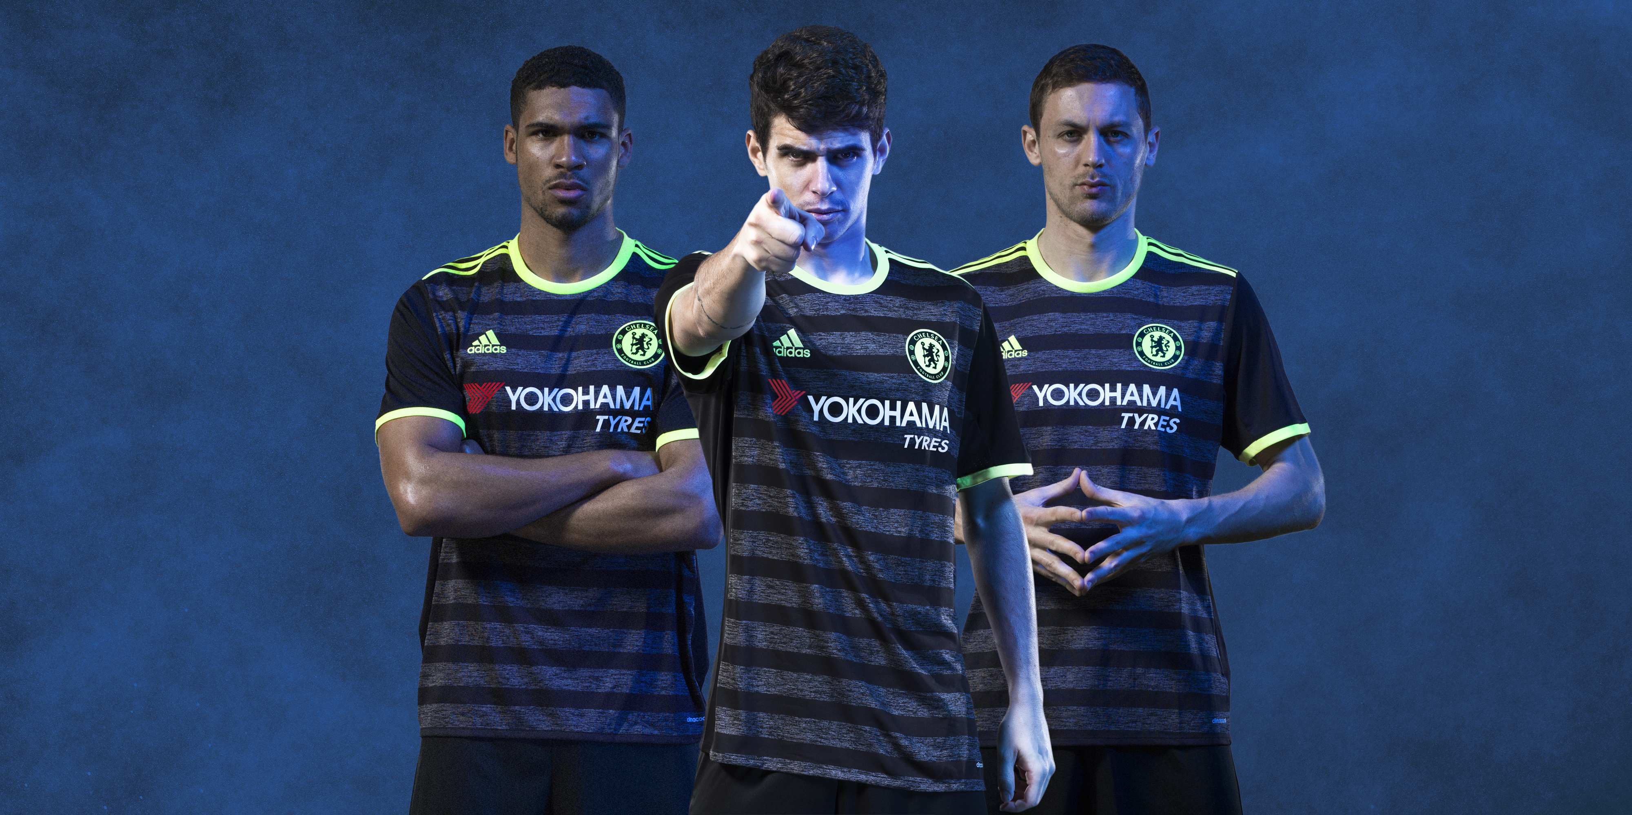

London/Herzogenaurach, 11th July 2016 – Chelsea Football Club and adidas have today unveiled the new away kit for the 2016/17 season.

Showing the two faces of the club, the new season kits combine the strong traditions of a proud club and it‘s renewed commitment to become the best once more. These two themes are reflected in the kit through a combination of classic, traditional styles and street inspired, fresh, commercial designs

With a disruptive new look, the away kit features engineered mélange stripe fabric in grey and black with neon yellow accents, short shoulder stripes, a two colour crest and an engineered collar tape featuring “Chelsea FC” text.

This colour scheme has been ever present across the 2000s, popular amongst fans and players alike and a key feature of the club’s landmark successes across this decade including winning the UEFA Champions League, Premier League and FA Cup.
The kit will be worn for the first time during the club’s US tour on Saturday 30 July, when Chelsea take on Real Madrid in Michigan, but you can order now to receive it on Wednesday 20 July.
You can now pre-order the new away kit through www.chelseafc.com/shopping and follow @adidasuk and @ChelseaFC on Twitter and Facebook to join the conversation around the new kit.
- END -
For further media information please visit http://news.adidas.com/GLOBAL/PERFORMANCE/FOOTBALL or contact:

Ben Goldhagen
Senior PR Manager – adidas football
Email: ben.goldhagen@adidas.com
Tel: 07861 182501

Notes to editors:

About adidas Football

adidas is the global leader in football. It is the official sponsor / official supplier partner of the most important football tournaments in the world, such as the FIFA World Cup™, the FIFA Confederations Cup, the UEFA Champions League, the UEFA Europa League and the UEFA European Championships. adidas also sponsors some of the world’s top clubs including Manchester United, Real Madrid, FC Bayern Munich, Juventus, Chelsea and AC Milan. Some of the world’s best players also on the adidas roster are Leo Messi, Paul Pogba, Gareth Bale, Thomas Müller, Luis Suárez, James Rodríguez, Diego Costa and Mesut Özil.

About Chelsea Football Club

Chelsea Football Club is one of the world’s top football clubs. Chelsea were UEFA Champions League winners in 2012, following that success by lifting the UEFA Europa League trophy in 2013. Founded in 1905, Chelsea is London’s most central football club, based at the iconic 42,000-capacity Stamford Bridge stadium.

Nicknamed ‘The Blues’, Chelsea are four-time English Premier League champions and have also lifted the FA Cup seven times, the Football League Cup five times, the UEFA Cup Winners’ Cup twice, the UEFA Super Cup once and the Football League Championship once, in 1955. The Europa League triumph saw Chelsea become the first English club to win all three major UEFA competitions, and the first club ever to hold both the Champions League and Europa League at the same time.

In addition to possessing some of the world’s most recognisable players, Chelsea has also invested in its future with a state-of-the-art Academy and training centre in Cobham, Surrey. Since its opening in 2007, the club has lifting the FA Youth Cup trophy five times and the UEFA Youth League twice. The Chelsea Ladies team also won the FA Women’s Super League and FA Women’s Cup double in 2015.

Additionally, the Chelsea Foundation boasts one of the most extensive community initiatives in sport, working in 30 countries around the world, helping improve the lives of more than 900,000 children and young people each year.

