adidas celebrates Mesut Özil’s unrivalled touch and vision in latest First Never Follows film

- Young football fans praise Özil’s ability to assist season after season -
- Özil wears new ACE 16+ PURECONTROL in latest film from adidas -
- Özil ready to provide for Germany at UEFA EURO 2016TM this summer -

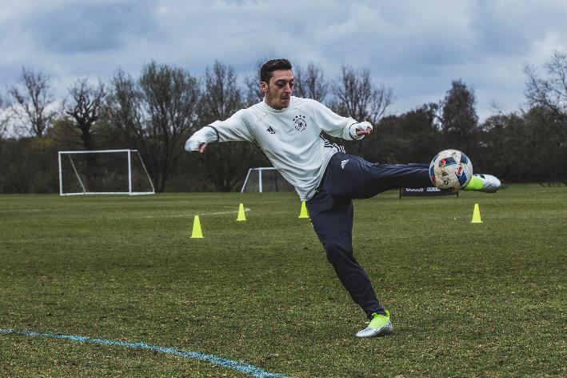

Herzogenaurach, 2nd July 2016 – Germany’s king of assists, Mesut Özil, stars in the latest First Never Follows film launched by adidas today, ahead of his country’s quarter-finals clash with Italy at UEFA EURO 2016 TM.

Özil once again proved himself to be a regular provider for his club with 19 assists in all competitions last season setting a new league record. He will hope to emulate that form this summer for his country as Germany look to become the first nation since Spain to hold both the FIFA World Cup and UEFA EURO trophies.

The film is the latest in the First Never Follows film series from adidas and is told through the eyes of a young football fan. Özil has made assisting an art form for club and country during his career and has inspired fans worldwide with his touch, vision and ability to see passes that others cannot.

Özil, who has been wearing the ACE 16+ PURECONTROL since January, can be seen in the film wearing the new colourway of the world’s first high performance laceless boot, the boots he will be wearing this summer at the UEFA EURO 2016TM.

To view the film, visit https://youtu.be/-ujnZkCWQOQ

For further information please visit adidas.com/football or go to facebook.com/adidasfootball or follow @adidasfootball on twitter to join the conversation.

- END -

For further media information please visit http://news.adidas.com/GLOBAL/PERFORMANCE/FOOTBALL or contact:

Simon Bristow  PR Director – Herzo Newsroom  Email: simon.bristow@adidas.com  Tel: +49/9132/84-73 703 | Alan McGarrie  Global Director PR & Social Media, adidas Football  Email: alan.mcgarrie@adidas.com  Tel: +49/9132/84-4686
Notes to editors:
About adidas Football
adidas is the global leader in football. It is the official sponsor / official supplier partner of the most important football tournaments in the world, such as the FIFA World Cup™, the FIFA Confederations Cup, the UEFA Champions League, the UEFA Europa League and the UEFA European Championships. adidas also sponsors some of the world’s top clubs including Manchester United, Real Madrid, FC Bayern Munich, Juventus, Chelsea and AC Milan. Some of the world’s best players also on the adidas roster are Leo Messi, Paul Pogba, Gareth Bale, Thomas Müller, Luis Suárez, James Rodríguez, Diego Costa and Mesut Özil.

