adidas and German Football Association extend partnership until 2022

- Reigning World Champions to extend their over 60-year association with adidas –
- “We belong together” says Herbert Hainer, CEO of the adidas Group -

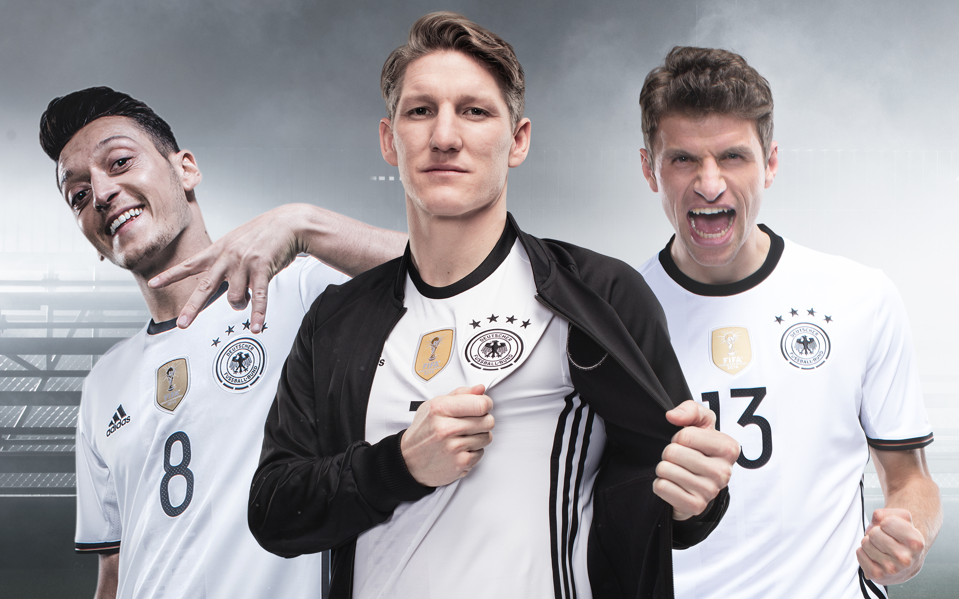

Paris/Frankfurt/Herzogenaurach, June 20, 2016 – One of the longest and most successful partnerships in sport continues: Today, the German Football Association (DFB) and adidas officially announced the extension of their long-term partnership. DFB President Reinhard Grindel and Herbert Hainer, CEO of the adidas Group, confirmed in Paris that adidas will remain the Official Supplier of the world’s largest sports federation until 2022.

During their over 60-year partnership, the DFB and adidas have celebrated many sporting successes including four World Cup and three EURO titles for the German men’s national team as well as two World Cup and eight EURO trophies for the women’s team. As part of the new agreement, adidas will continue to be a dedicated and reliable partner not only to the DFB but also to its national associations to further develop football in Germany on all levels.

“We are looking forward to continuing our close and trusting cooperation with the DFB”, said Herbert Hainer, CEO of the adidas Group. “We belong together, as both the DFB with its national teams and we as an international sporting goods company excellently present Germany around the globe. We represent everything the ‘made in Germany’ seal of quality stands for: we are successful, we are innovative and we deliver quality; we are cosmopolitan, multi-cultural and bring joy. As part of our long-term strategy, we will increase our production volume in Germany again and plan to also produce the DFB jerseys directly in our home market.

“These were the most transparent, most demanding and ultimately for the DFB the economically most successful negotiations in the history of our Association. I am very pleased that we've managed to extend the contract with adidas, our partner for decades. adidas is reliable, knows the DFB and is supporting us with upcoming innovations such as the construction of the new DFB academy or the further development of fussball.de. We will use the money to make the DFB and German football even better. Our investments will be focused on both professional football and the work done at the grassroots level. We will also strengthen our national associations and further improve in particular our talent promotion programmes,” said DFB President Reinhard Grindel.

For further information please visit adidas.com/football or go to facebook.com/adidasfootball or follow @adidasfootball on twitter to join the conversation.

- END -

For further media information please visit http://news.adidas.com/GLOBAL/PERFORMANCE/FOOTBALL or contact:

Simon Bristow  PR Director – Herzo Newsroom  Email: simon.bristow@adidas.com  Tel: +49/9132/84-73 703 | Alan McGarrie  Global Director PR & Social Media, adidas Football  Email: alan.mcgarrie@adidas.com  Tel: +49/9132/84-4686
Notes to editors:
About adidas Football
adidas is the global leader in football. It is the official sponsor / official supplier partner of the most important football tournaments in the world, such as the FIFA World Cup™, the FIFA Confederations Cup, the UEFA Champions League, the UEFA Europa League and the UEFA European Championships. adidas also sponsors some of the world’s top clubs including Manchester United, Real Madrid, FC Bayern Munich, Juventus, Chelsea and AC Milan. Some of the world’s best players also on the adidas roster are Leo Messi, Paul Pogba, Gareth Bale, Thomas Müller, Luis Suárez, James Rodríguez, Diego Costa and Mesut Özil.

