EMBARGOED UNTIL JUNE 17, 10AM (CET)

adidas celebrates the host nation of UEFA EURO 2016 with limited edition Paris Pack

- Special edition football boot part of adidas Football’s Limited Collection –
- Disruptive design of red, white and blue represents flag of France -
- Available in street and pitch versions of X and ACE -

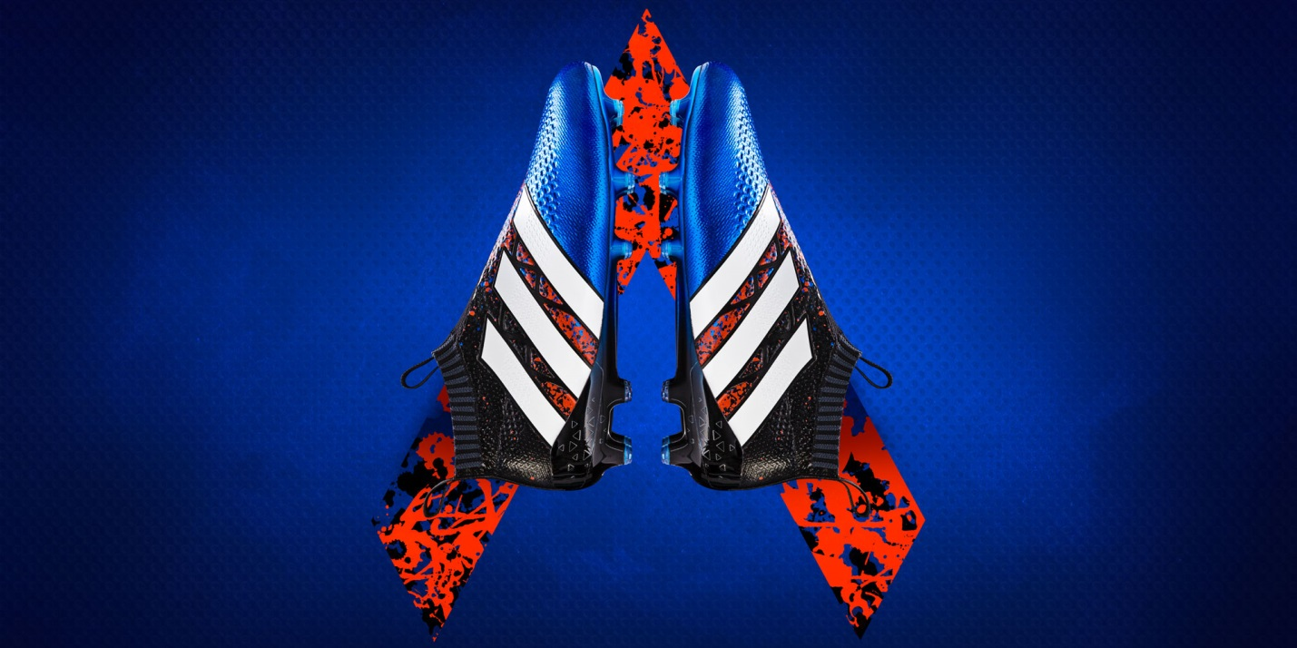
Herzogenaurach, 17th June – Today adidas Football pays homage to the host nation of UEFA EURO 2016 with the launch of the Paris Pack, a limited edition collection of footwear for the pitch and street.

Available in street versions ACE 16.1 ST, X 16.1 ST and pitch versions ACE 16+ PURECONTROL and X 16+ PURECHAOS, Paris Pack features an explosion of colour in red, white and blue to represent the host nation of this summer’s tournament.

The ACE 16.1 ST features a PRIMEMESH Upper Material, PRIMECUT Ankle Sock and Low to the Ground Futsal Outsole with Heel BOOST Cushioning, offering the ultimate control for street players looking to dictate the game. The X 16.1 ST features a Textile Upper Material, TECHFIT Sock and Football BOOST Lifestyle Outsole – designed for the street player who likes to cause chaos with incredible skill and speed.

The pitch versions have the same technical features as the latest range of high performance adidas boots, the Mercury Pack, with the ACE 16+ PURECONTROL and X 16+ PURECHAOES completing Paris Pack.

The X16+ PURECHAOS is designed to harness speed. The updated SPRINTFRAME outsole delivers traction and stability for high-speed movements whilst the TECHFIT lacing system provides a glove-like fit. The ACE 16+ PURECONTROL features a Primeknit upper and NON STOP GRIP, delivering an unrivalled surface for close ball control.

Paris Pack will be available to purchase in limited quantities from today.

For further information please visit adidas.com/football or go to facebook.com/adidasfootball or follow @adidasfootball on twitter to join the conversation.

- END -

For further media information please visit http://news.adidas.com/GLOBAL/PERFORMANCE/FOOTBALL or contact:

Simon Bristow  PR Director – Herzo Newsroom  Email: simon.bristow@adidas.com  Tel: +49/9132/84-73 703 | Alan McGarrie  Global Director PR & Social Media, adidas Football  Email: alan.mcgarrie@adidas.com  Tel: +49/9132/84-4686
Notes to editors:
About adidas Football
adidas is the global leader in football. It is the official sponsor / official supplier partner of the most important football tournaments in the world, such as the FIFA World Cup™, the FIFA Confederations Cup, the UEFA Champions League, the UEFA Europa League and the UEFA European Championships. adidas also sponsors some of the world’s top clubs including Manchester United, Real Madrid, FC Bayern Munich, Juventus, Chelsea and AC Milan. Some of the world’s best players also on the adidas roster are Leo Messi, Paul Pogba, Gareth Bale, Thomas Müller, Luis Suárez, James Rodríguez, Diego Costa and Mesut Özil.

