adidas presents First Never Follows film for Latin America

- James Rodriguez, Claudio Bravo, Angel Di María and Miguel Layún star in film-

- Launch video celebrates players’ drive to be first, on and off the pitch -

- First Never Follows series announces the arrival of Mercury Pack boot collection -

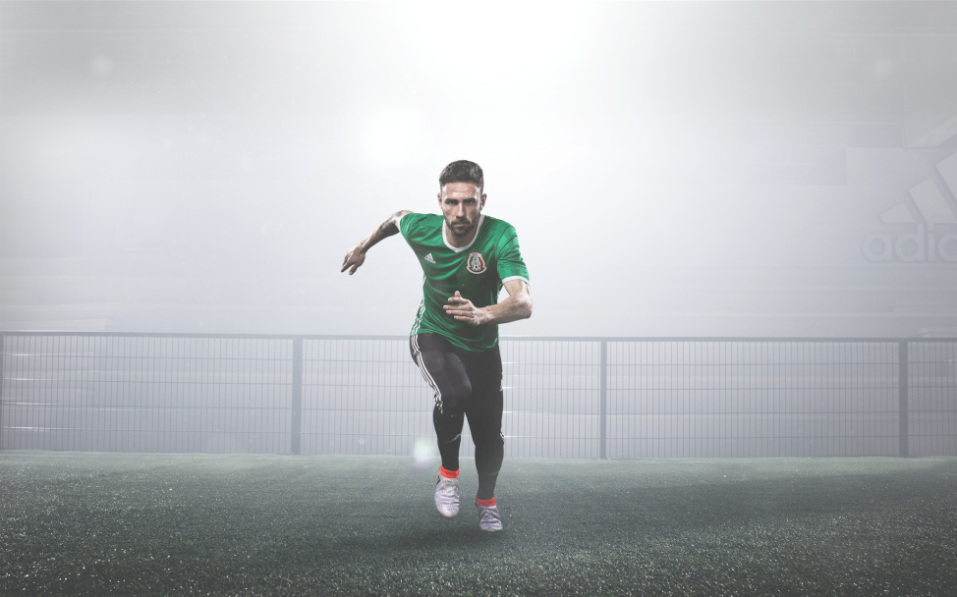

Herzogenaurach, 9th June 2016 - adidas Football has launched its latest video in the First Never Follows film series, focussing on stars of the Copa America Centenario. Featuring James Rodriguez, Claudio Bravo, Angel Di María and Miguel Layún, the film celebrates the players’ unique drive to be number one.

The film shows the players showcasing the attributes that inspire them to be first in everything they do – from playing for their countries, being faster than an opponent or making the whole country dance to their rhythm by creating a new piece of skill.

Chile goalkeeper Claudio Bravo is seen wearing the fresh new ACE 16+ PURECONTROL, with Layún, Di Maria and James wearing the new X16+ PURECHAOS.

The First Never Follows film series celebrates the unveiling of adidas’ striking new Mercury Pack boot collection, worn on pitch during the Copa América Centenario, the most important football tournament on the continent.

To view the film, visit https://www.youtube.com/watch?v=6xWpkYJuNLo

For further information please visit adidas.com/football or go to facebook.com/adidasfootball or follow @adidasfootball on twitter to join the conversation.

- END -

For further media information please visit http://news.adidas.com/GLOBAL/PERFORMANCE/FOOTBALL or contact:

Simon Bristow  PR Director – Herzo Newsroom  Email: simon.bristow@adidas.com  Tel: +49/9132/84-73 703 | Alan McGarrie  Global Director PR & Social Media, adidas Football  Email: alan.mcgarrie@adidas.com  Tel: +49/9132/84-4686
Notes to editors:
About adidas Football
adidas is the global leader in football. It is the official sponsor / official supplier partner of the most important football tournaments in the world, such as the FIFA World Cup™, the FIFA Confederations Cup, the UEFA Champions League, the UEFA Europa League and the UEFA European Championships. adidas also sponsors some of the world’s top clubs including Manchester United, Real Madrid, FC Bayern Munich, Juventus, Chelsea and AC Milan. Some of the world’s best players also on the adidas roster are Leo Messi, Paul Pogba, Gareth Bale, Thomas Müller, Luis Suárez, James Rodríguez, Diego Costa and Mesut Özil.

