EMBARGOED 10TH JUNE – 10AM (CET)

Paul Pogba ready to win First major trophy with France as he stars in latest First Never Follows film

- Pogba’s on and off pitch style celebrated in latest First Never Follows film -
- Young football fans pay tribute to Pogba’s style -
- Pogba ready to lead his country to glory on home turf this summer -

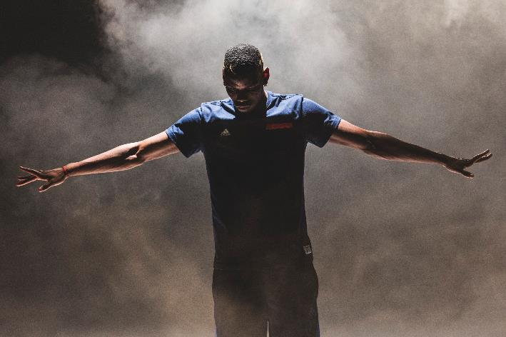

Herzogenaurach, 10th June 2016 – The world’s most exciting footballer, Paul Pogba, is the star of the latest First Never Follows film from adidas, which launched today ahead of his country’s opening game in the UEFA EURO 2016TM. Pogba has been making headlines on and off the pitch in his rise to superstardom and hopes to lead his country to glory on home turf this summer.

The film is narrated by a young football fan as he tries to recreate Pogba’s trademark strike in a local small sided football pitch. The film pays tribute to Pogba’s unique style, with fresh haircuts, trending goal celebrations and even his own hashtag – #pogboom. Pogba has inspired young fans all over the world that it’s not what you do, but how you do it that matters.

In the film, Pogba wears the new ACE 16+ PURECONTROL, the boots that he’ll wear at the UEFA EURO 2016TM as he bids to win his first major tournament for his country.

To view the film, visit https://youtu.be/hfEig1nTshQ

Ahead of the opening game of UEFA Euro 2016 TM, Paul Pogba said:
“I always aim to be a leader - by being the first in everything I do - on and off the pitch. From being the first to try new skills to the first to showcase a fresh new style, being first is what inspires me and drives me to create moments that everyone remembers.”

For further information please visit adidas.com/football or go to facebook.com/adidasfootball or follow @adidasfootball on twitter to join the conversation.

- END -

For further media information please visit http://news.adidas.com/GLOBAL/PERFORMANCE/FOOTBALL or contact:

Simon Bristow  PR Director – Herzo Newsroom  Email: simon.bristow@adidas.com  Tel: +49/9132/84-73 703 | Alan McGarrie  Global Director PR & Social Media, adidas Football  Email: alan.mcgarrie@adidas.com  Tel: +49/9132/84-4686
Notes to editors:
About adidas Football
adidas is the global leader in football. It is the official sponsor / official supplier partner of the most important football tournaments in the world, such as the FIFA World Cup™, the FIFA Confederations Cup, the UEFA Champions League, the UEFA Europa League and the UEFA European Championships. adidas also sponsors some of the world’s top clubs including Manchester United, Real Madrid, FC Bayern Munich, Juventus, Chelsea and AC Milan. Some of the world’s best players also on the adidas roster are Leo Messi, Paul Pogba, Gareth Bale, Thomas Müller, Luis Suárez, James Rodríguez, Diego Costa and Mesut Özil.

