Paul Pogba shows off boss cut with ‘dab’ celebration

- Pogba given ultimate boss hairstyle backstage -
- adidas releases latest clip to celebrate Pogba’s arrival -

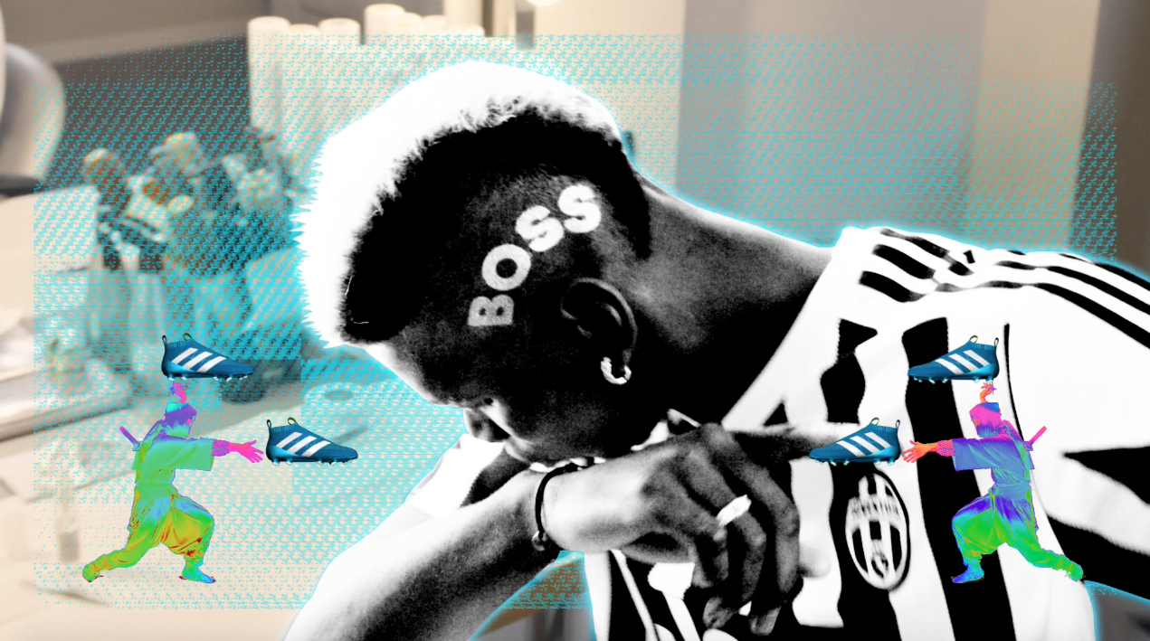

Herzogenaurach, date TBC – Earlier this month, adidas announced the latest star to join its global roster of footballing talent with Paul Pogba, the hottest property in football, joining the brand. Today, the world’s biggest football brand released the final video in a series of short clips to celebrate Pogba’s long term partnership with adidas and his move into the new blue ACE 16+ Purecontrol.

Pogba has become renowned for his swag on and off the pitch, with his goals, celebrations and hairstyles creating hype in football all over the world. In the latest video, Pogba is sat backstage getting the ultimate boss hairstyle, before spinning on his chair performing his now trademark ‘dab’ goal celebration.

Watch the clip at: https://youtu.be/FbyGmP0D9b0

- END -

For further media information please visit http://news.adidas.com/GLOBAL/PERFORMANCE/FOOTBALL or contact:

Simon Bristow  PR Director – Herzo Newsroom  Email: simon.bristow@adidas.com  Tel: +49/9132/84-73 703 | Alan McGarrie  Global Director PR & Social Media, adidas Football  Email: alan.mcgarrie@adidas.com  Tel: +49/9132/84-4686

Notes to editors:
About adidas Football
adidas is the global leader in football. It is the official sponsor / official supplier partner of the most important football tournaments in the world, such as the FIFA World Cup™, the FIFA Confederations Cup, the UEFA Champions League, the UEFA Europa League and the UEFA European Championships. adidas also sponsors some of the world’s top clubs including Manchester United, Real Madrid, FC Bayern Munich, Juventus, Chelsea and AC Milan. Some of the world’s best players also on the adidas roster are Leo Messi, Paul Pogba, Gareth Bale, Thomas Müller, Luis Suárez, James Rodríguez, Diego Costa and Mesut Özil.

